**Faculty of Business**

**Management Information Systems Department**

**Graduation Project**

**SAFE ZONE**

**An Application for Parking & car care center services**

**Supervised By:**

**Dr: Mohamed Moustafa Al-Abbassy**

**Submitted By:**

**Abdelrahman Nabil Ibrahim**

**Abdelrahman Sherif Mostafa**

**Abdelrahman Othman Abd El Megid Hasan**

**Mohamed fouad Mohamed zaki**

**Mohammed Abd El Aziz Selim Ghareeb**

**Mohammed Mohammed Abd El Fatah Bekhet**

**Yousef Sherif Salah Ali**

**Reem Esam El Deen Mohammed Abd El Rahman**

**Salma Gamal Mohammed Eid**

**Youmna Mohammed Saad Zaghlol**

**Rana Said Mohammed Ali**

**Nayera Abdelshafi Muhammad Bakr**

# June 2024

﷽

**صدق الله العظيم**

**(سوره النجم)**

**Acknowledgement:**

Dear Professors,

As we reach the culmination of our graduation project, we find ourselves reflecting on this journey with immense gratitude. Your guidance, wisdom, and unwavering support have been the cornerstones of our success.

Throughout this challenging and rewarding experience, your expertise has not only enhanced our academic knowledge but also inspired us to push the boundaries of our capabilities. Your constructive feedback and encouragement have been invaluable, enabling us to transform our ideas into a cohesive and meaningful project.

We are profoundly thankful for the time and effort you have invested in our growth

Special thanks to Dr. Mohamed Mostafa & Mr. Bahaa

for their endless support, kind and understanding spirit during our project.

Thanks also go to:

DR. Yasser Abd El-Ghaffar

DR. Ghada El Khayat

DR. Abeer Ameer

|  |
| --- |
| Table of content |
| Chapter (1): - Introduction.…………………………………. |
| 1.1. Introduction & Idea………………………………………………………................. |
| 1.2. Problem………………………………………………………………........................ |
| 1.3. Motivation………………………………………………………................................ |
| 1.4. Mission……………………………………………………........................................ |
| 1.5. Vision……………………………………………………………………………….. |
| Chapter (2): Survey and Technology Tools…....................... |
| 2.1. Survey……………………………………………………………………………….. |
| 2.2. Social media………………………………………………………………………… |
| 2.3. Tools and technology used…………………………………………........................... |
| Chapter (3): Analysis And Design………………………….. |
| 3.1. Personas………………………………………………………………………………  3.2. User stories…………………………………………………………………………...  3.4. Business model………………………………………………………………………  3.4. competitive Analysis…………………………………………………………………  3.5 UML Diagrams………………………………………………………………………  3.6. DFD………………………………………………….................................................  3.7 DFD Child Diagrams. …………………………………………………….………….  3.8 Activity DFDs. …………………………………………………….……………..  3.9. Use case Diagram…………………………………………………………………….  3.10. Use case scenario …………………………………………………………………...  3.11. Activity Diagram……………………………………………………………………  3.12. Schema………………………………………………………………………………………………  3.13. Entity Relationship Diagram (ERD)………………………………………………..   |  | | --- | | Chapter (4): Implementation…………………….…….……..  Code Snippets:  4.1. Admin View Page…………………………………………………………………………………………………..…..…  4.2. Package Reservation………………………………………………………………………………….…………………  4.3 Reservation Page…………………………………………………………………………………………………………  4.4 Car Services Page…………………………………………………………………………………………………………  4.5 Add Vehicle Page……………….………………………………………………………………………………………….  4.6 Profile Page………………………………………………………………………………………………………………….  4.7 Users Sign Up……………………………………………………………………………………………………………….  4.8 Login Page……………………………………………………………………………………………………………………  4.9 Home page………………………………………………………………………………………………………………….. | | Chapter (5): Conclusion and results……………………….  5.1. Conclusion………………………………………………………………………………………………………….………  5.2. Future work……………………………………………………………………………..…………………………………. | |

**Chapter (1):-** **Introduction**

* 1. **Introduction & Idea**

**The Safe Zone app is designed to provide users with a secure and convenient solution for parking their vehicles. It allows users to find and reserve parking spaces in designated Safe Zone parking lots. Once parked, users can monitor their vehicles remotely using live camera feeds accessible through the app. The app offers real-time surveillance of the parking area, allowing users to keep an eye on their vehicles from anywhere. They can view live video streams of their parked cars, ensuring peace of mind and add security against theft or damage.**

* 1. **Problems & Solutions**

**The Safe Zone app addresses several problems related to vehicle parking and security:**

**Lack of Secure Parking: It provides a solution for finding secure parking spaces, which can be a significant concern in crowded urban areas.**

**Time-Consuming Search for Parking: The app helps users quickly find available parking spaces without the need to drive around searching, saving time and reducing stress.**

**Remote Monitoring: By offering live camera feeds, the app solves the problem of not being able to monitor parked vehicles, giving users the ability to check on their vehicle’s safety remotely.**

**Theft and Damage: The real-time surveillance feature acts as a deterrent against theft and damage, addressing concerns about vehicle security in parking lots.**

**Convenience: The app adds convenience by allowing users to reserve parking spaces in advance & enjoying with service packages as they want or booking extra services.**

**Peace of Mind: With the ability to monitor their vehicle at any time, users gain peace of mind knowing that their vehicle is under surveillance and less likely to be tampered with.**

* 1. **Motivation**

**The motivation behind the Safe Zone app is to enhance personal safety and security for individuals who need to park and monitor their vehicles. It aims to address concerns such as:**

**Providing a Secure Environment: Ensuring that users have access to safe parking spaces where their vehicles are less likely to be subjected to theft or damage.**

**Ease of Access: Offering a convenient way to find and reserve parking spaces, reducing the time and effort typically spent searching for a spot.**

**Real-Time Surveillance: Allowing users to monitor their vehicles remotely, giving them peace of mind knowing that they can keep an eye on their cars at any time.**

**Emergency Assistance: Enabling users to quickly alert Safeguarding Services when help or assistance is needed, thereby extending the reach of campus safety and security.**

**These motivations are centered around the real-time needs of individuals who use parking facilities daily and seek a reliable and efficient way to ensure their vehicles' safety. The app's features are designed to cater to these needs by providing a user-friendly platform for parking space reservation and vehicle surveillance.**

* 1. **Mission**
* **To expand & stand still in the market.**
* **To raise our market share & to have our stamp.**
* **Start from Egypt as a country as this service is barely rare.**
  1. **Vision**

**We seek for providing High quality services for cars of the A-class specially with safety tools.**

**Chapter (2): Survey and Technology Tools**

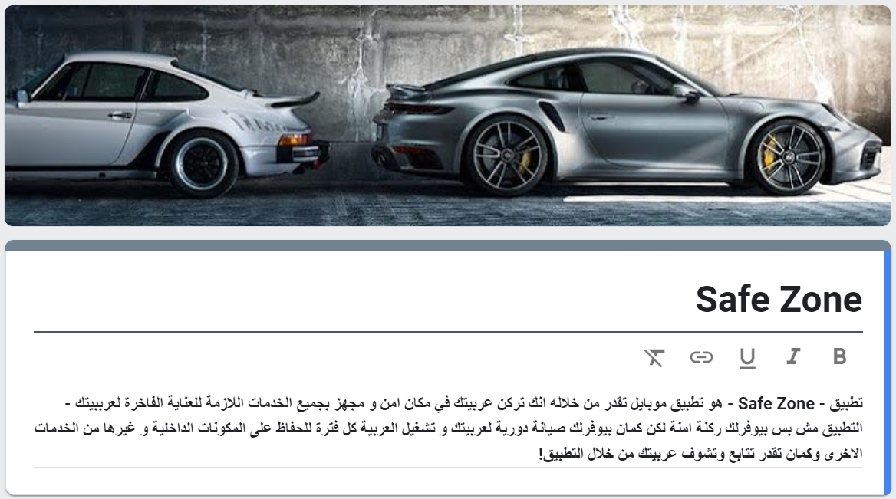**(2.1) Survey**

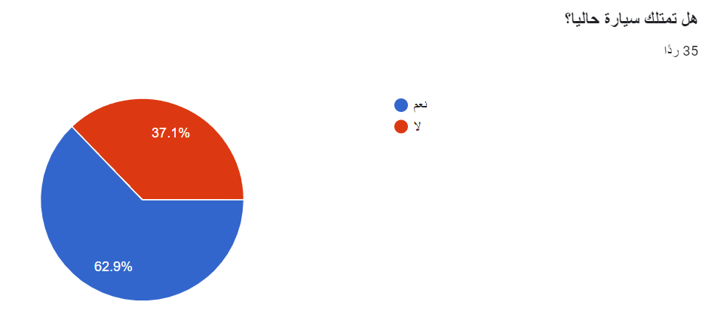**We conducted this survey to extract some data about our potential users and we got 35 responces that differ between users who have cars and users who are seeking to have one.**

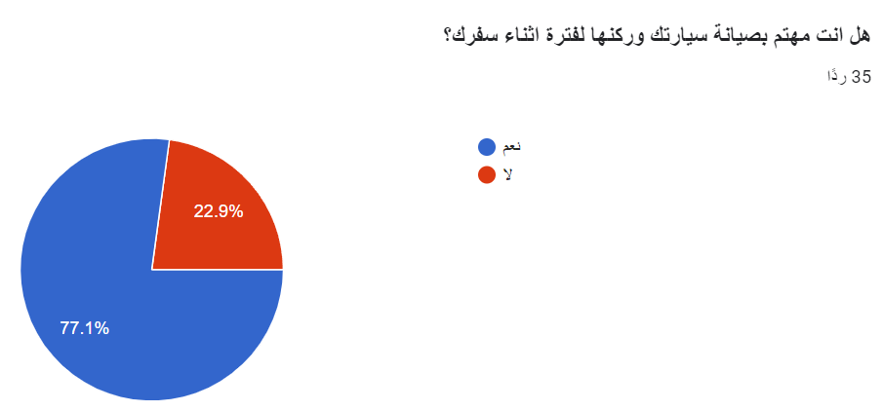**27 responses came to answer that they have cars that represents 77.1% of total responses.**

**About more than half response came to that they would prefer keeping their cars in a trustful garage for a long period while traveling.**

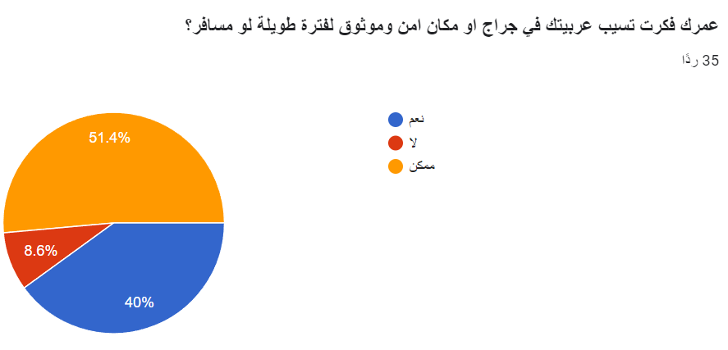

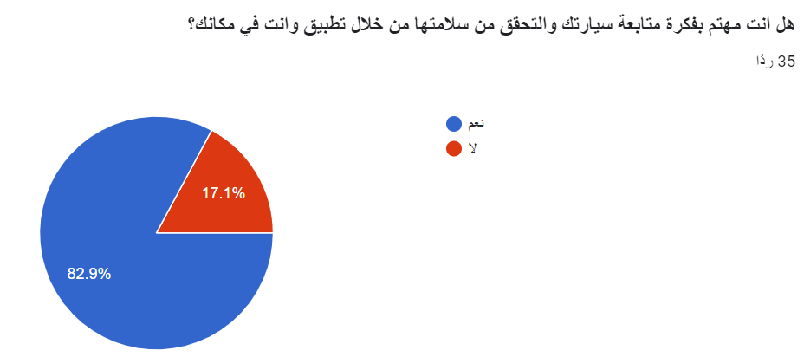**Most of responses cared about monitoring their car safety from the application.**

**Most of responses came to care about paying to provide maintenance & cleaning to their cars through the application.**

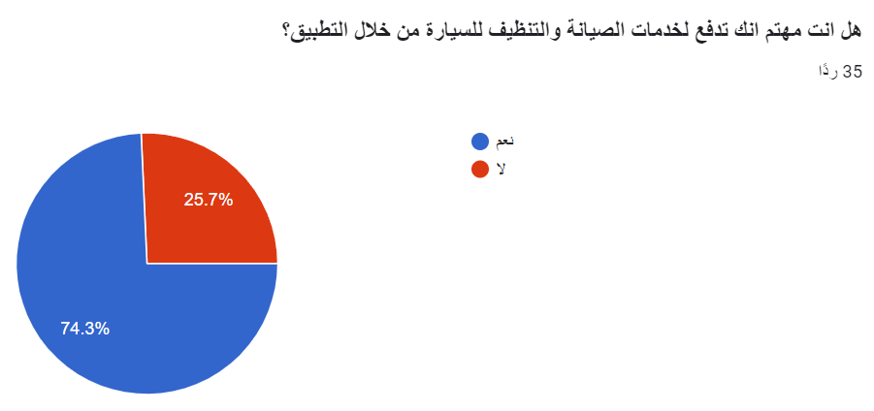

**Responses differed between City center & near to malls and other related areas.**

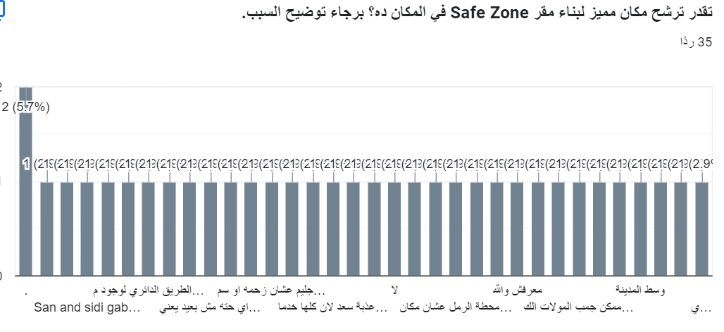

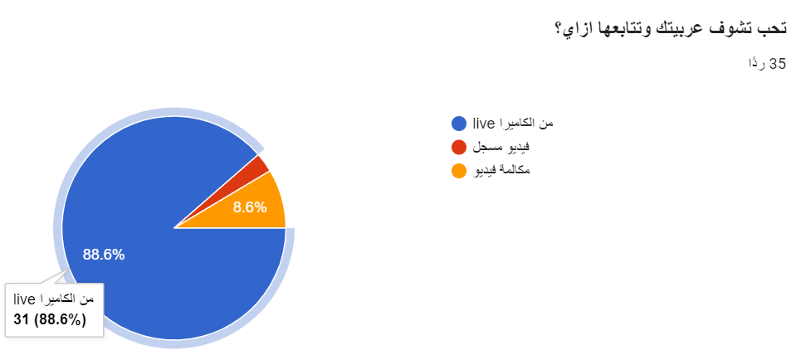**Most of responses tend to monitor their cars through the live camera feed.**

**responses preferred to keep their car in safe zone care center between 6 months and 1 month.**

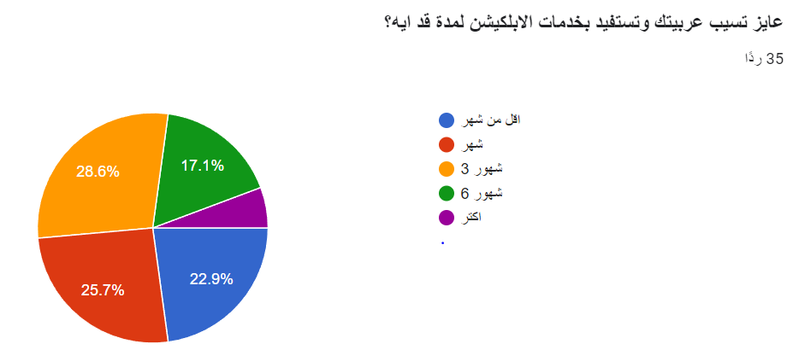

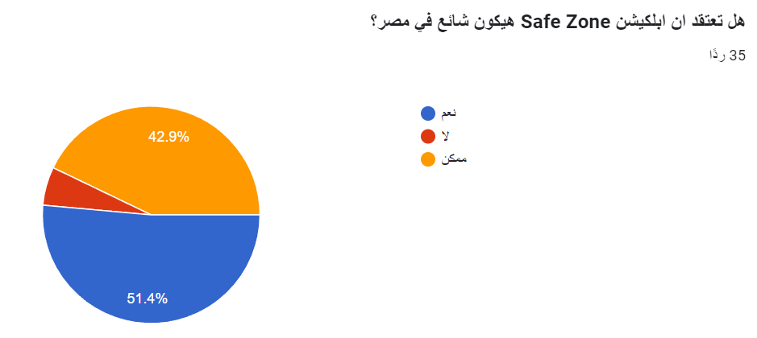**Most of responses came to think that safe zone app will be common in Egypt.**

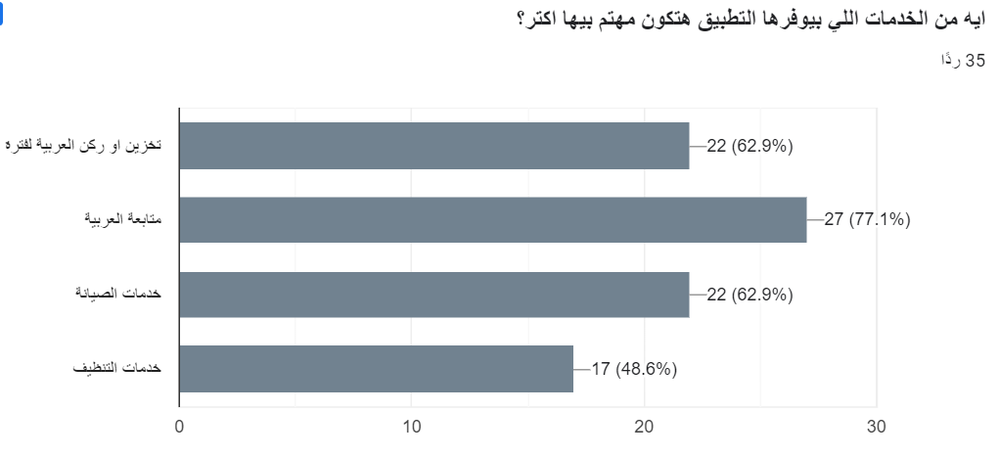**Most of responses cared the most about their car monitoring service.**

**Responses were between 500 to 2000 given to the services introduced from the application.**

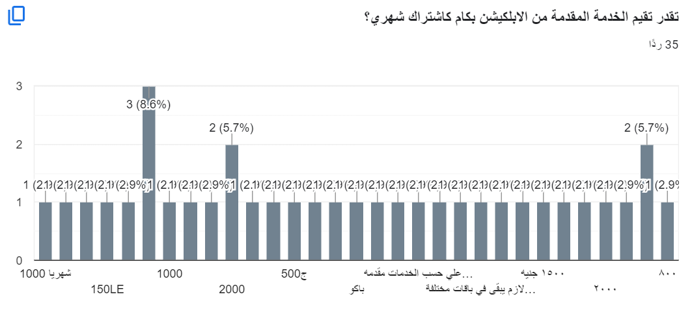

**(2.2) Social Media platforms**

**Safe Zone Facebook page**



[Safe Zone](https://web.facebook.com/profile.php?id=61559738572051&mibextid=qi2Omg&rdid=J24XnNf3jgba8T42&share_url=https%3A%2F%2Fweb.facebook.com%2Fshare%2FJnvFL16Su1pnKhRy%2F%3Fmibextid%3Dqi2Omg%26_rdc%3D1%26_rdr) --> link

**2.3 Tools and technology used:**

**Diagramming Software:**

**Figma**

**is a cloud-based vector design tool that is widely used in the field of UI/UX design. It allows UX and UI designers to create, collaborate on, and share their designs. Here are some key features of Figma:**

* **Real-time Collaboration: Figma is built for collaboration across the entire product development team, allowing you to design experiences together.**
* **Prototyping: Figma’s prototyping tools make it easy to build high-fidelity, no-code interactive prototypes right alongside your designs.**
* **Design Consistency: With reusable assets in shared libraries, you can standardize components and variables, saving time and maintaining consistency.**
* **Customer Journey Diagramming: You can easily diagram your customer journey and user flows in Figma using Figma’s whiteboarding tool.**

**{ URL :** [**https://www.figma.com/**](https://www.figma.com/) **}**

**Lucidchart:**

**is a web-based diagramming and visualization application used for creating flowcharts, organizational charts, mind maps, wireframes, UML diagrams, and other types of visual representations.**

**1. Diagram Creation: Lucid chart allows users to create a wide range of diagrams including:**

* **Flowcharts**
* **Mind maps**
* **Network diagrams**
* **Organizational charts**

**{URL:** [**https://www.lucidchart.com/pages/**](https://www.lucidchart.com/pages/) **}**

**Edraw Max:**

**is a versatile diagramming software developed by EdrawSoft, used for creating a wide range of diagrams and charts. Here are some key features and aspects of Edraw Max:**

**{URL:** [**https://www.edrawmax.com/**](https://www.edrawmax.com/) **}**



**draw.io:**

**is a technology stack for building diagramming applications, and the world’s most widely used browser-based end-user diagramming software.used to create a wide variety of diagrams and flowcharts**

{URL: <https://www.drawio.com/>}

**Database Tools :**

**Cloud Firestore :**

**is a flexible, scalable database for mobile, web, and server development offered by Firebase and Google Cloud. It's a NoSQL database, meaning it stores data in a document format rather than rigid tables like traditional relational databases**.

{URL: <https://firebase.google.com/docs/firestore>}

**Cloud Storage:**

**for Firebase is built on fast and secure Google Cloud infrastructure for app developers who need to store and serve user-generated content, such as photos or videos.**

{URL: <https://firebase.google.com/docs/storage/>}

**Front-End Tools:**

**Flutter:**

is an open-source UI software development toolkit created by Google. It is used for building natively compiled applications for mobile (iOS and Android), web, and desktop (Windows, macOS, Linux) from a single codebase.

{URL: <https://flutter.dev/>}

**Dart:**

is an open-source, general-purpose programming language developed by Google. It is designed for building web, server, desktop, and mobile applications. Dart is the language behind the Flutter framework, which is used for creating cross-platform mobile and web applications

{URL: <https://dart.dev/>}

**Back-End:**

**Firebase:**

is a comprehensive platform developed by Google for building and managing mobile and web applications. It provides a suite of tools and services to help developers create high-quality apps, improve user engagement, and grow their business.

{URL : <https://firebase.google.com/> }

--------------------------------------------------------------------

Chapter 3 (Analysis and Design)

--------------------------------------------------------------------

Customer segment description “Persona”:

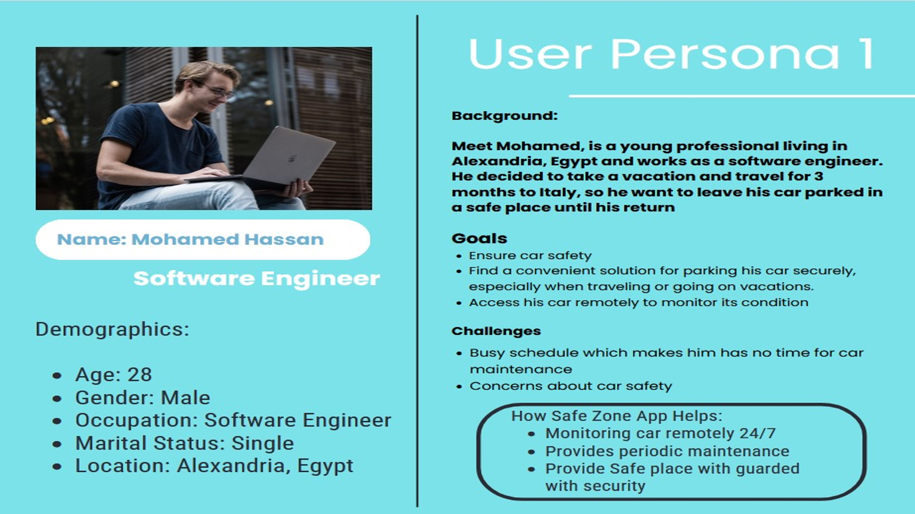

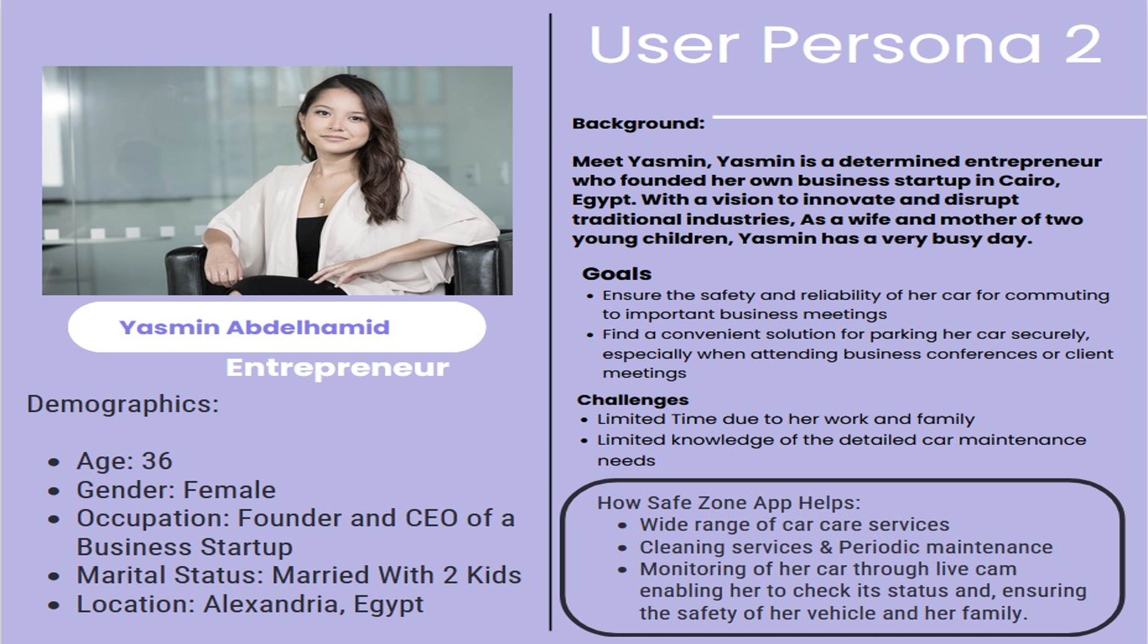

User Story:

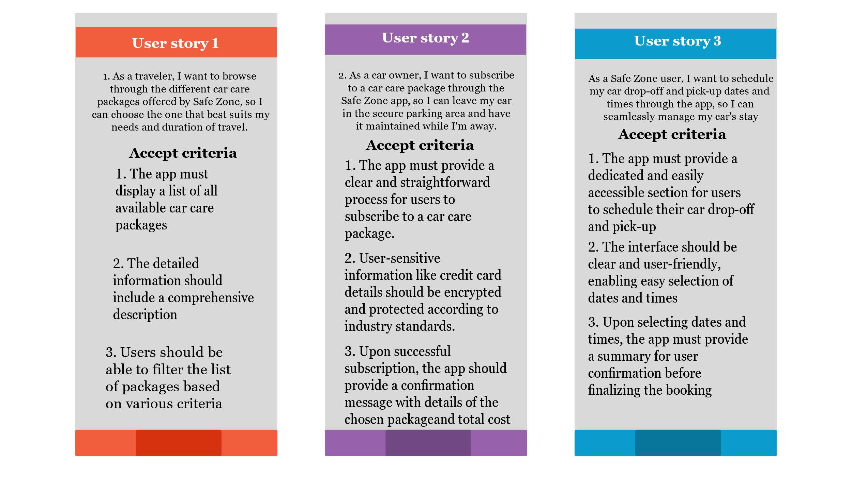

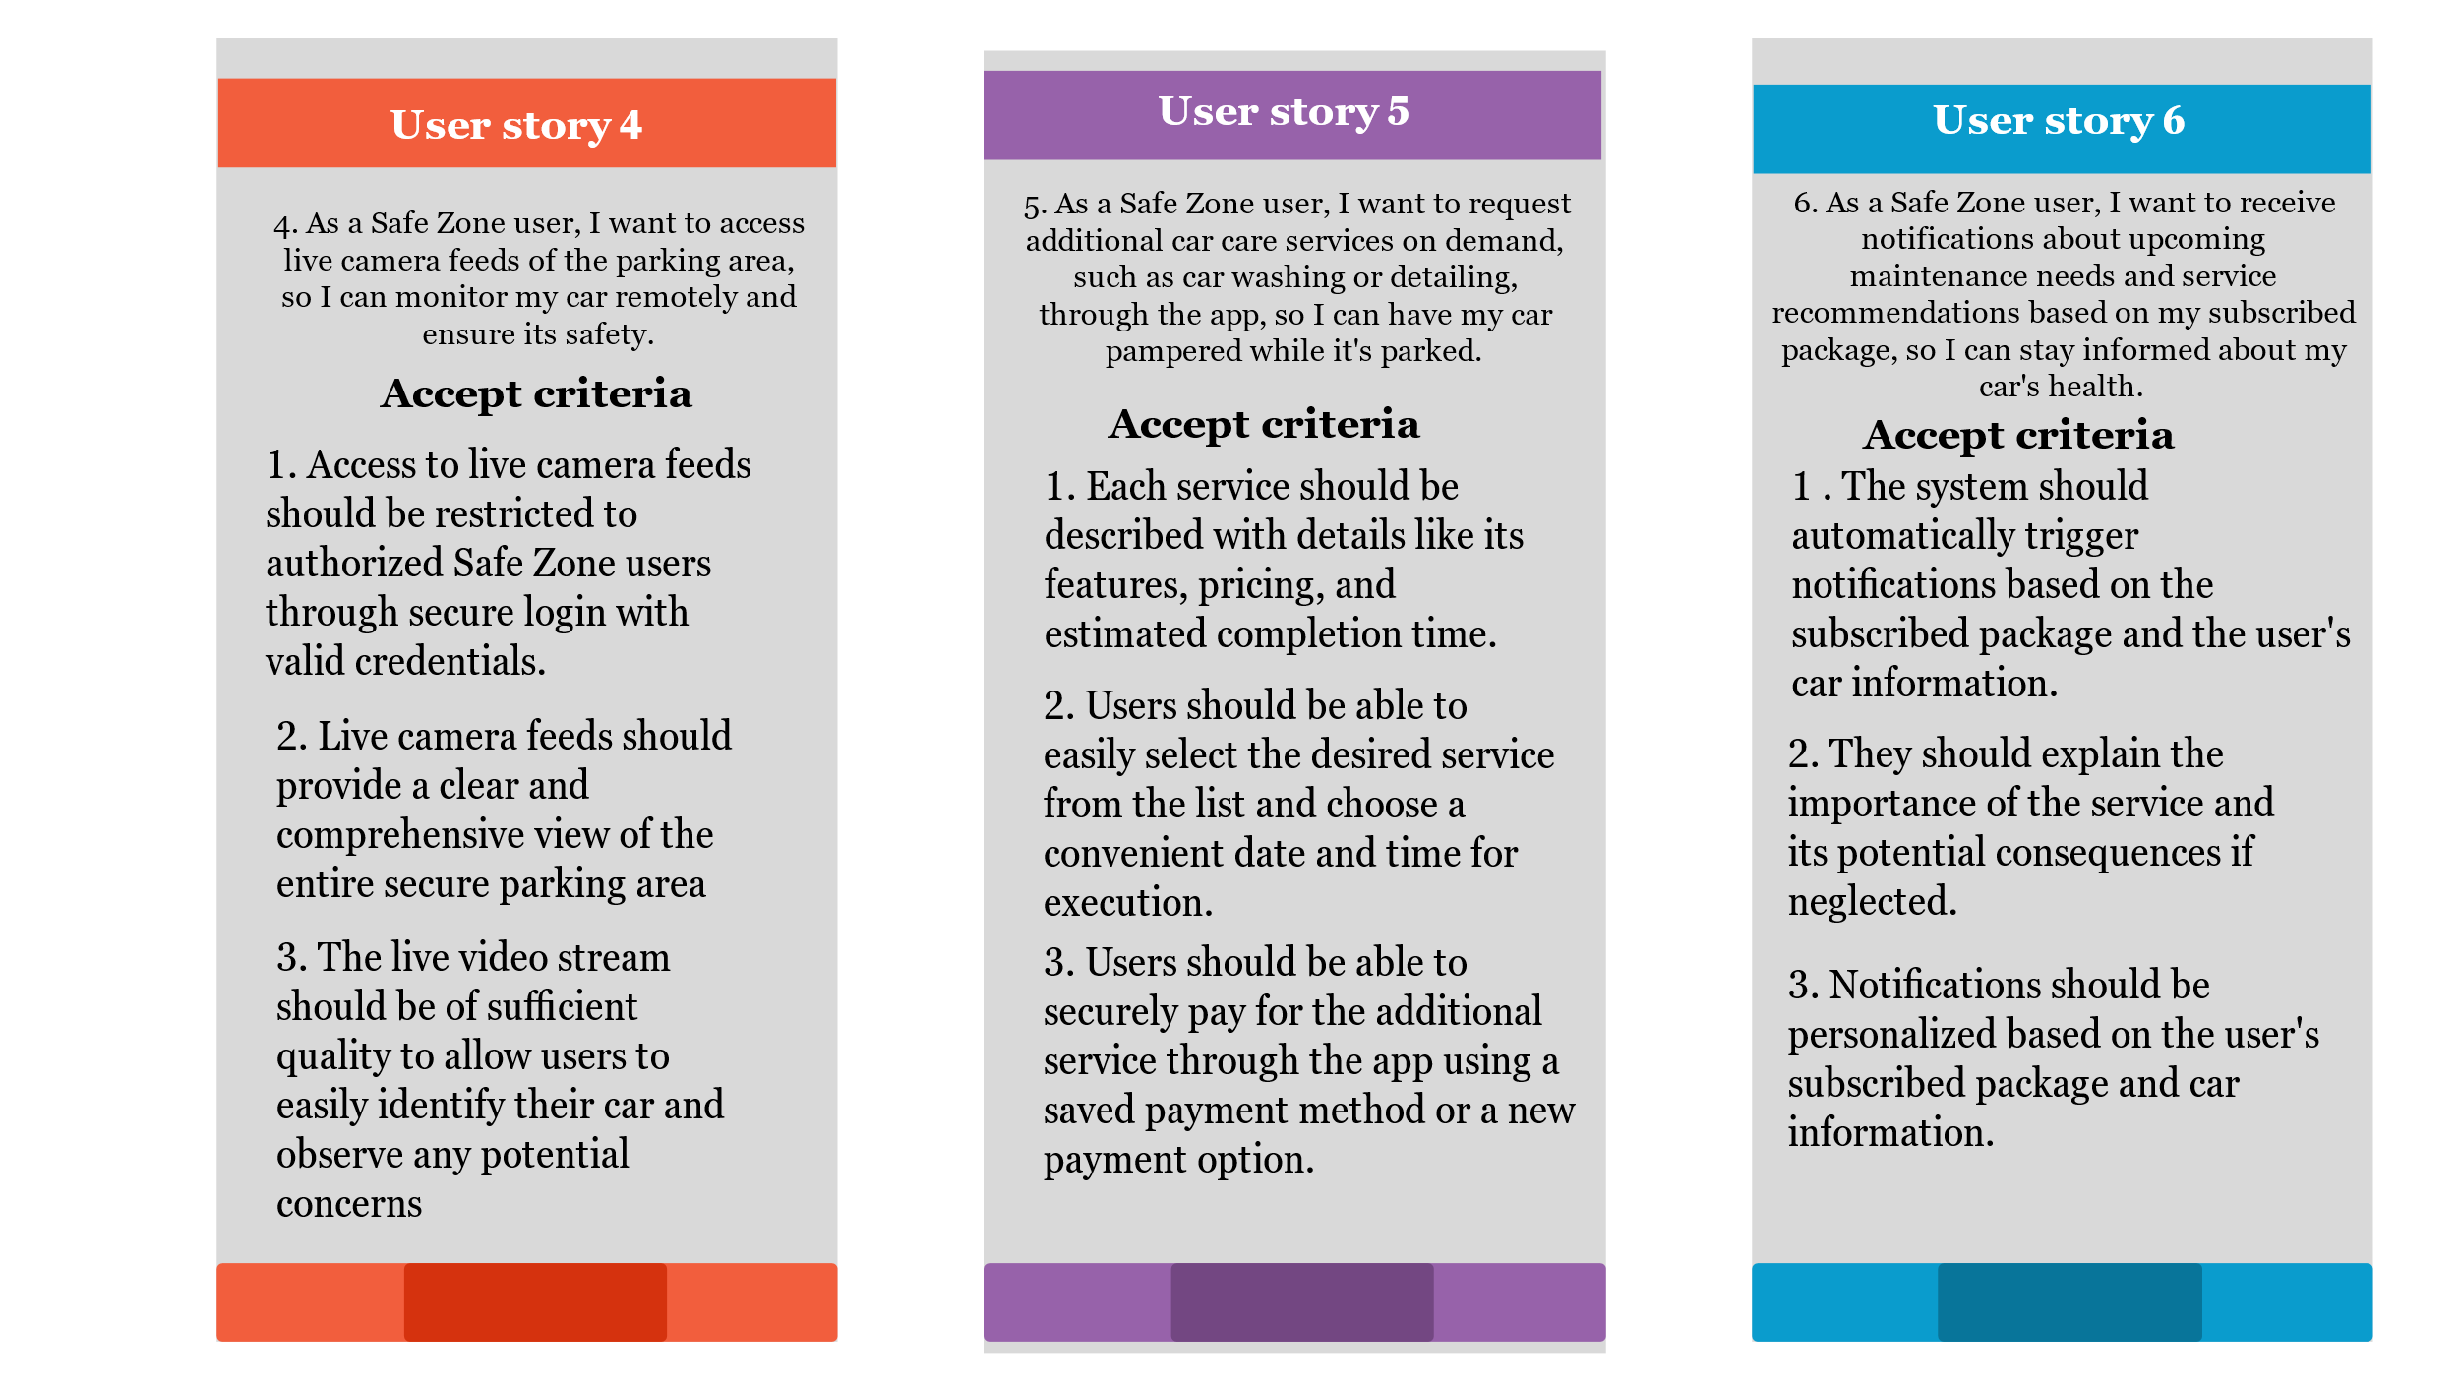

[**Business Model Canvas**](https://businessmodelanalyst.com/business-model-canvas/) **:**

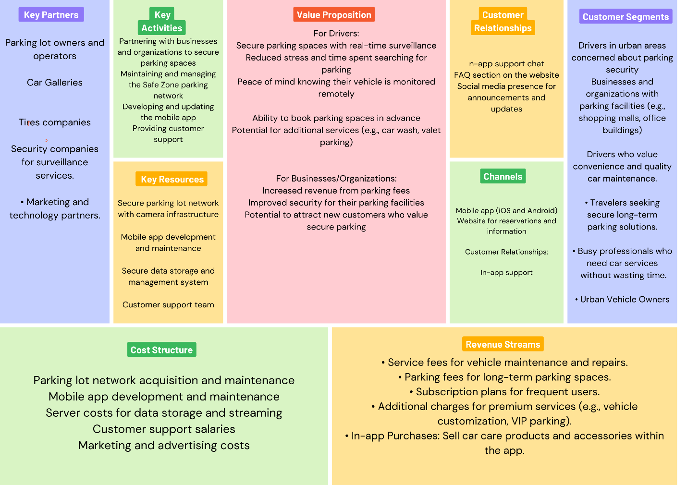

Our business model:

Business to Customer / B2C

Our business model is based on serving the customers, our company provide services and the customers are getting benefit of these services​.

Revenue Model: Based on subscription in services packages that the website provides.

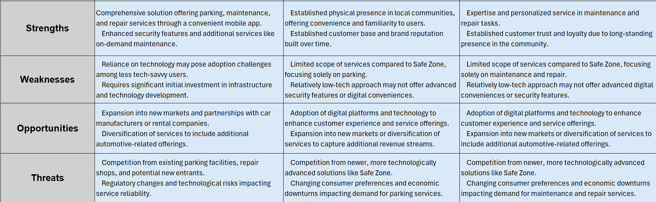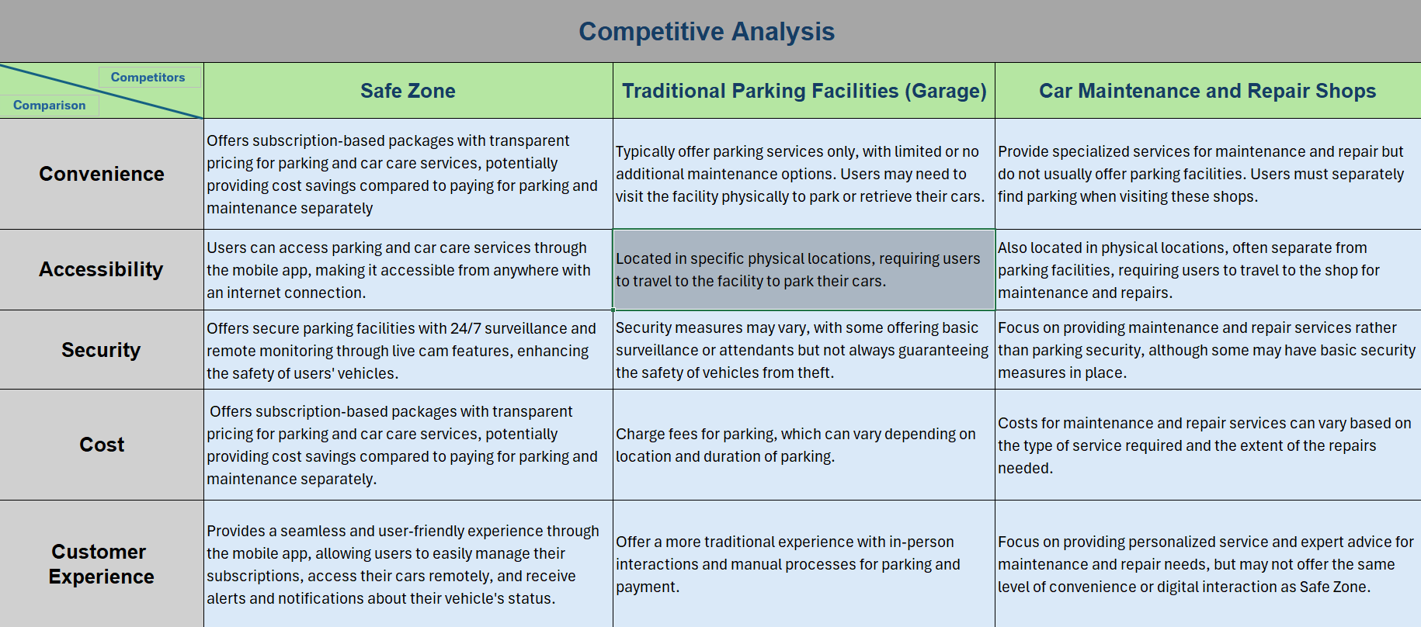Competitive Analysis & SWOT Analysis:

This chapter discusses the analysis and design phases of the project. It shows the different diagrams built to show how the system work, what does it consist of, and whom are the users.

**3.1. System Analysis:**

**3.1.1. UML Diagrams:**

Use case diagram:

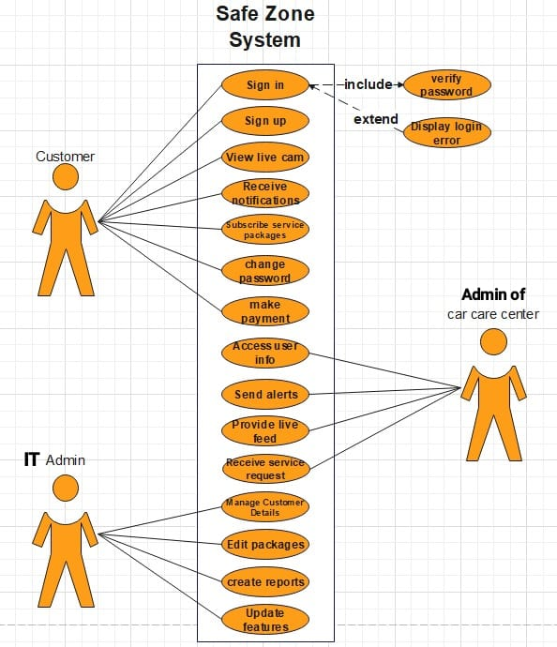

Actors:

**Customer:** Users of the app who want to park and monitor their vehicles.

**Car Care Center:** Provides maintenance services and live feed of the car care process.

**IT Admin:** Manages the app's system, service packages, and customer details.

**The Use Cases:**

**# Customer**

***1- Signup/Login***: To access the app and its features.

***2- Reserve Parking:*** To find and reserve a parking space.

***3- View Live Camera:*** To monitor their vehicle remotely. –

***4- Receive Notifications***: For updates on vehicle status and parking lot conditions. “ Car Care Center”

***5- Receive Service Requests:*** From customers for vehicle maintenance.

***6- Access User Info:*** For servicing purposes.

***7- Send Alerts:*** About vehicle status during servicing.

***8- Provide Live Feed:*** Of the car care process upon request.

**# Admin**

***1- Manage Customer Details:*** For administrative purposes.

***2- Edit Service Packages:*** To update service offerings.

***3- Generate Reports:*** For business analytics.

***4- Update System Features:*** To enhance app functionality.

# System - *Safe Zone App System**: Facilitates all interactions, processes payments, and provides real-time surveillance capabilities.

**3.2.DFD:**

**context diagram**

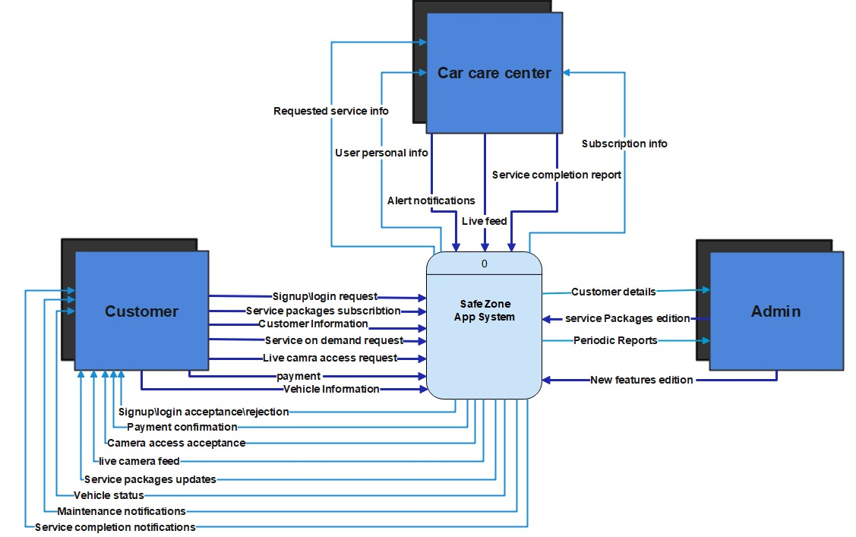

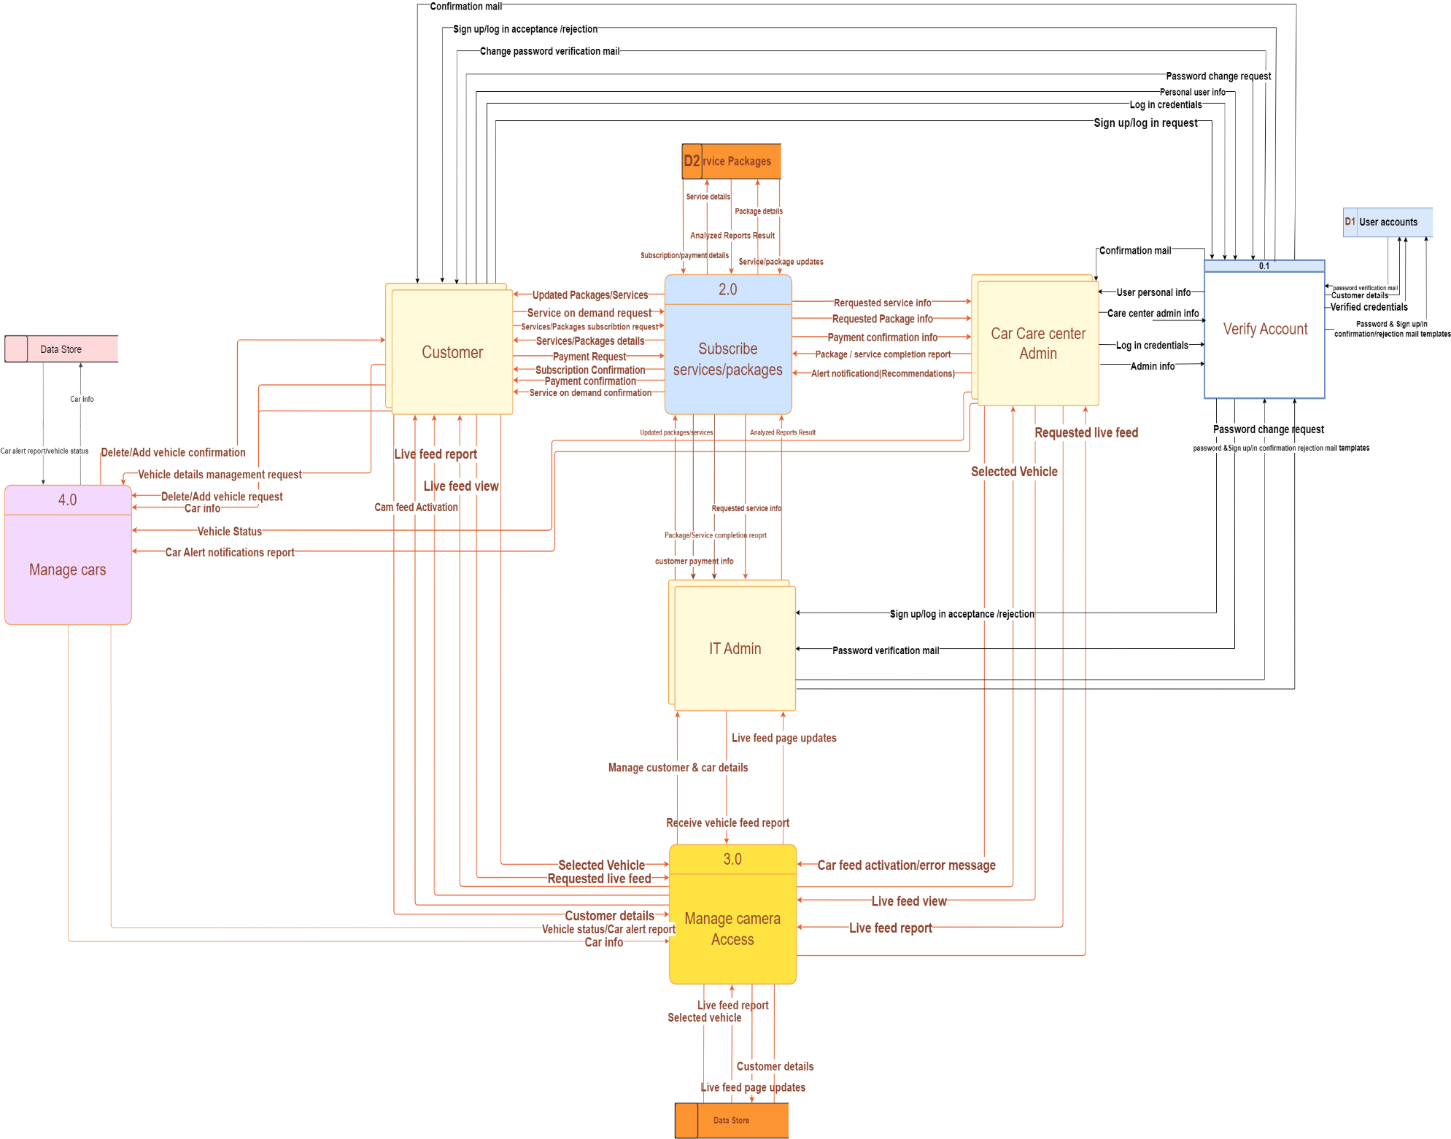**Level 0 DFD:**

**child diagrams of verify account process**

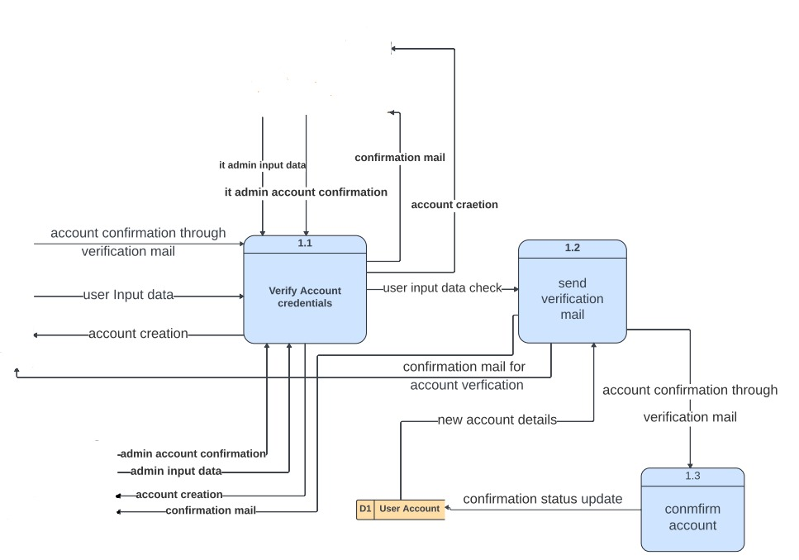

**child diagrams of the Service/package process:**

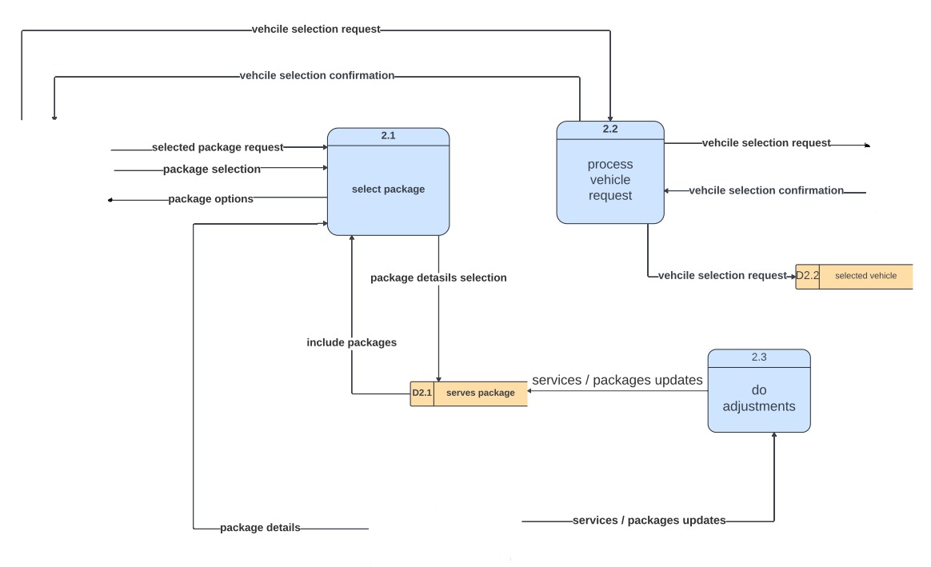

**2nd child diagrams of subscribe services/ packages process:**

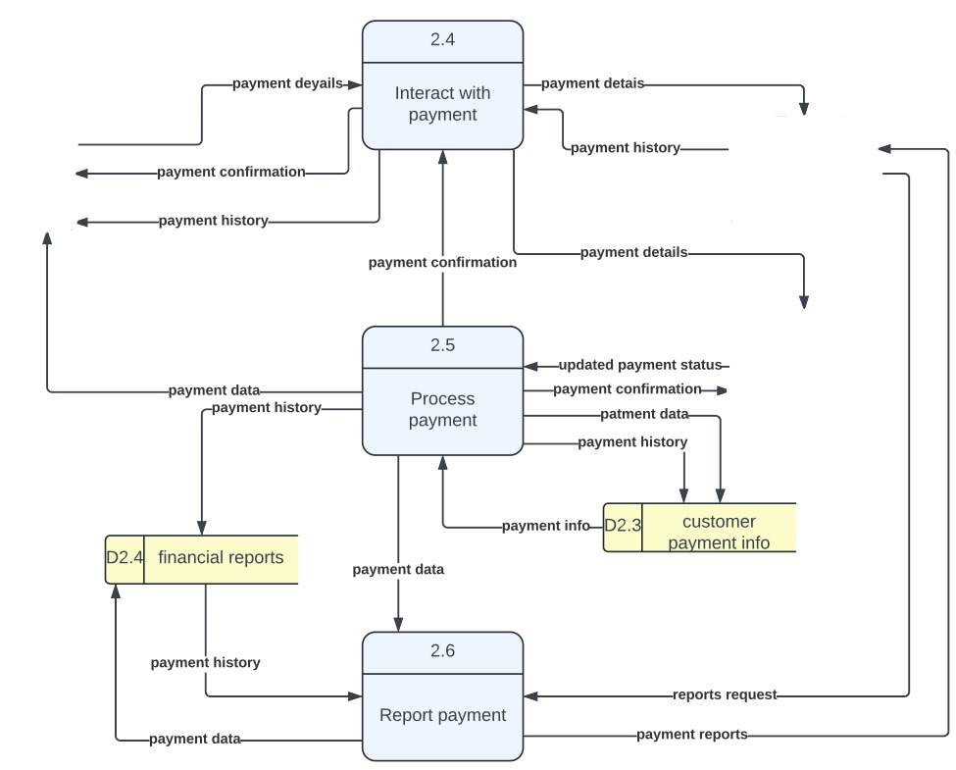

**child diagrams for manage cars process:**

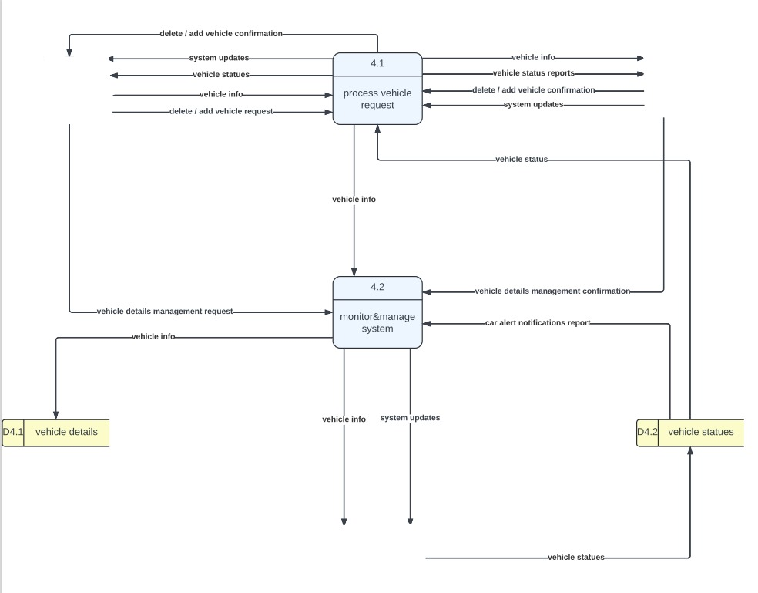

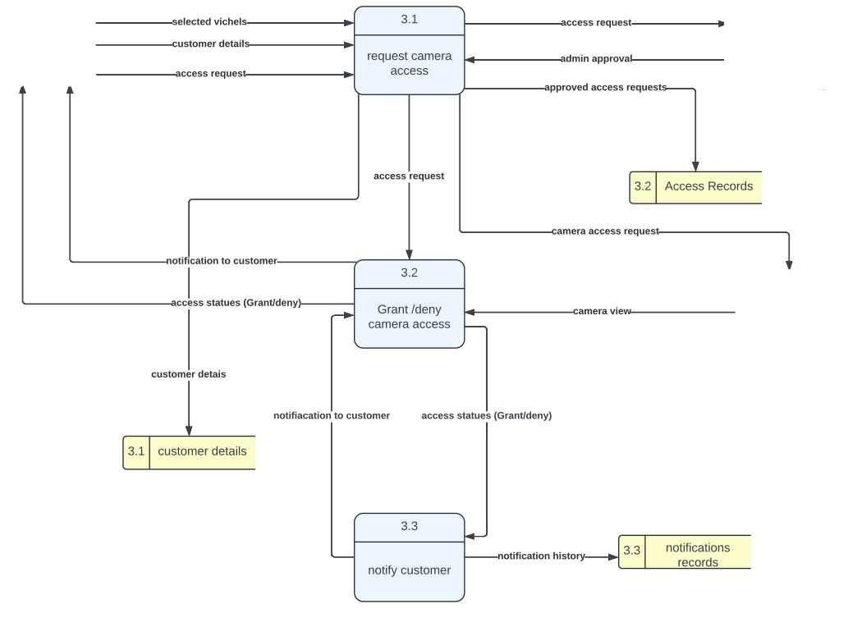**child diagrams for camera access process:**

**3.3. Activity Diagram:**

**sign up , sign in , change password & receive notifications activity diagrams:**

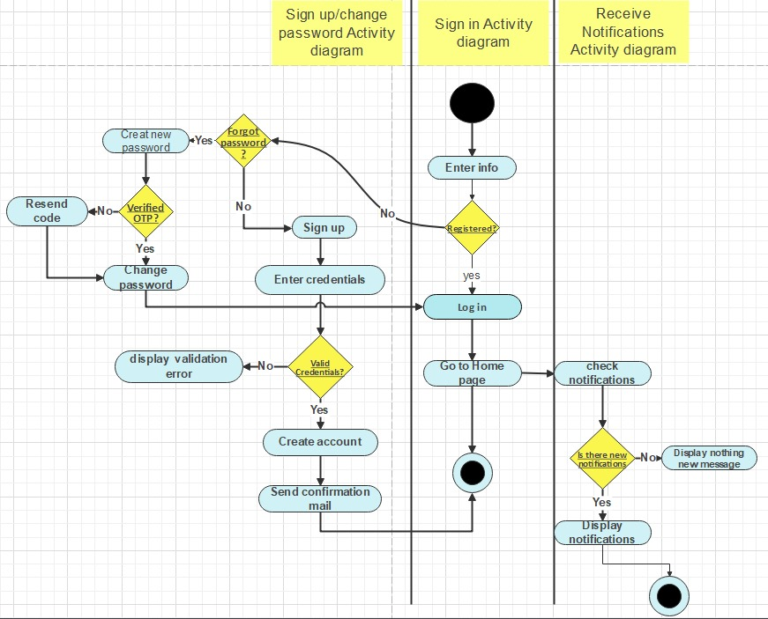

The flowchart depicts the process of adding a new vehicle and managing its details in a mobile app. Users can start by entering their details and capturing images of their car and license plate. Then, they can select their vehicle type, brand, model, and license plate number. Finally, the app saves the vehicle details securely.

**Edit Packages Activity Diagram:** 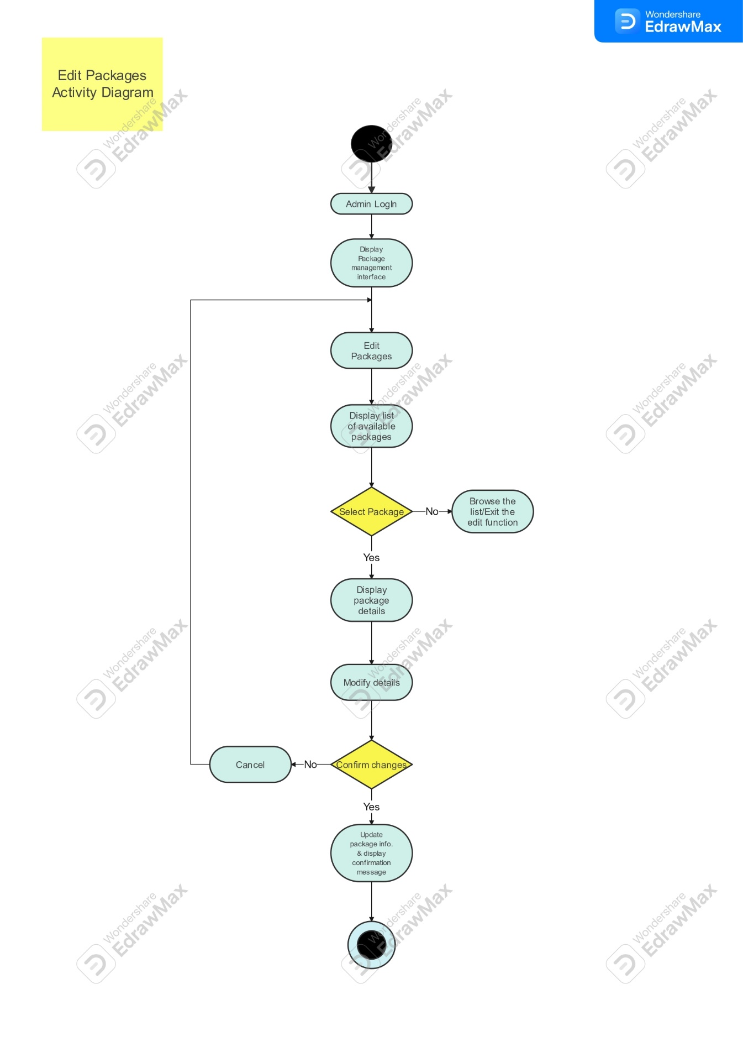

The flowchart outlines steps to subscribe to a service package. It starts with browsing available packages. The user then selects a package and confirms their subscription. If confirmed, they can proceed to payment. The user chooses a payment method and enters their information. Finally, the system processes the payment and updates the account.

**Manage Customer Details Activity Diagram:**

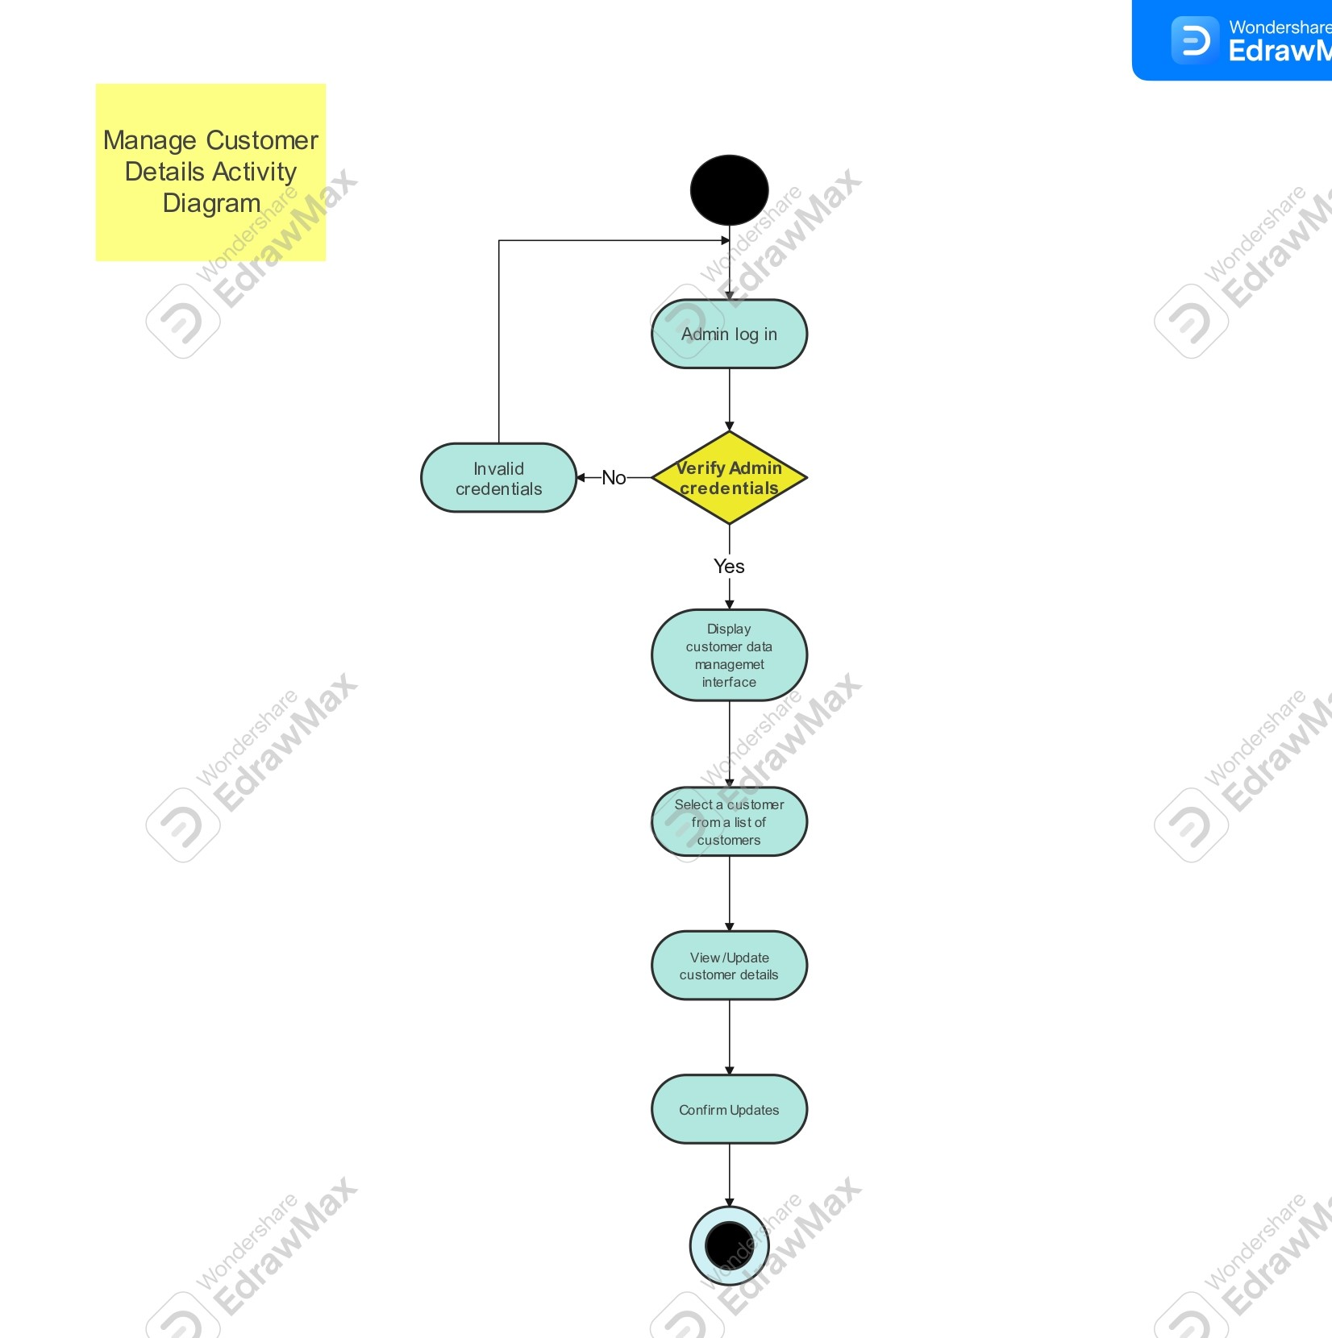

The image is a flowchart showing how to add a vehicle to a car service app. First, the user enters their details. Next, they capture images of their car and license plate. Then, they choose their vehicle information, including type, brand, model, and license plate number. Finally, the app saves the vehicle details securely.

**Receive Service Request Activity Diagram:**

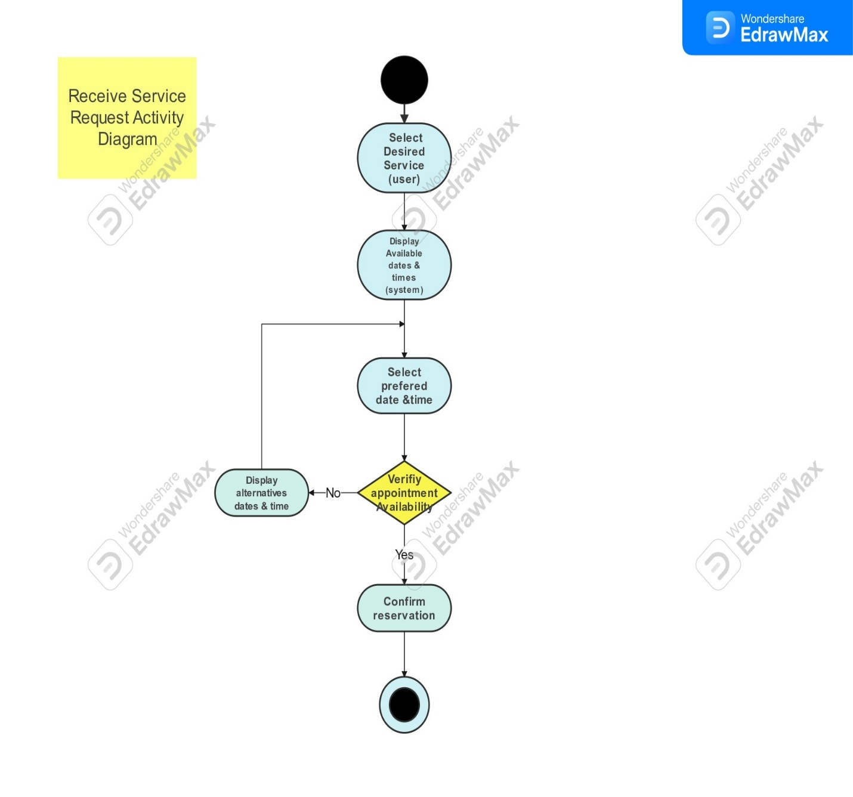

The image is a flowchart of a typical service request process. It begins with a customer submitting a service request. Next, the system displays a list of available services for the customer to choose from. The customer then selects their desired service and a preferred date and time. The system checks availability and displays confirmation or offers alternative dates and times. Finally, the customer confirms the reservation.

**Access user Info Diagram:**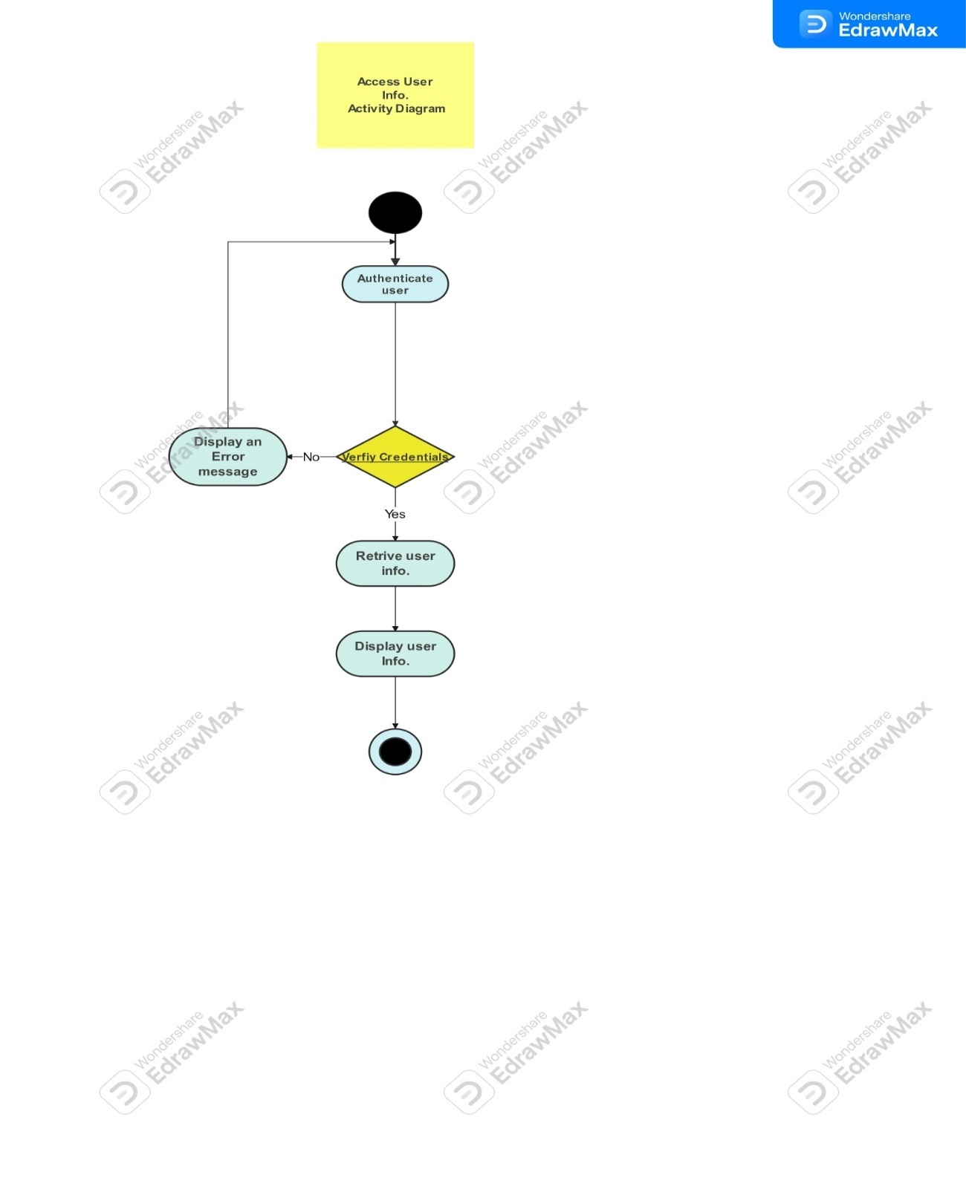

The flowchart outlines the process of adding a new vehicle to a mobile app. It begins with fetching the user's name. Then, the user adds images of their car and license plate. Next, they enter details like vehicle type, brand, model, and license plate number. Finally, the app saves the vehicle information securely.

**Create Reports Activity Diagram:**

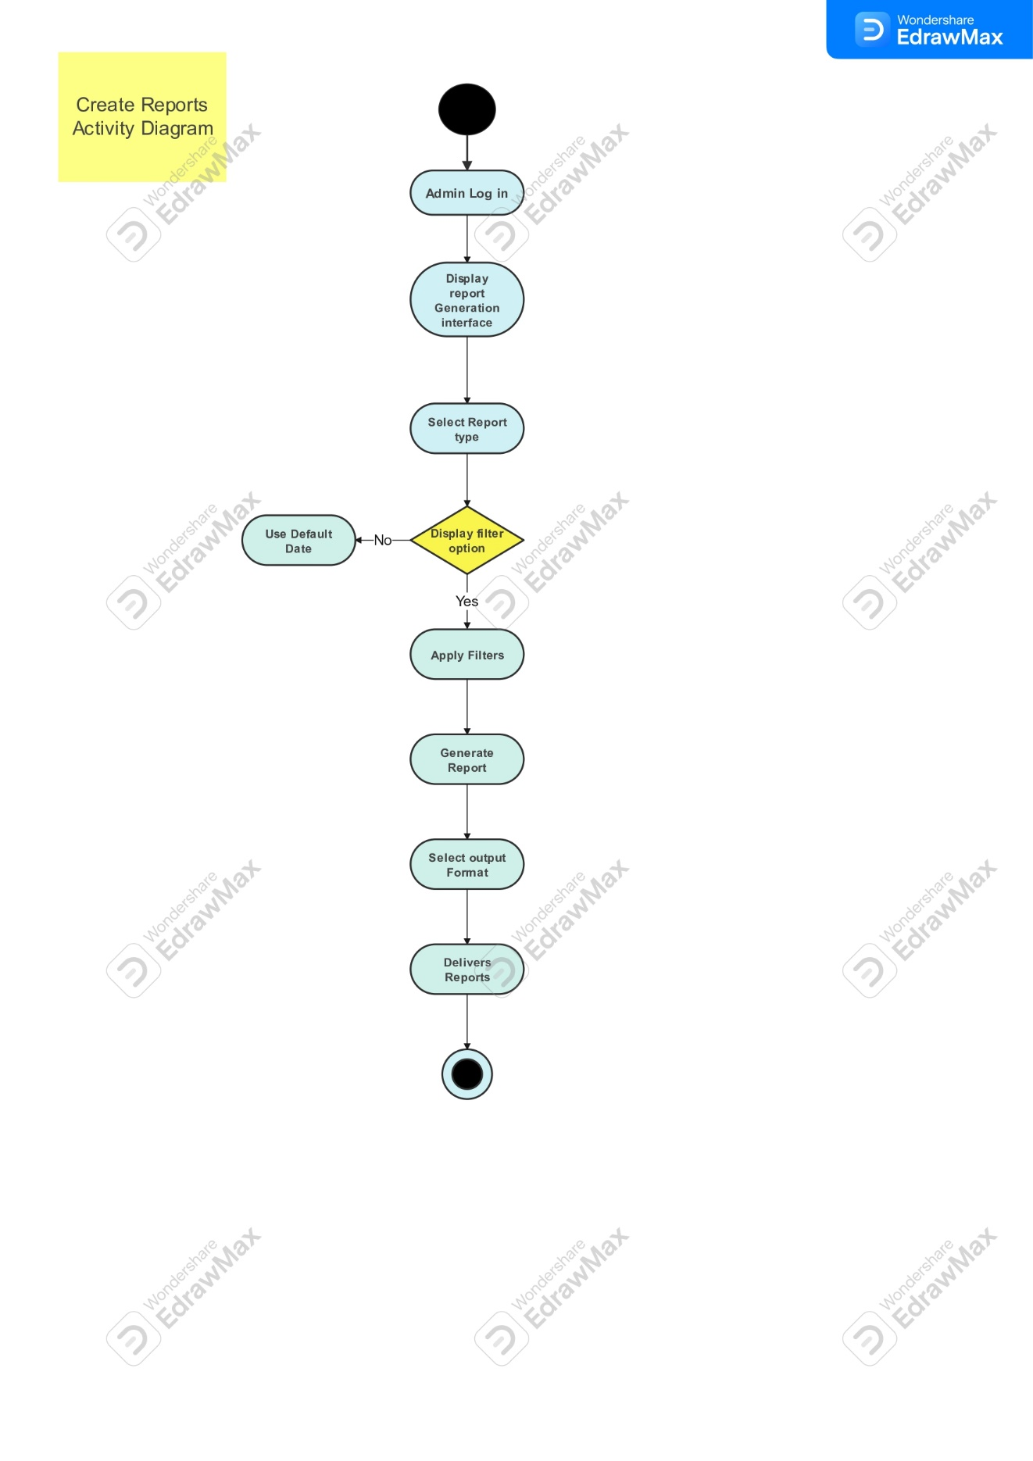

This flowchart outlines adding a vehicle to a car service app. First, users input their details. They then capture images of their car and license plate. Next, they select their vehicle's type, brand, model, and license plate number. Finally, the app securely saves the vehicle data.

**Send Alerts Activity Diagram:**

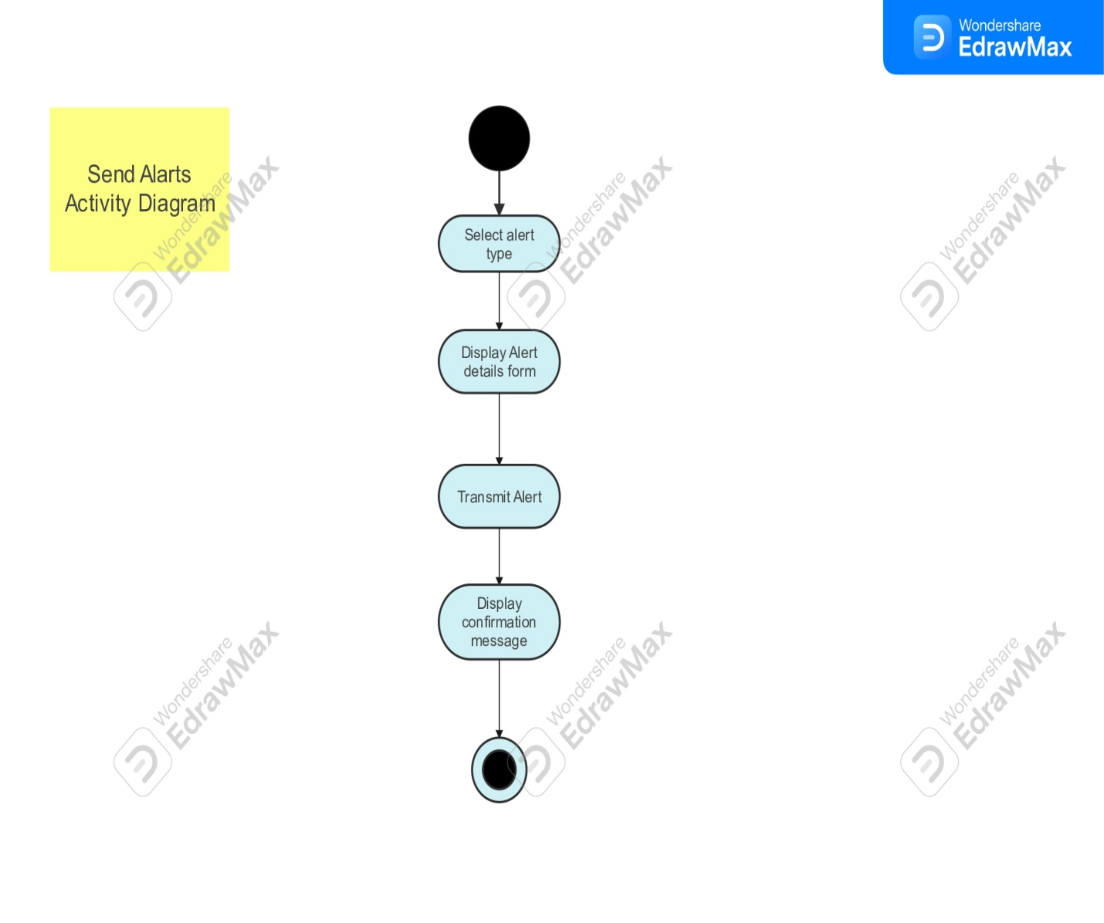

The flowchart outlines adding a vehicle to a car service app. First, the user fetches their user data. Then, they capture images of their car and license plate. Next, they enter details like vehicle type, brand, model, and license plate number. Finally, the app securely saves the vehicle information.

**Update Features Activity Diagram:**

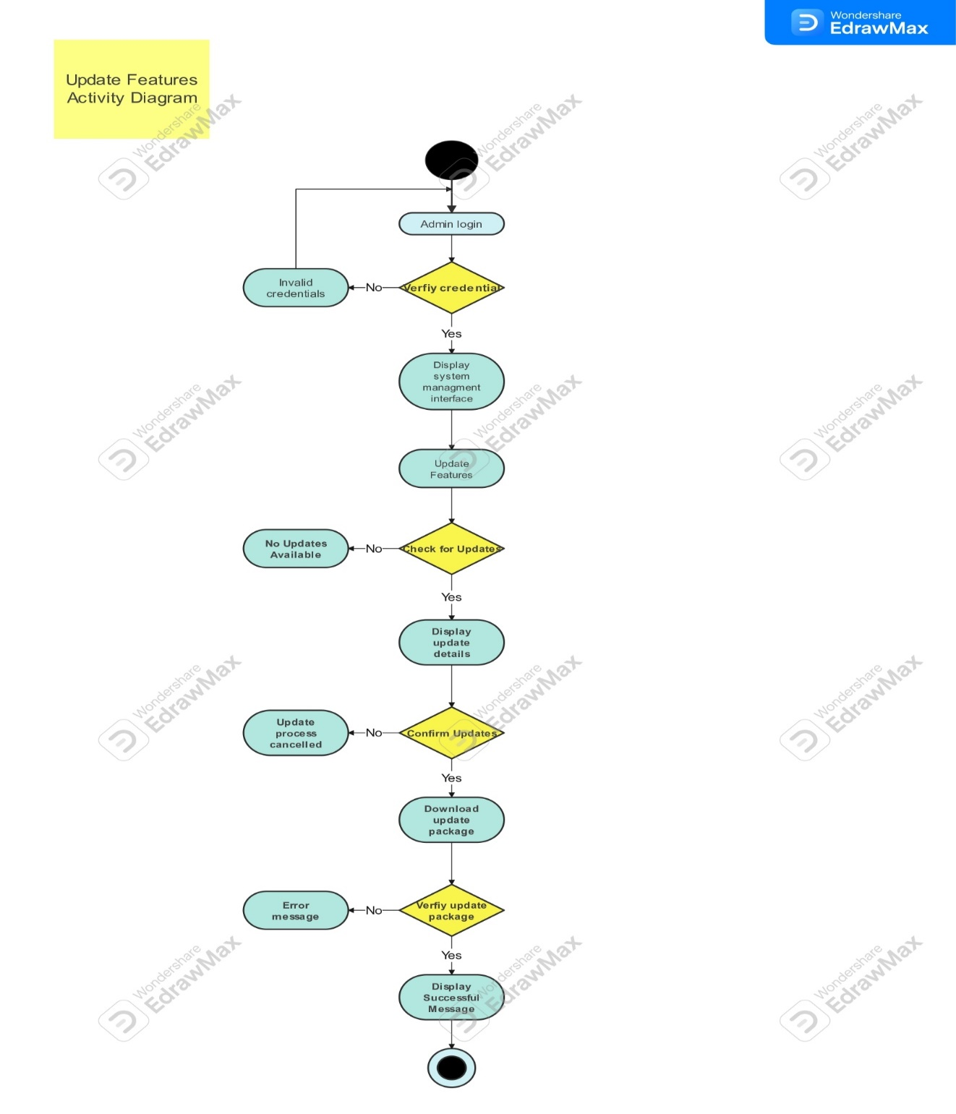

This flowchart outlines adding a vehicle to a car service app. First, the app fetches the user's name. Then, the user captures images of their car and license plate. Next, they select their vehicle information, including type, brand, model, and license plate number. Finally, the app securely saves the vehicle details.

**Provide Live Feed Activity Diagram:**

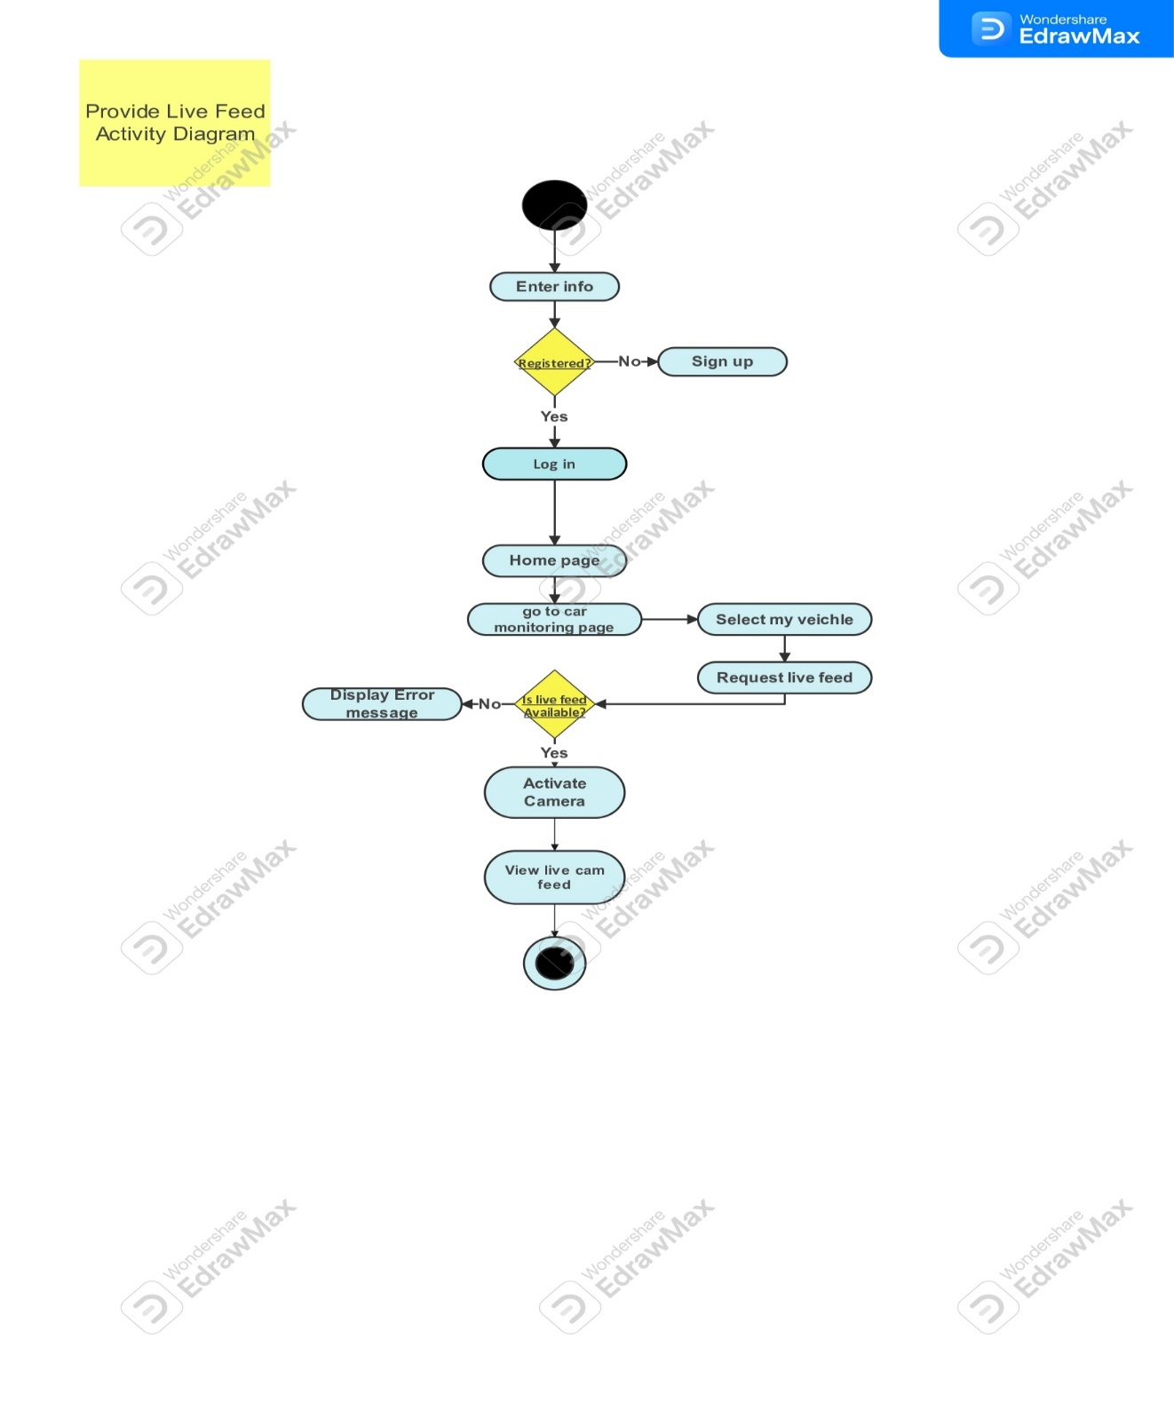

This flowchart outlines adding a vehicle to a car service app. First, users provide their details. They then capture images of their car and license plate. Next, they choose their vehicle's make, model, and license plate number. Finally, the app securely saves the vehicle data.

**Subscribe Service Package and Make Payment Diagram:**

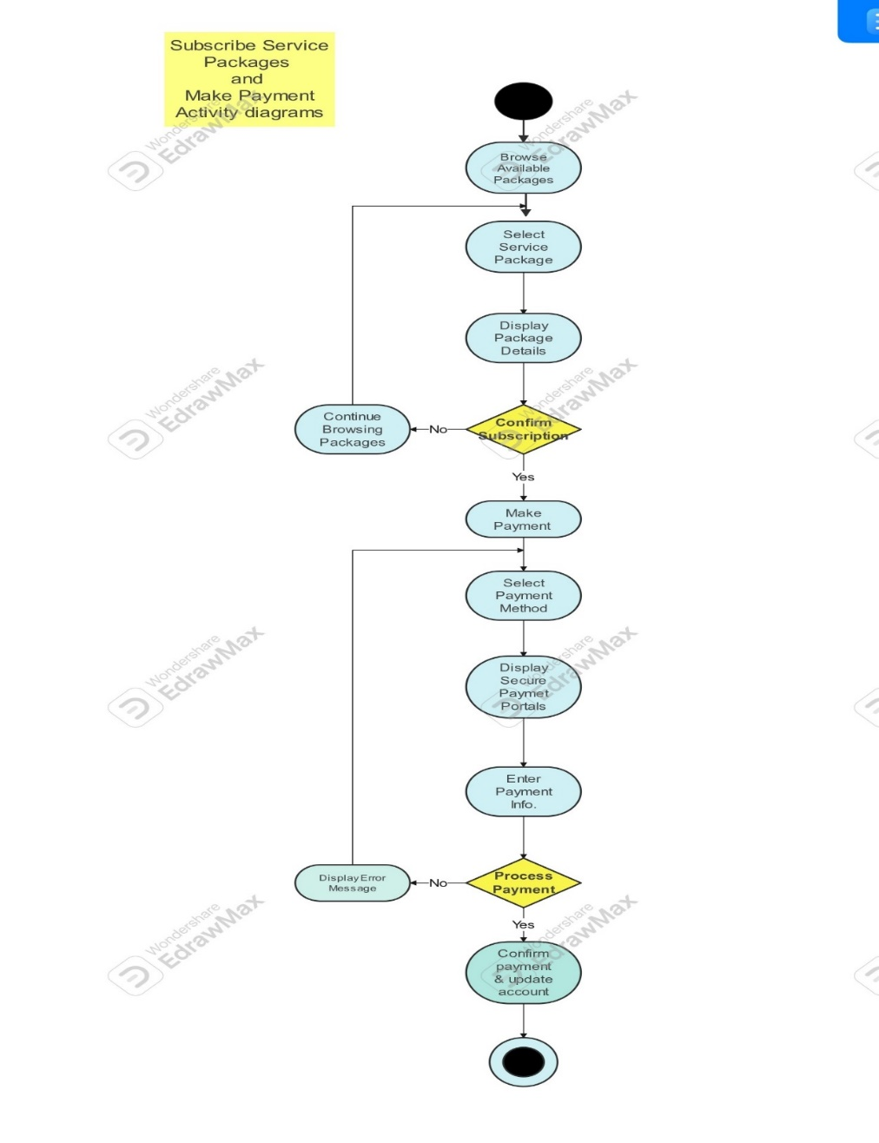

The flowchart shows how to subscribe to a service package and make a payment. It starts with browsing available service packages. Then, the user selects a service package and confirms the subscription. If the user confirms, they can proceed to make a payment. The user selects a payment method and enters their payment information. Finally, the system processes the payment and updates the account.

**View live feed Activity Diagram:**

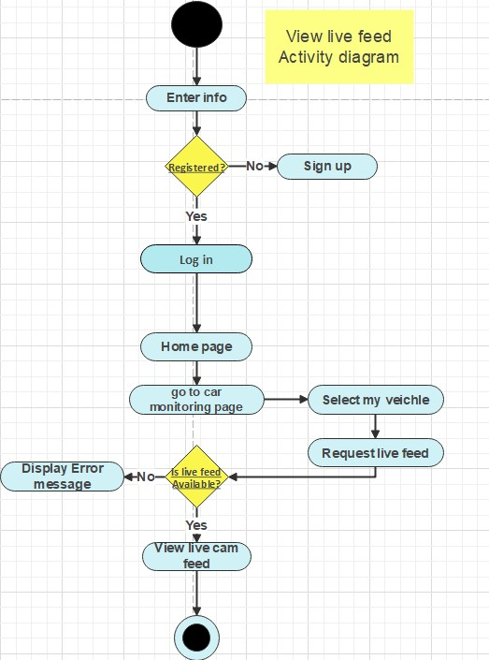

The flowchart depicts steps to view a live feed on a website.First, enter the website and log in. If successful, proceed to the homepage and select the desired live feed. Finally, request the live feed. An error message appears if the feed is unavailable.

Schema:

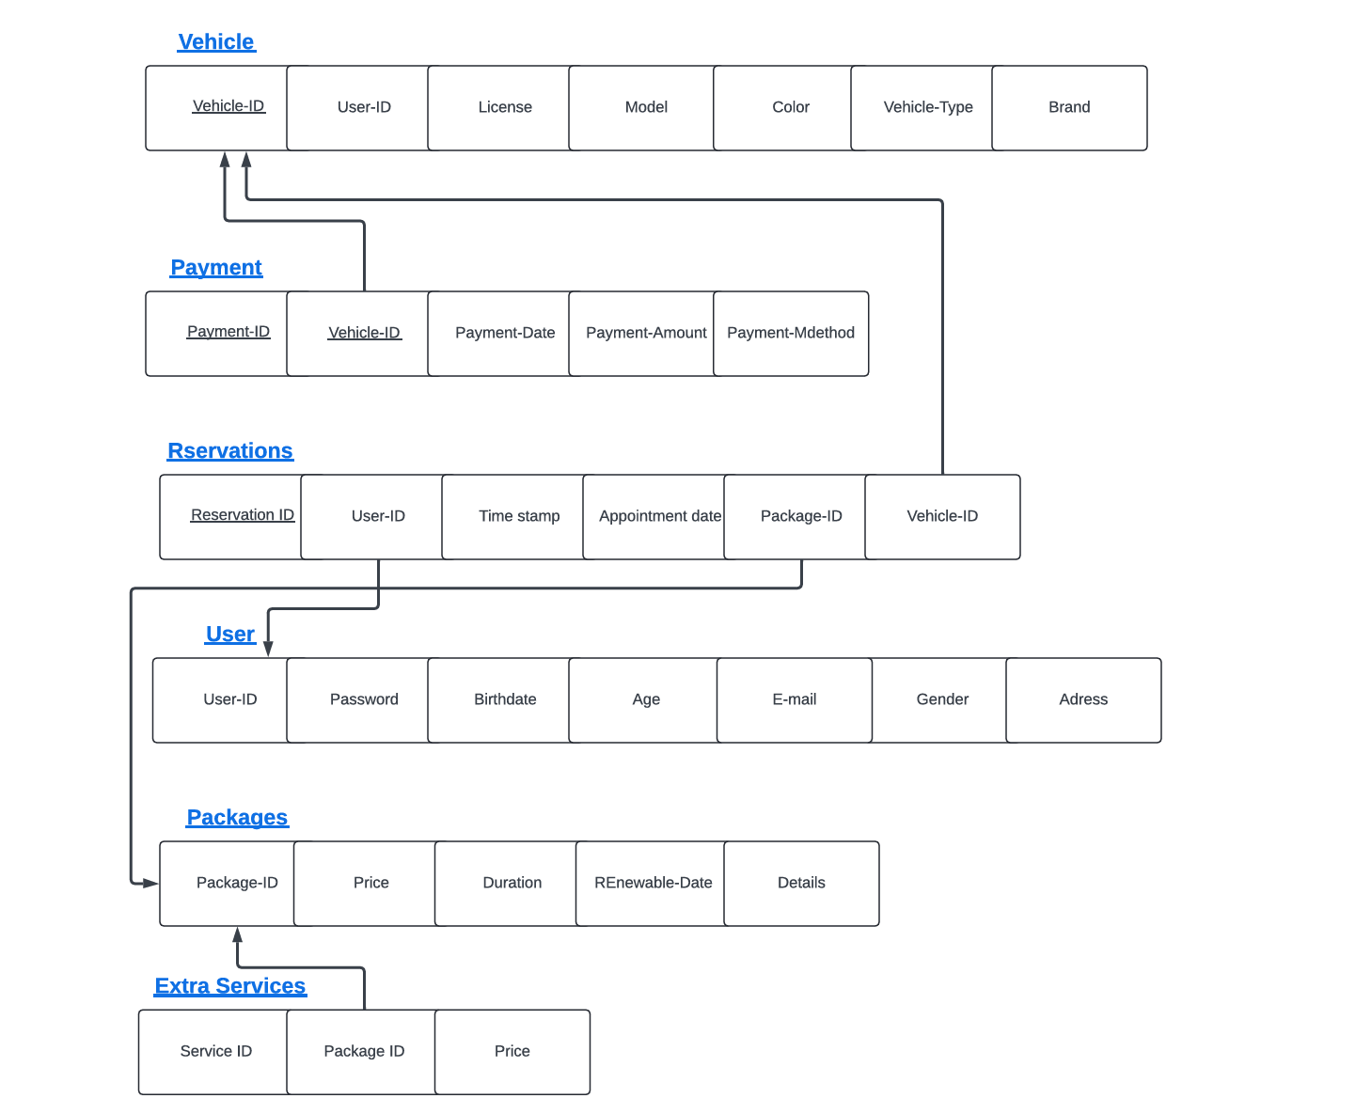

Erd model:

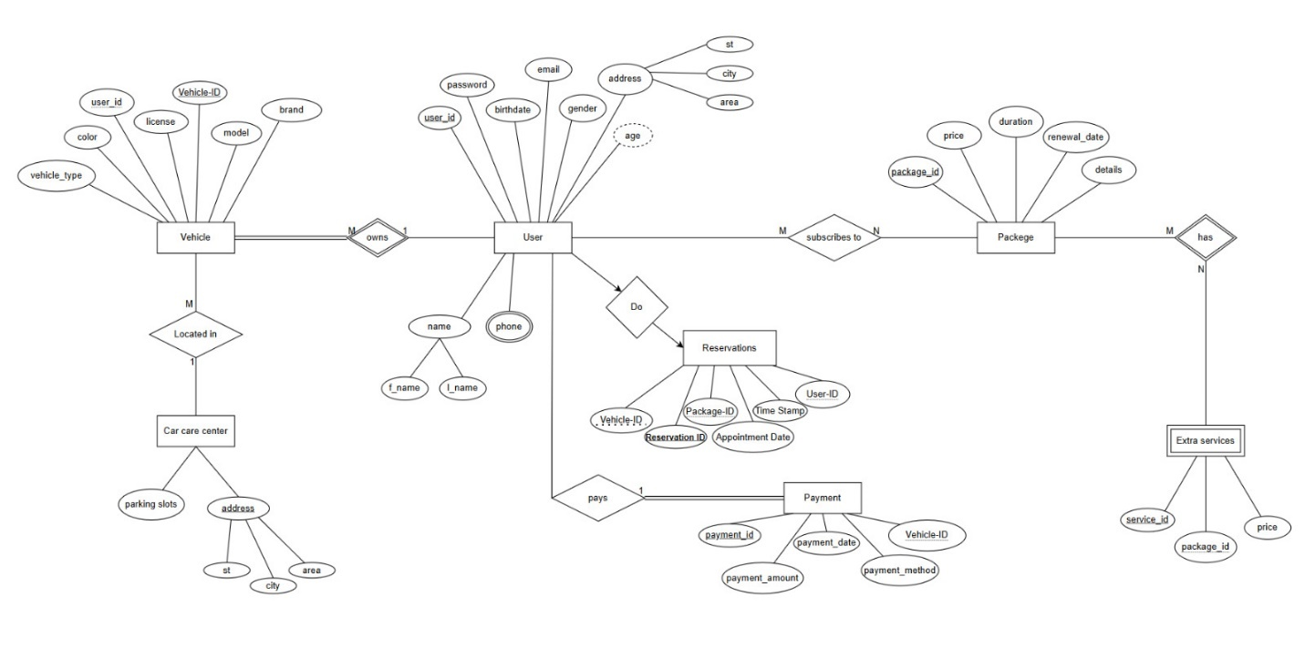

--------------------------------------------------------------------

Chapter 4 (Implementation)

--------------------------------------------------------------------

4.1. Admin View Page

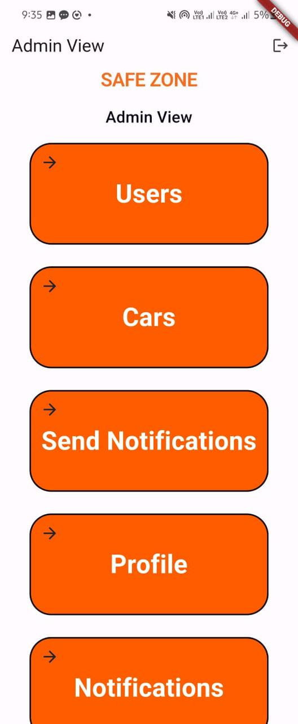

Admin view page

Overall Description:

The Admi View class presents an admin dashboard with options to view user data, car information, send notifications, access the profile, and view received notifications. Each feature is represented by a stylized frame that allows the admin to navigate to specific pages upon tapping.

This Flutter app is designed to provide a user-friendly interface for admins to manage different aspects of the system effectively

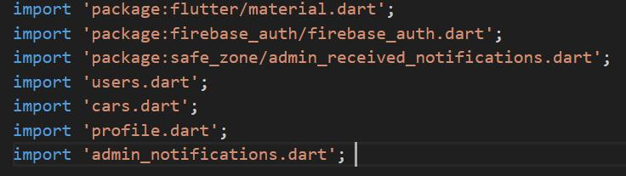

1-Imports:

Description: Importing necessary packages and files for the admin view functionality.

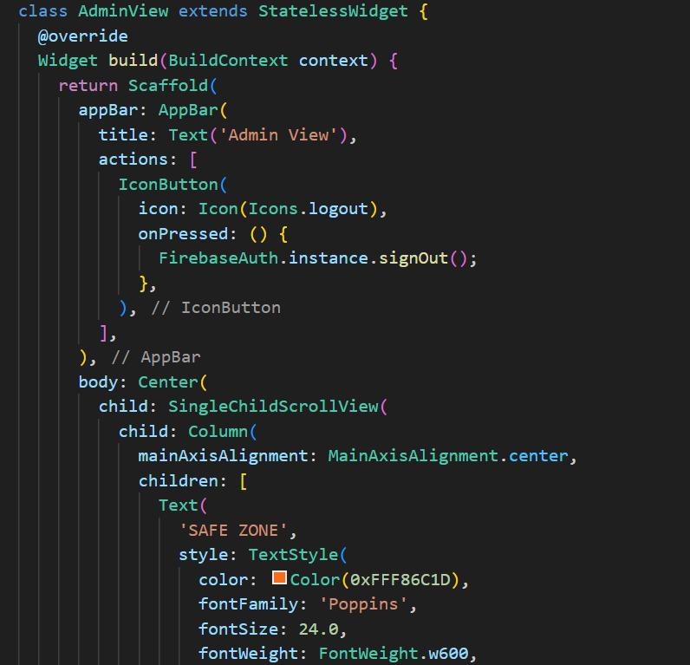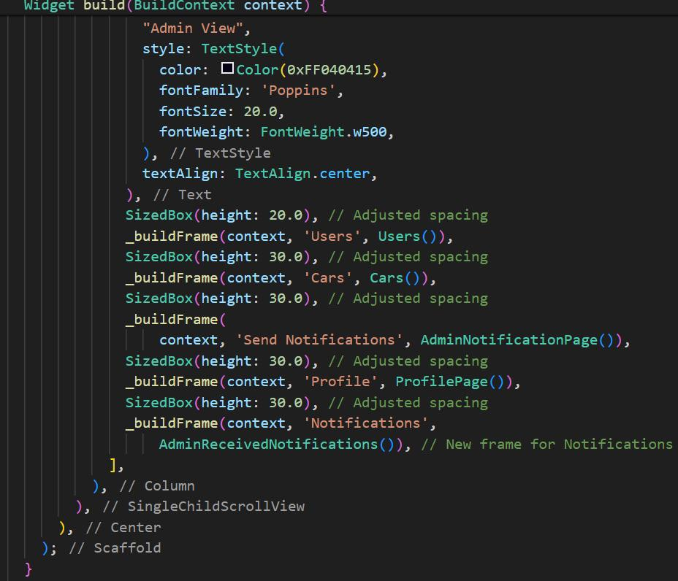

2-AdminView Class:

Description: Defines a stateless widget representing the admin view interface.

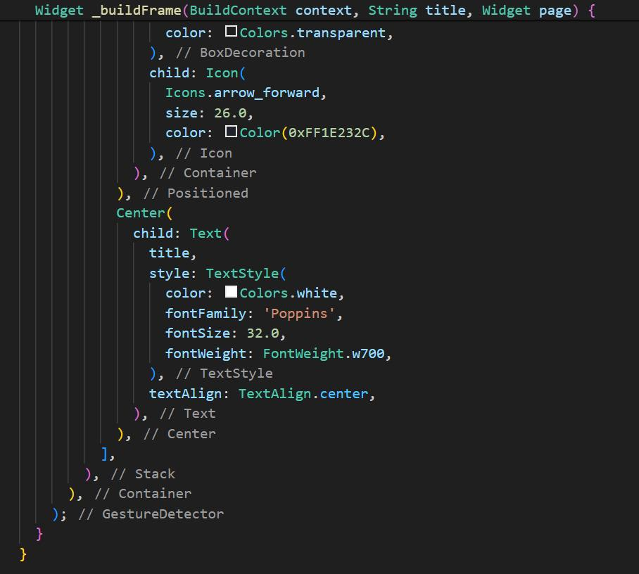

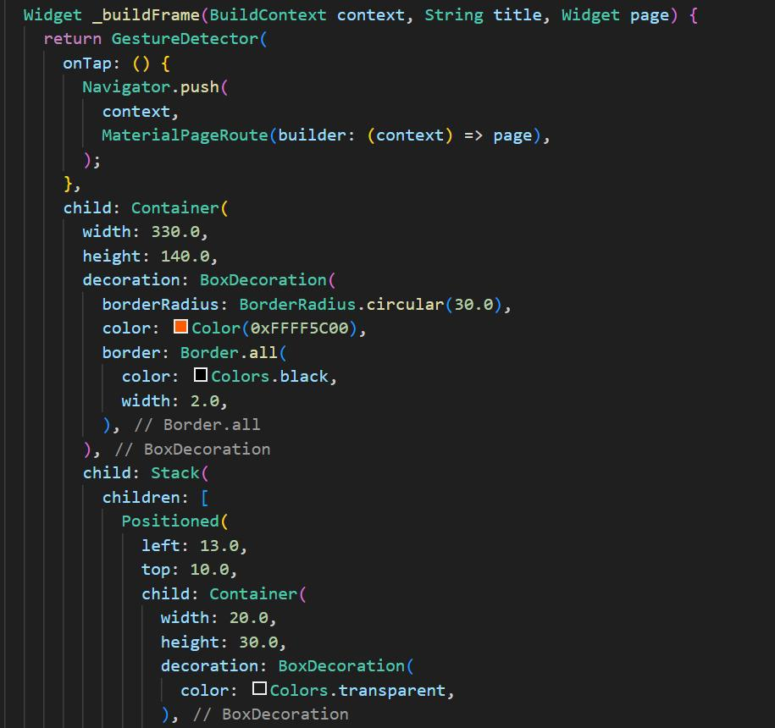

3-_buildFrame() Widget Function:

Description: Creates a stylized clickable frame widget for different functionalities.

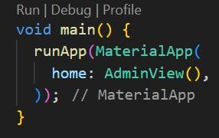

4-Main Function:

Description: Initializes the app with the AdminView widget as the starting screen.

4.2. Package Reservation

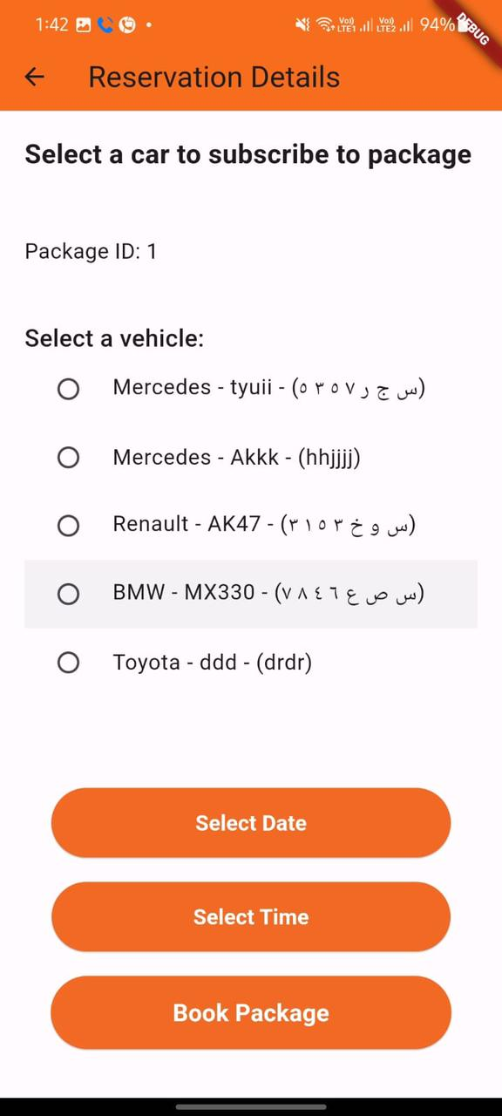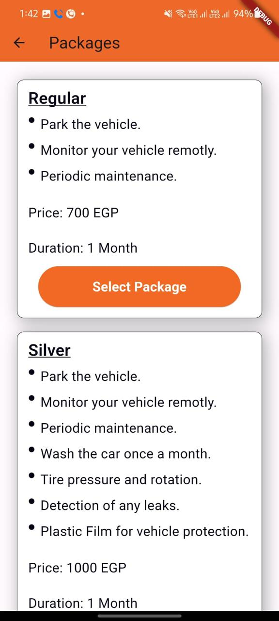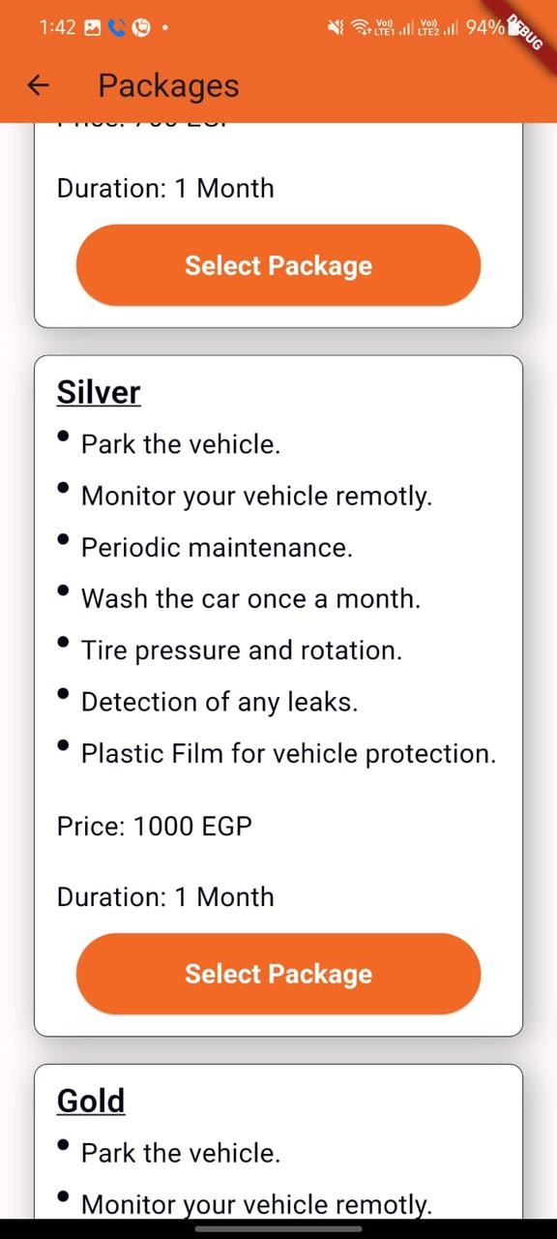

This Flutter app lets users manage package reservations for vehicles. Here's how it works:

* Users can browse available packages with details like name, services, price, and duration.
* They can select a package and proceed to make a reservation.
* The app allows them to choose a vehicle from their list (fetched from Firebase).
* Users can then select a date, time, and book the package.
* The app checks for available slots before saving the reservation and notifies the admin upon booking.

Overall, the app offers a user-friendly way to manage package reservations with real-time data updates using Firebase.

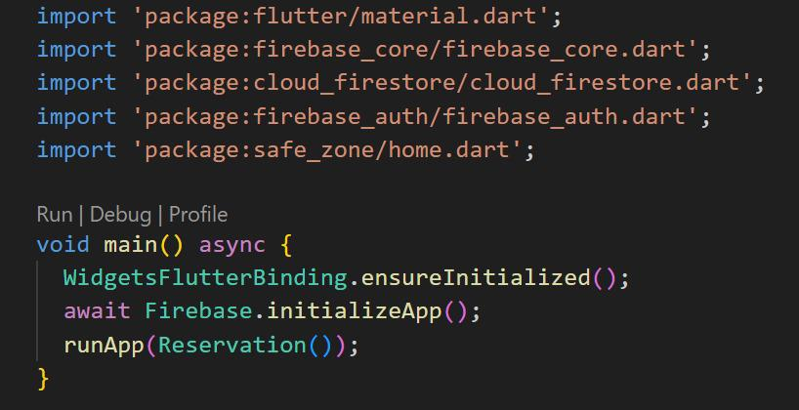

1. Initial Setup and Firebase Initialization:

Description: This snippet sets up the initial Flutter app, initializes Firebase services, and starts the app with the Reservation widget.

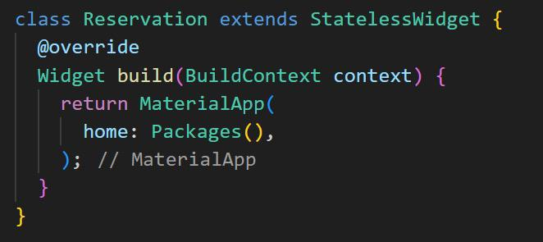

2. Reservation Class Definition:

Description: Defines a stateless widget Reservation that sets the Packages widget as the home screen of the app.

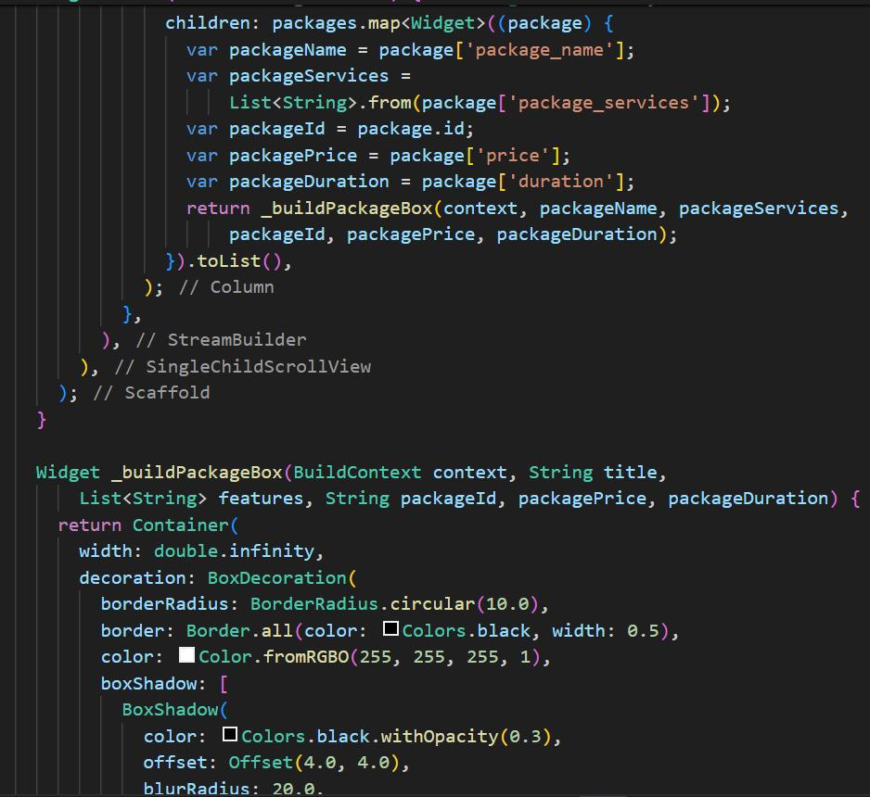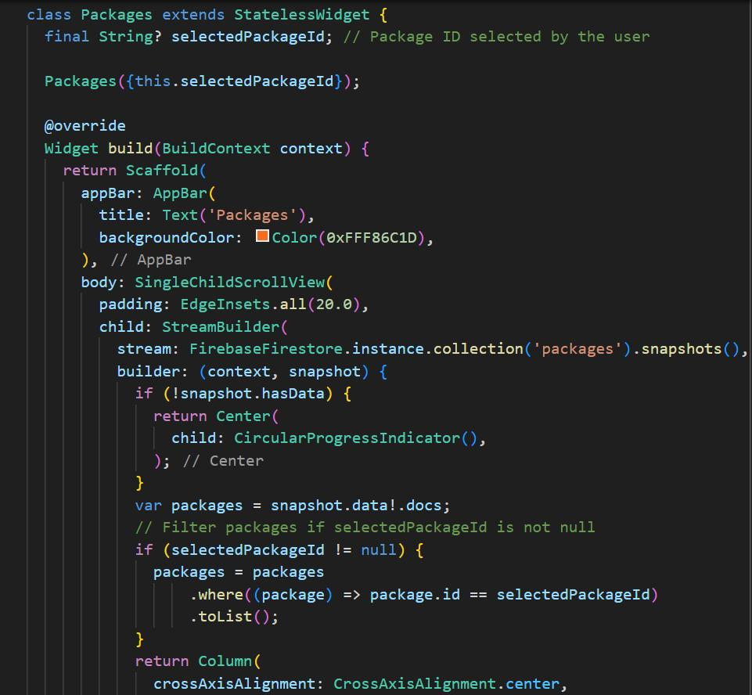

3. Packages Class for Displaying Packages:

Description: Manages the display of packages fetched from Firebase and allows users to select a package for reservation.

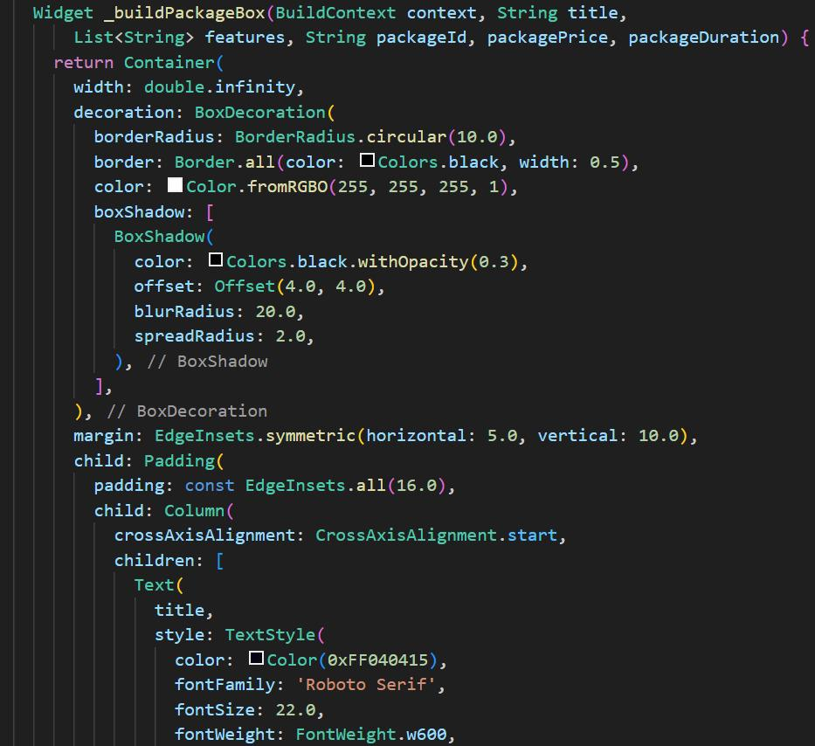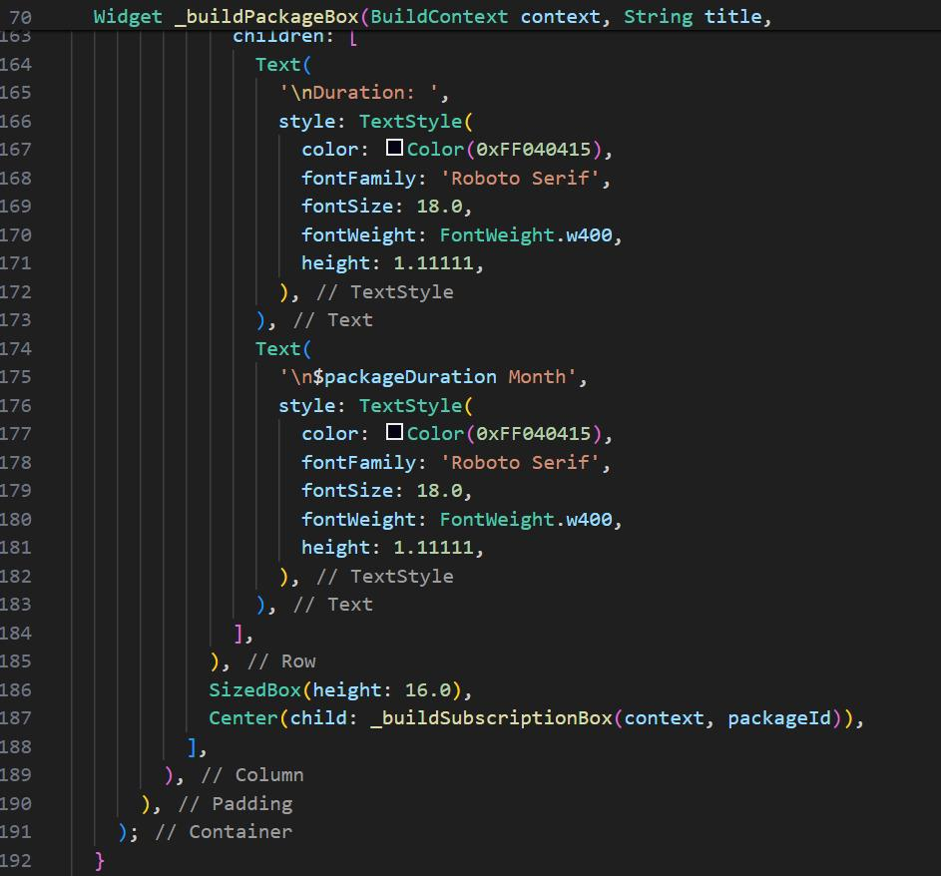

4. _buildPackageBox Widget:

Description: Creates a container to display package details like name, services, price, and duration for each package.

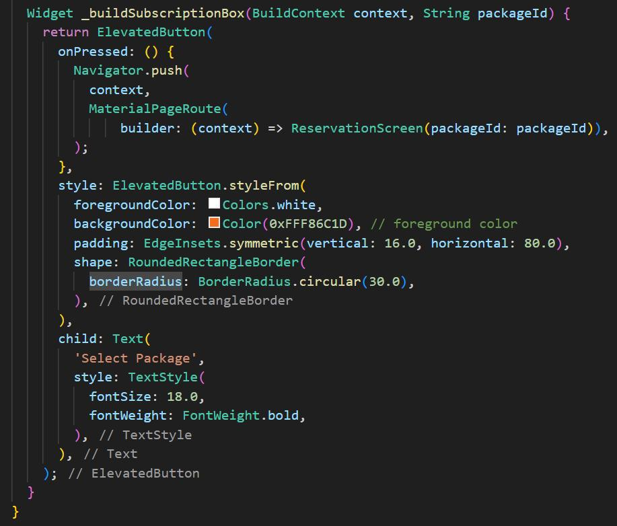

5. _buildSubscriptionBox Widget:

Description: Renders an elevated button allowing users to select a package for reservation and navigate to the ReservationScreen

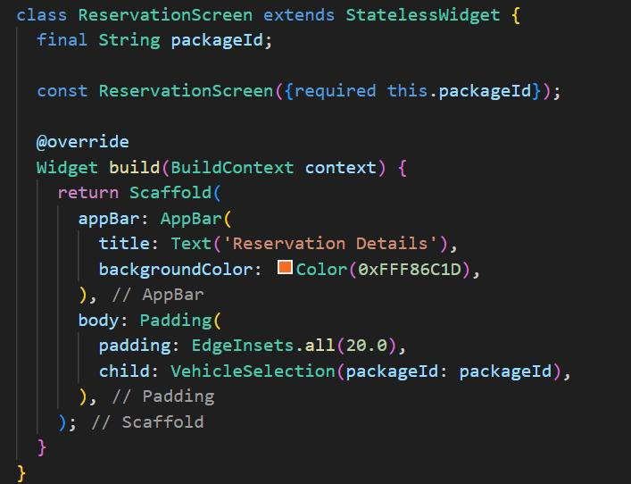

6. ReservationScreen Class:

Description: Defines a screen for reservation details, including vehicle selection and booking of the selected package.

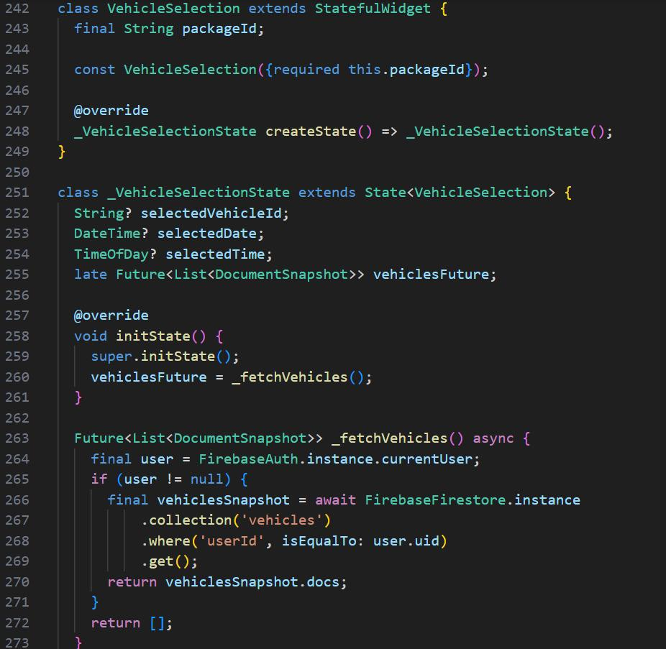

7. VehicleSelection Class:

Description: Manages the selection of vehicles for reservation, including date and time selection.

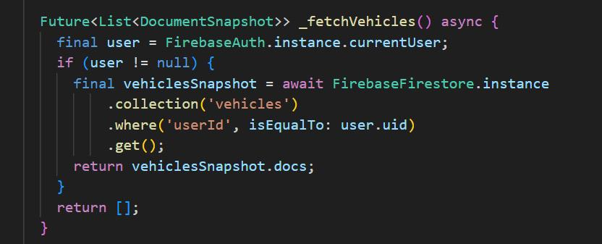

8. _fetchVehicles Method:

Description: Asynchronously fetches vehicles from Firestore based on the current user.

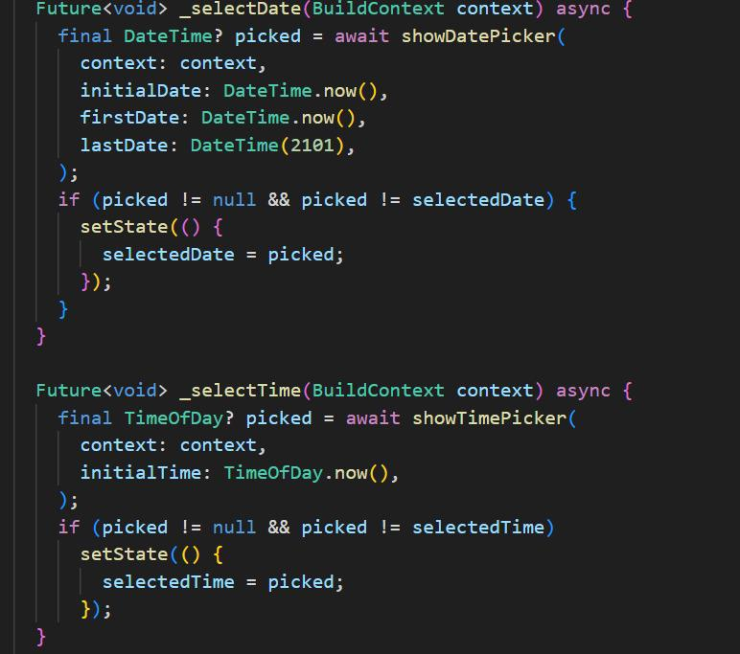

9. _selectDate and _selectTime Methods:

Description: Functions to handle the selection of date and time for the appointment.

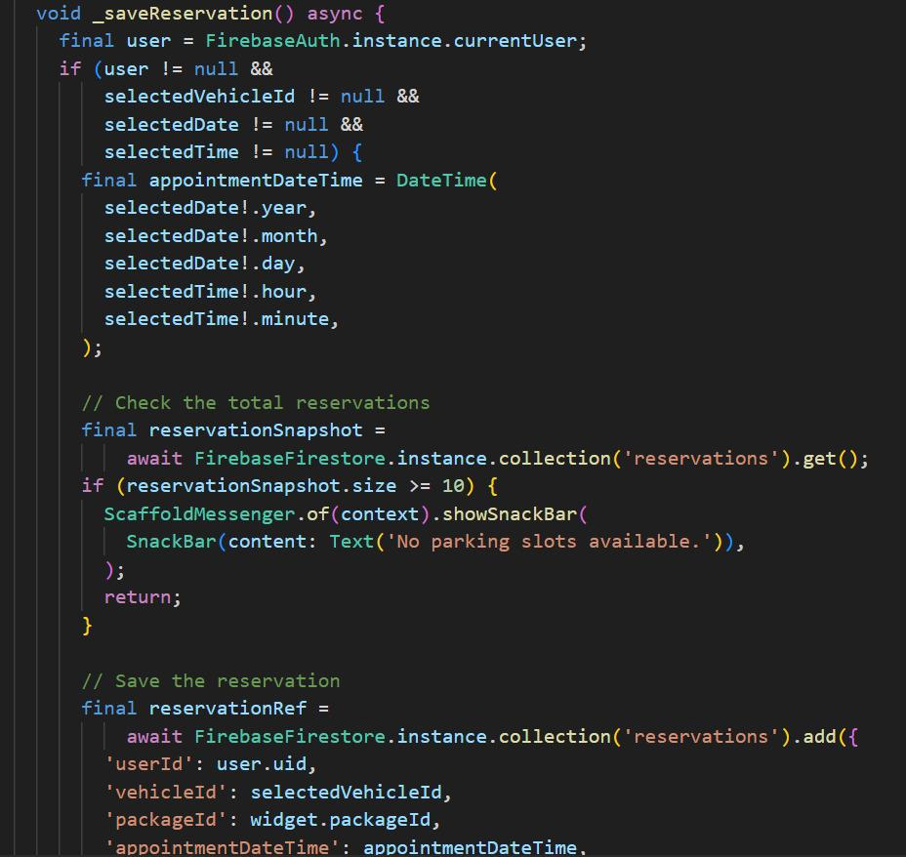

10. _saveReservation Method:

Description: Saves the reservation details in Firestore after selecting a vehicle, date, and time, and notifies the admin about the new reservation.

4.3. Reservations Page :

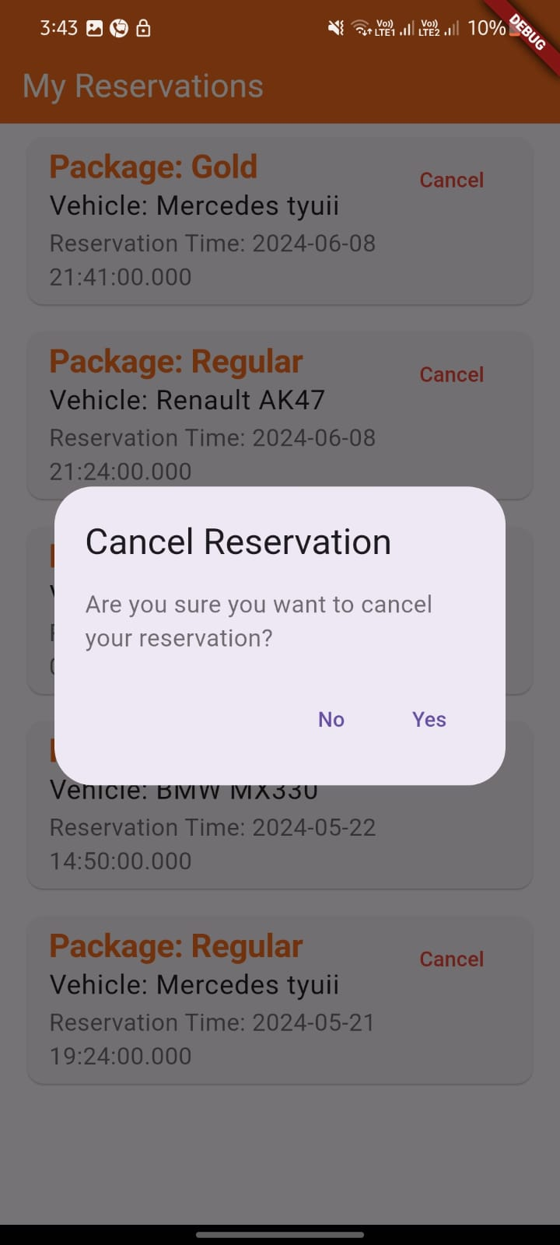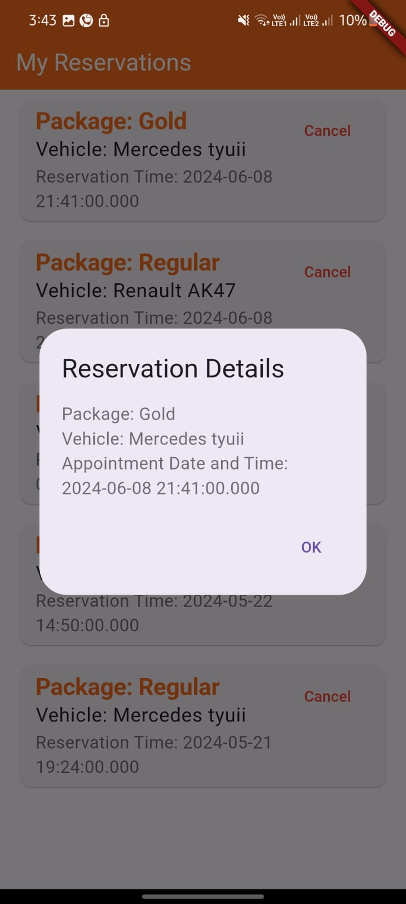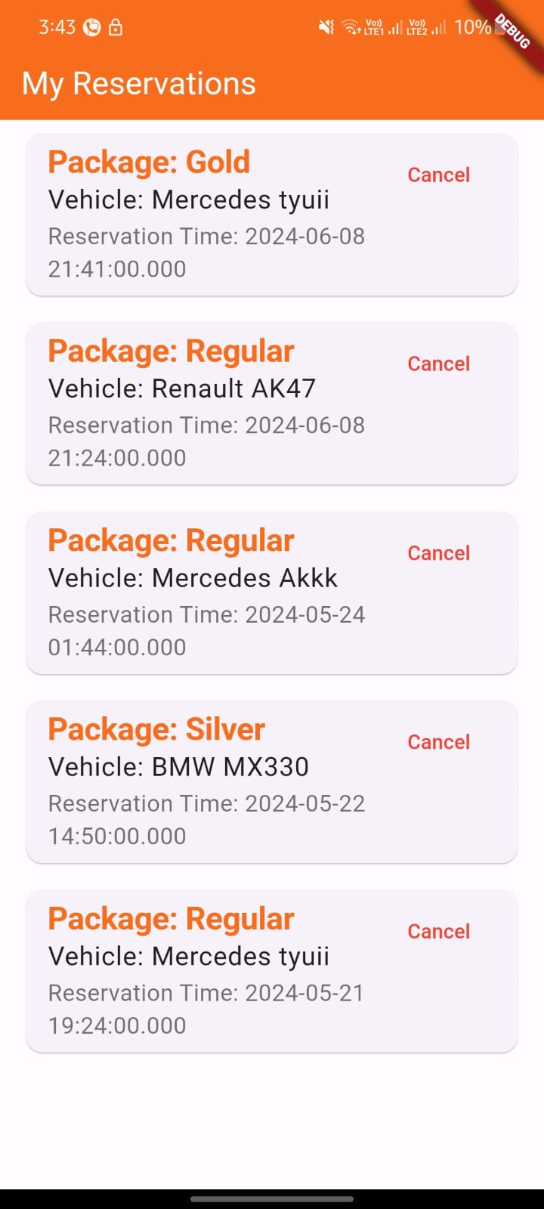

My Reservations Page:

This summary highlights the key functionalities behind managing reservations in the app:

Fetching Data:

Users' reservations are retrieved based on their ID and ordered chronologically.

Package names and vehicle details (brand & model) are fetched from Firestore for display.

Managing Reservations:

Users can cancel reservations with confirmation prompts and success messages.

New reservations are saved to Firestore with the selected vehicle and package.

User Interface:

The app utilizes FutureBuilders to fetch data asynchronously and update the UI with reservations, package/vehicle details, and available vehicles.

Various Flutter widgets create the user interface for displaying information and allowing interactions.

In essence, these functions work together to efficiently manage user reservations within the app.

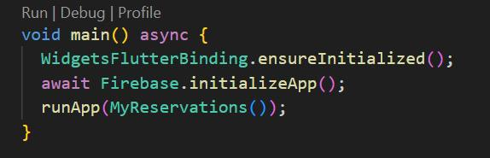

1-Firebase Initialization in main():

Description: Initializes the Flutter app and Firebase services.

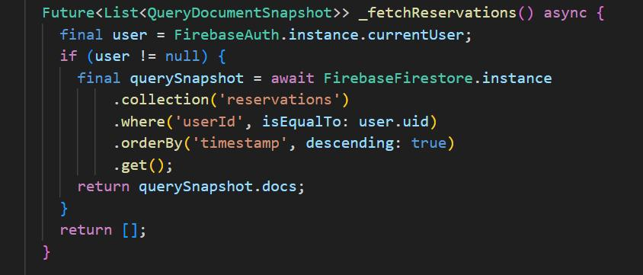

2-Fetching Reservations in _fetchReservations():

Description: Queries Firestore to fetch reservations for the current user

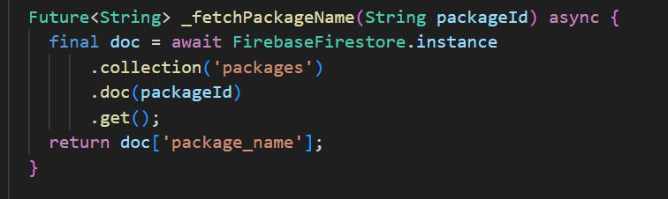

3-Fetching Package Name in _fetchPackageName(packageId

Description: Retrieves the package name from Firestore using the package ID.

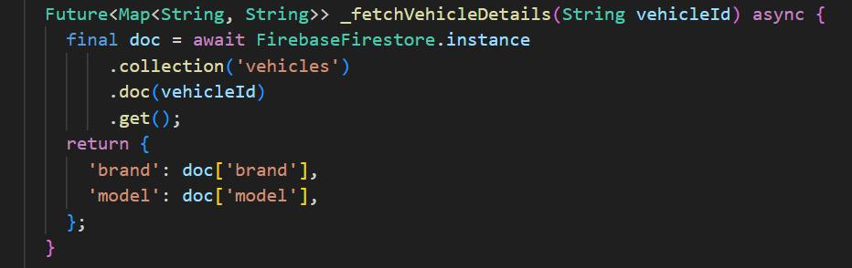

4-Fetching Vehicle Details in :

Description: Retrieves brand and model details of a vehicle from Firestore using the vehicle ID.

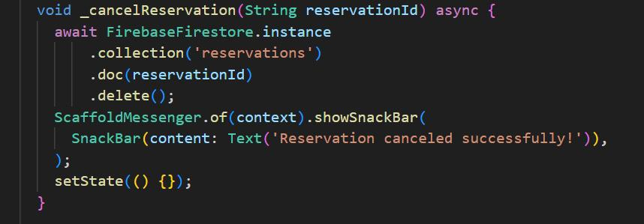

5-Canceling a Reservation in _cancelReservation(reservationId):

Description: Deletes a reservation from Firestore based on the reservation ID.

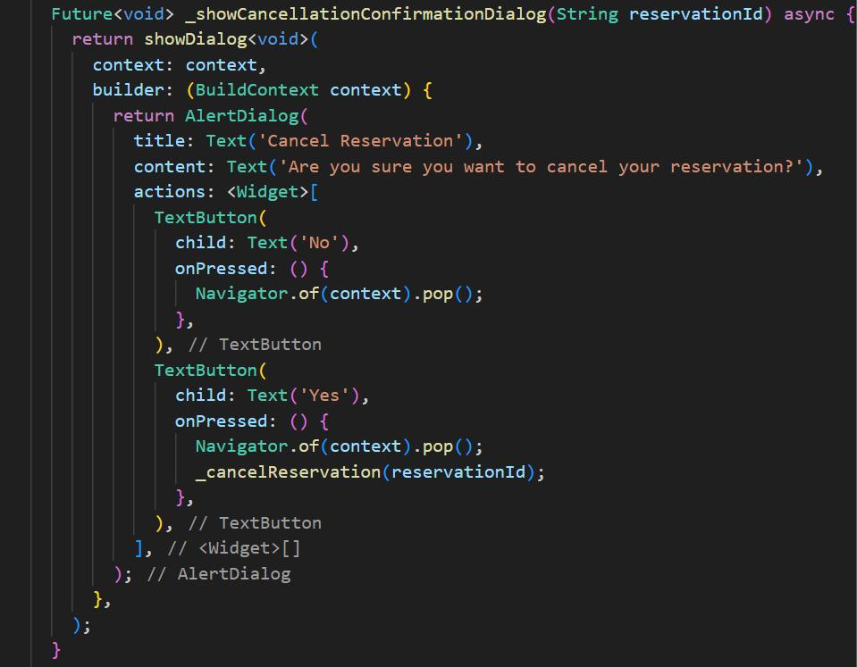

6-Showing Cancellation Dialog in _showCancellationConfirmationDialog(reservationId):

Description: Shows a dialog to confirm the cancellation of a reservation.

7-Firebase Operations and UI Setup in MyReservations & ReservationScreen:

Description: Sets up the Firebase instance and defines UI elements for displaying reservations and their details.

8-Animation Setup in _ReservationListState:

Description: Initializes an animation controller for smooth transition effects in the reservation list

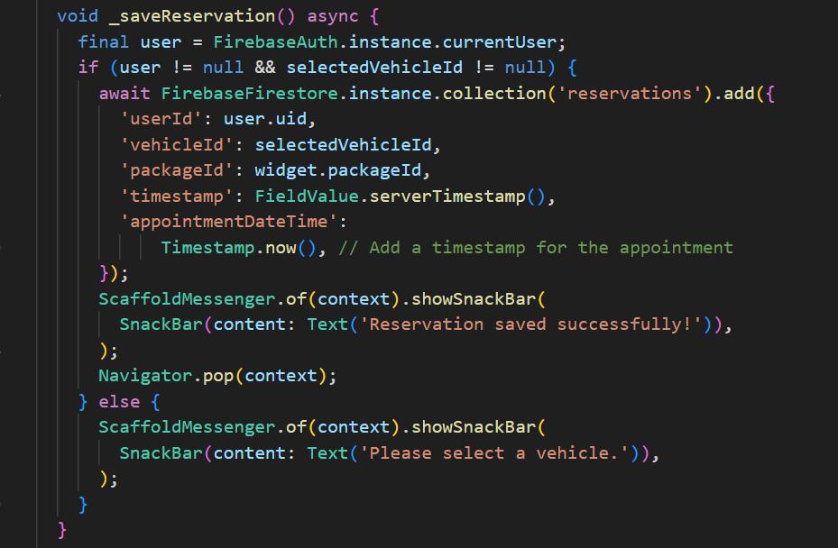

9-Saving a Reservation in _saveReservation() in VehicleSelection:

Description: Saves a new reservation linked to the selected vehicle and package ID in Firestore.

4.4. Car Services

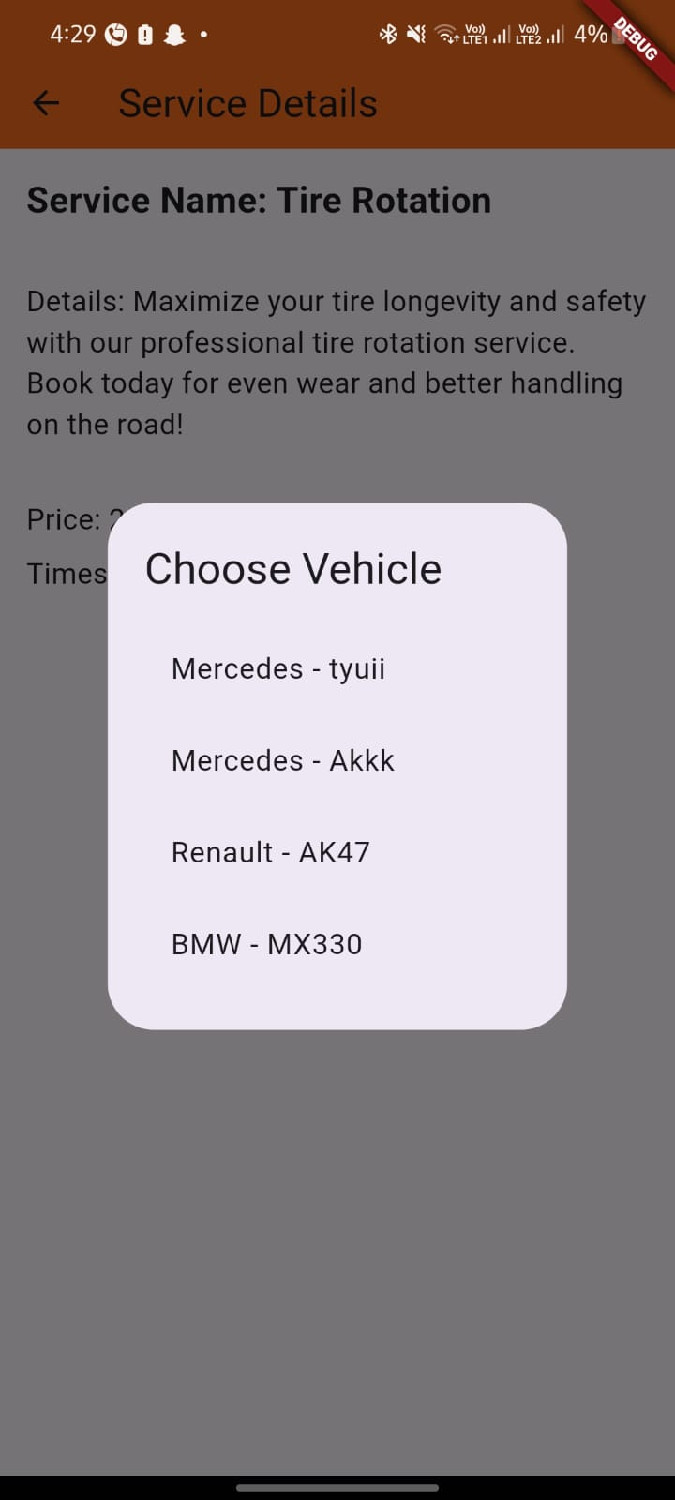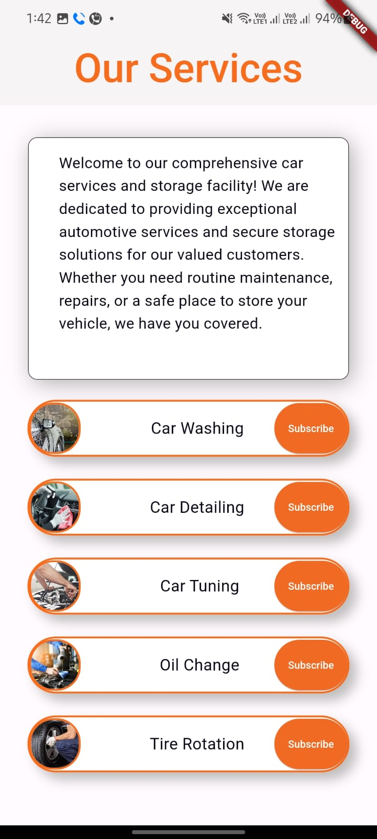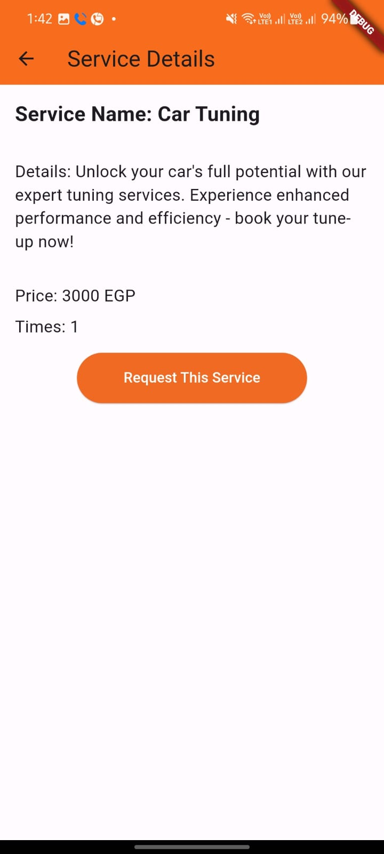

This code creates a mobile app for a car service business. Here’s what users can do:

* Browse and view details of various automotive services offered.
* Subscribe to service plans and choose vehicles for those services.
* Request specific services for their vehicles.
* Manage these actions through a user-friendly interface built with Flutter widgets.

The app interacts with Firebase for authentication and Firestore to manage service information, subscriptions, and requests.

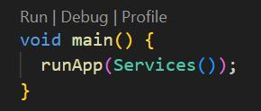

1. Main Function – main():

Description: Initializes the app and runs the top-level widget Services.

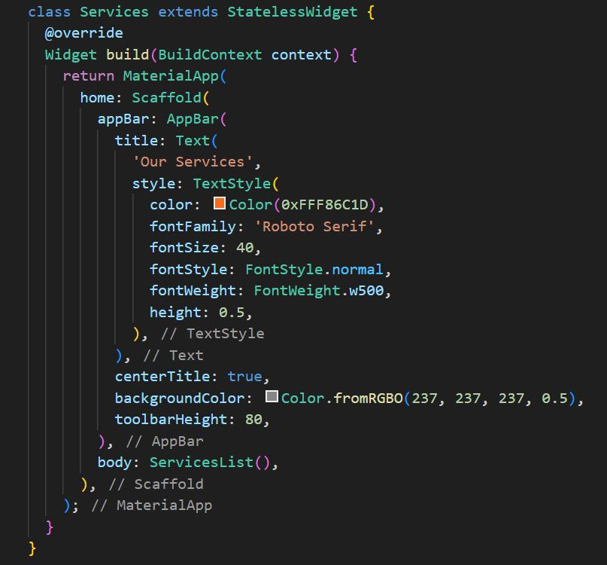

1. Widget – Services:

Description: Sets up the app theme and structure, displaying a list of services.

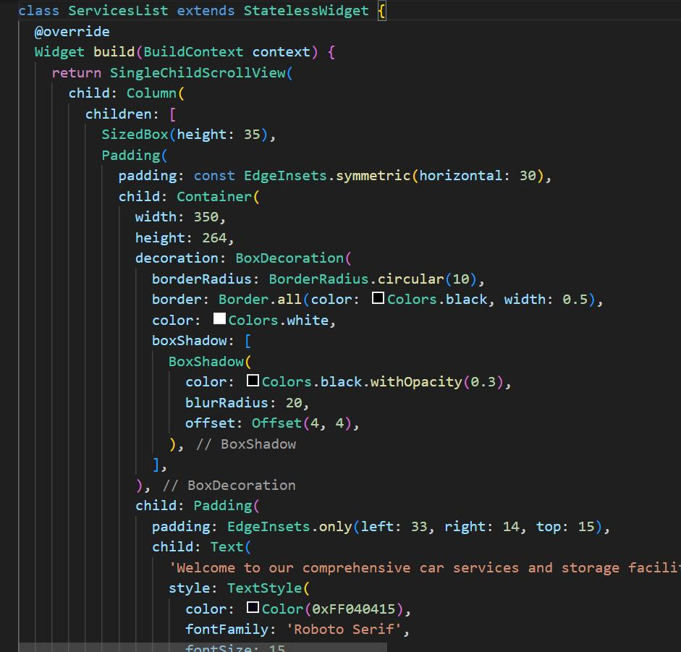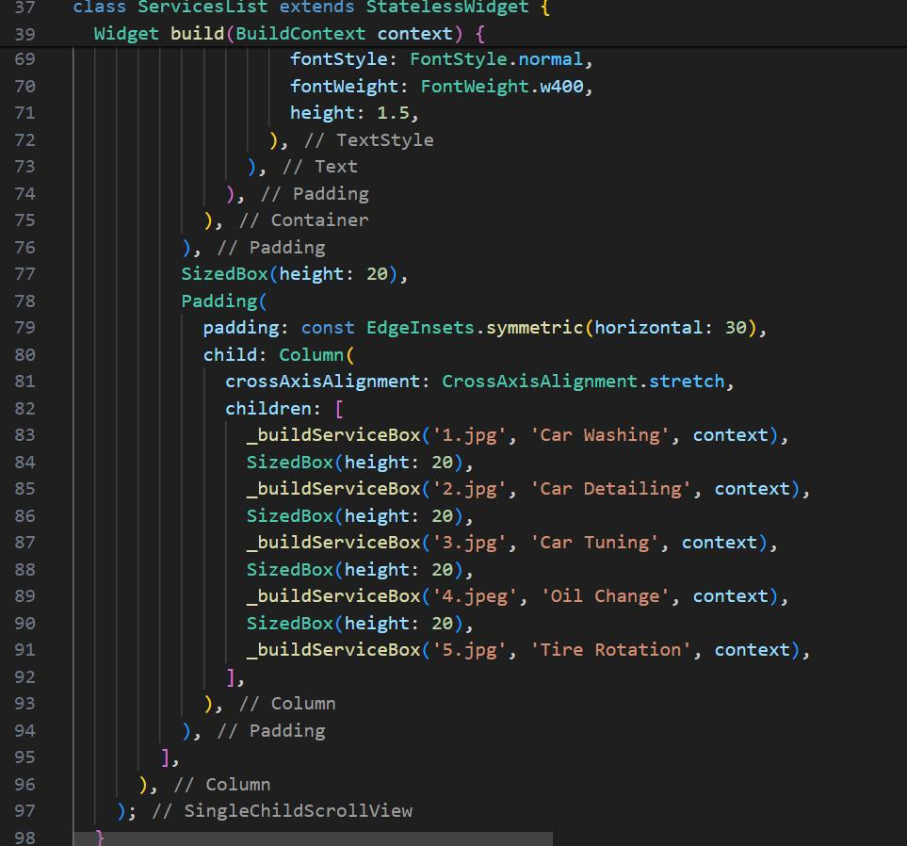

3. Widget – ServicesList:

Description: Displays a list of services with introductory text and service boxes.

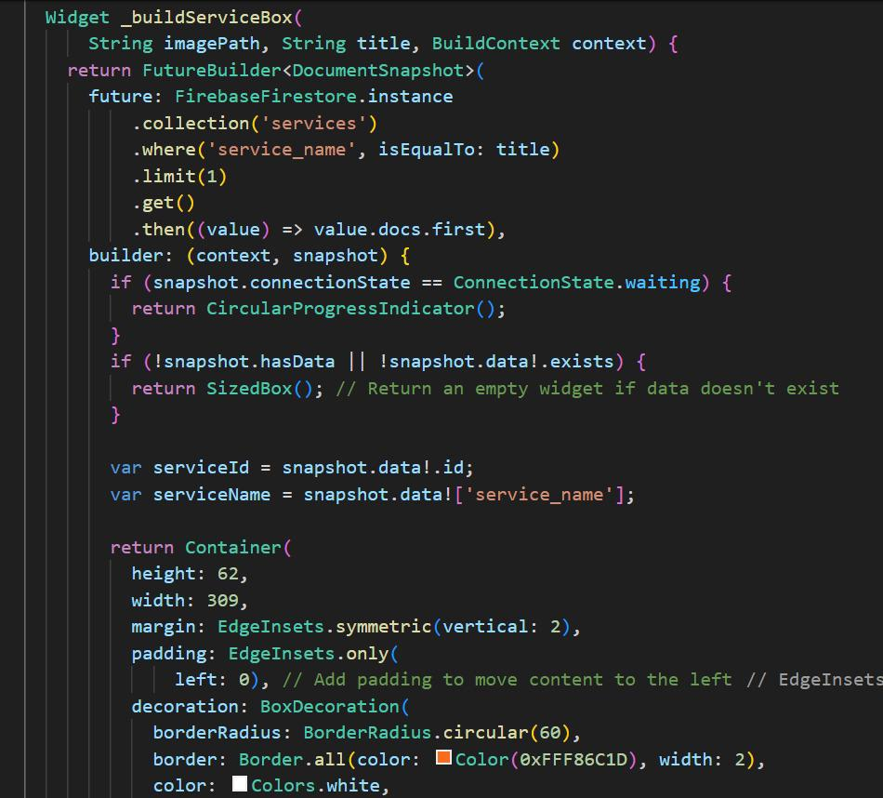

4. Widget - _buildServiceBox():

Description: Builds individual service boxes within the services list.

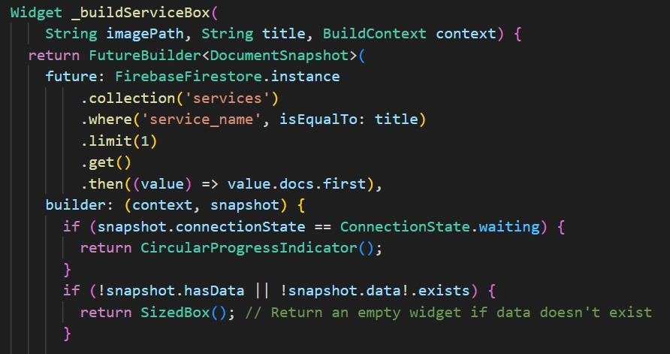

5. Service Data Retrieval – FutureBuilder:

Description: Fetches service details from Firestore based on the selected service name.

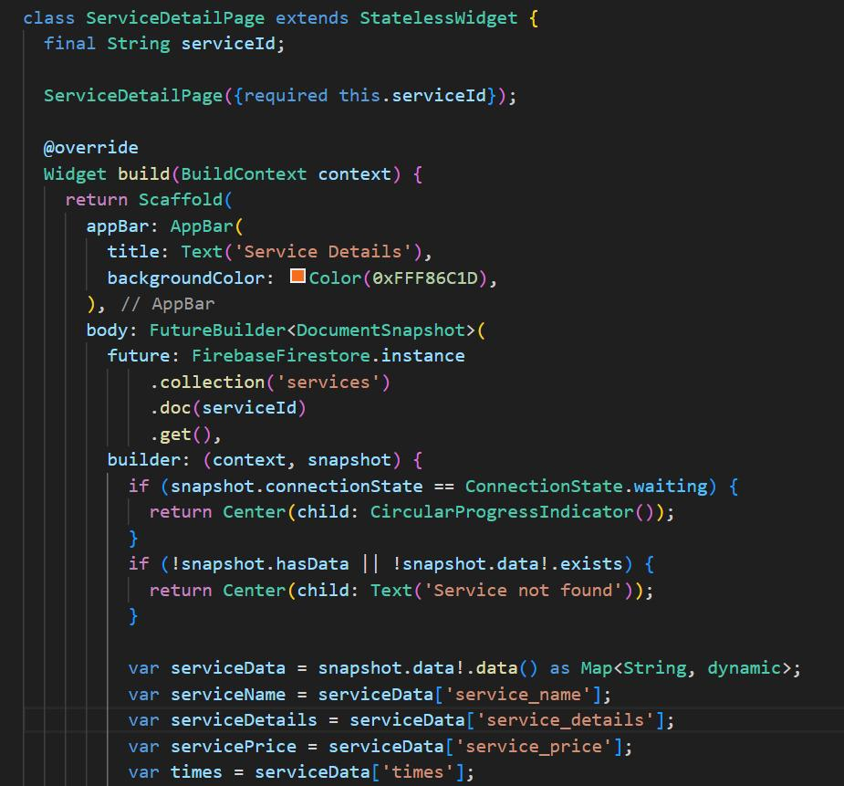

6. Widget – ServiceDetailPage:

Description: Displays detailed information about a selected service and allows users to request the service.

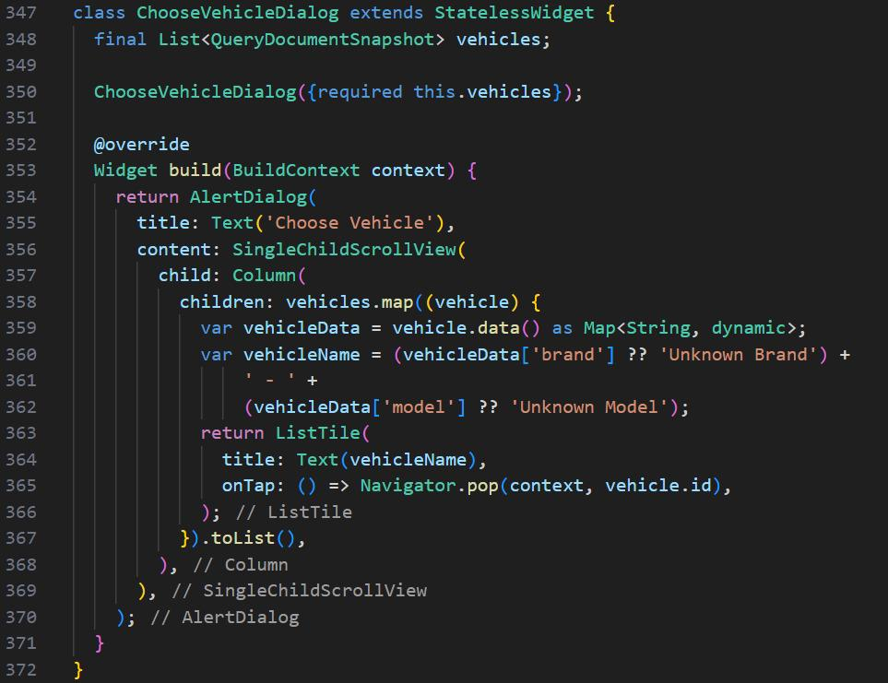

7. Dialog – ChooseVehicleDialog:

Description: Displays a dialog for users to choose a vehicle for requesting a service.

4.5. Add Vehicle Page:

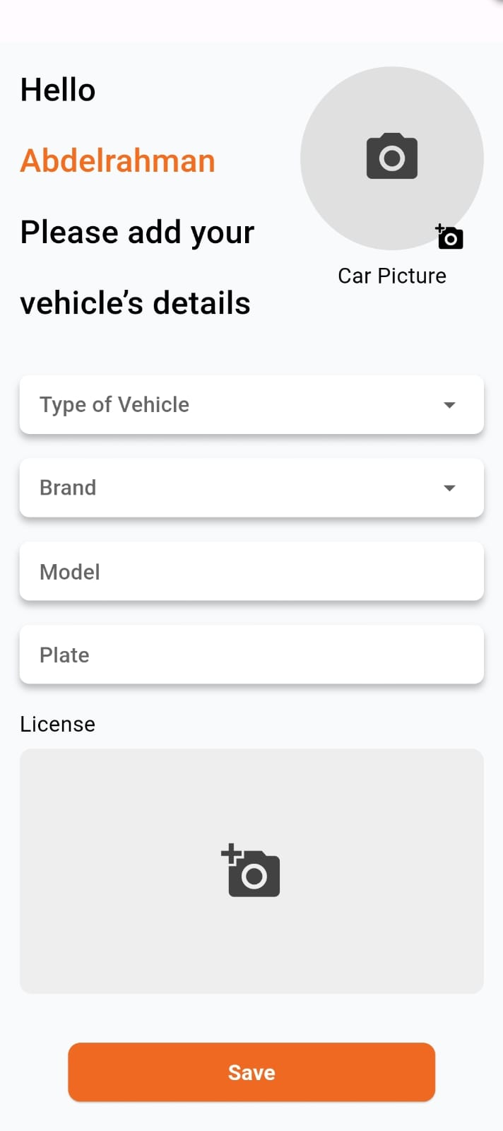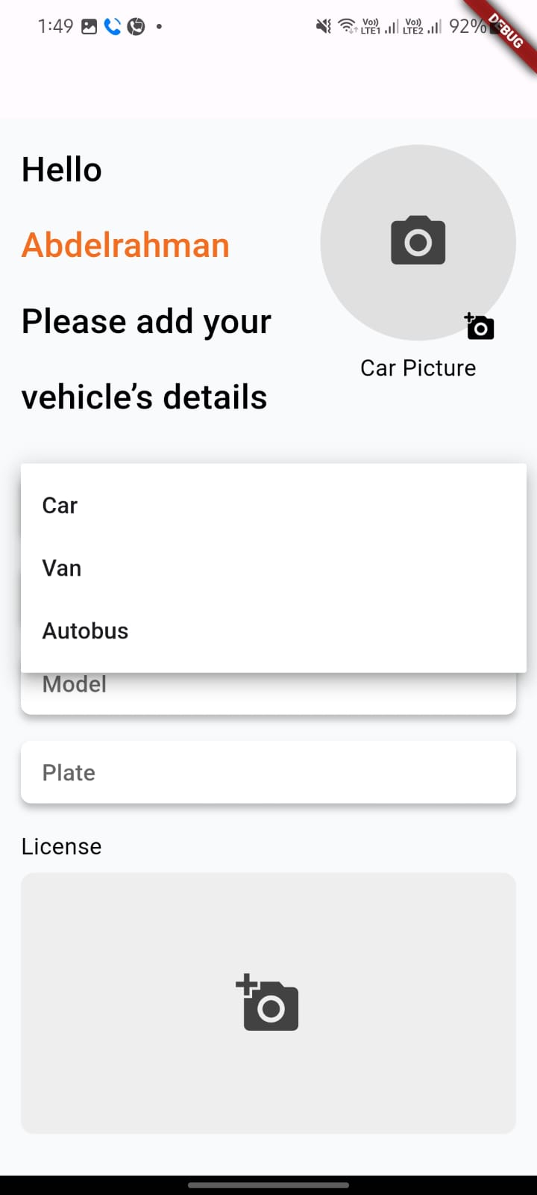

This code creates a mobile app for users to manage their vehicles. Here's what users can do:

* Add details about their vehicles, including capturing images of the car and license plate.
* Enter information like vehicle type, brand, model, and license plate number.

The app uses Firebase for several functionalities:

* **Authentication:** Ensures only registered users can add vehicles.
* **Firestore:** Stores all the vehicle details entered by the user.
* **Firebase Storage:** Stores the uploaded images of the car and license plate securely.

This allows users to easily manage their vehicle information within the app.

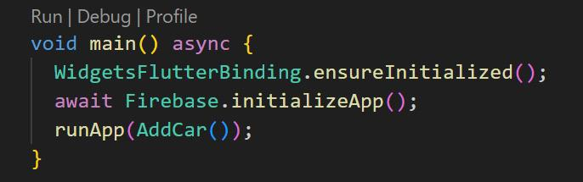

1-Firebase Initialization in main():

Description: Initializes the Flutter app and Firebase services.

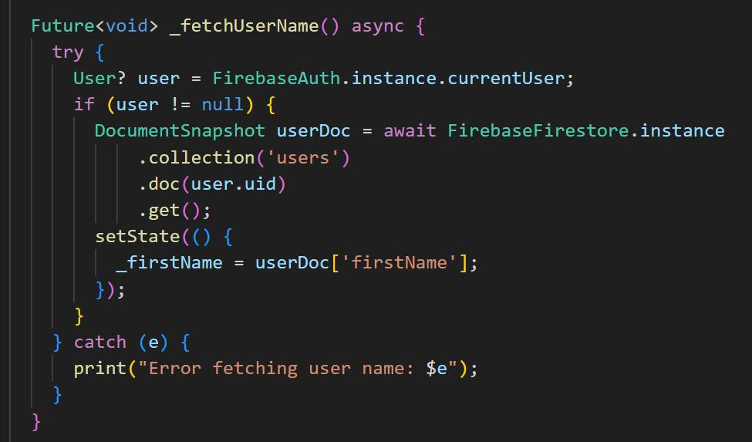

2-Fetching User Name in _fetchUserName():

Description: Retrieves the first name of the current user for personalization.

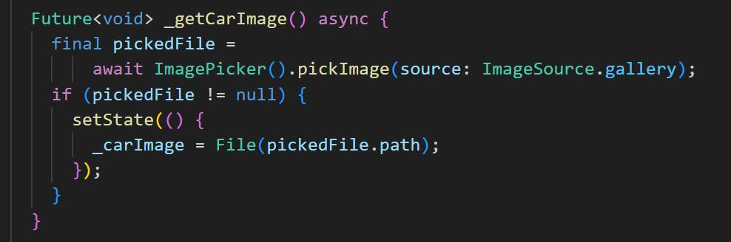

3-Image Selection for Car in _getCarImage():

Description: Implements the functionality for selecting a car image from the device's gallery

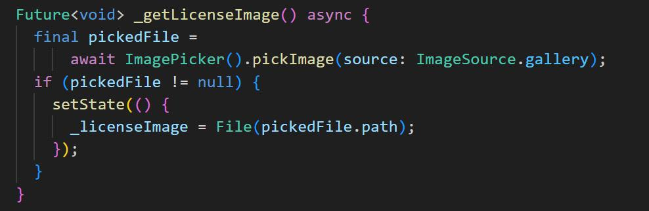

4-Image Selection for License in _getLicenseImage():

Description: Implements the functionality for selecting a license image from the device's gallery.

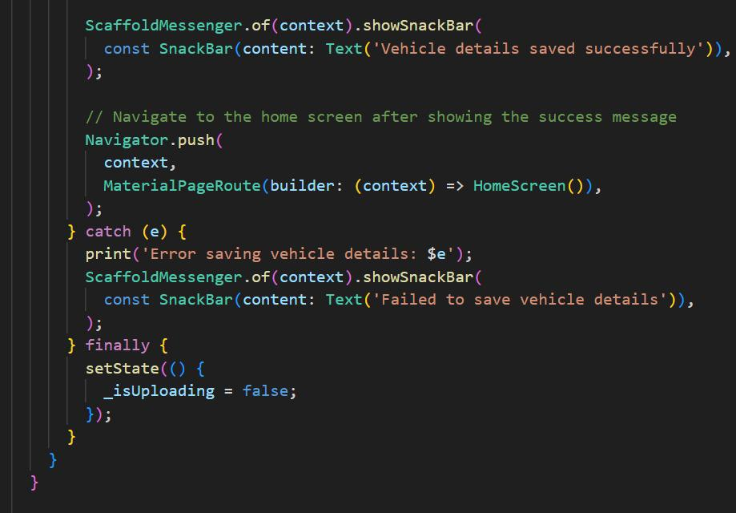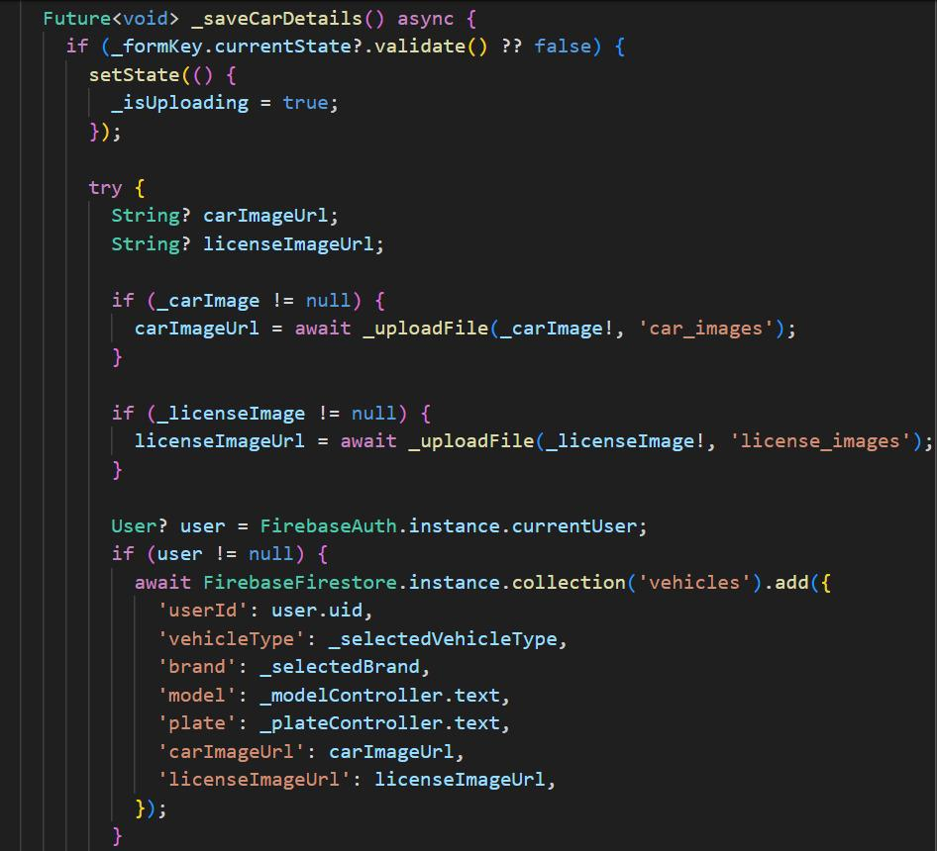

5-Saving Vehicle Details in _saveCarDetails():

Description: Validates the input data and saves the vehicle details, including uploaded images, in Firestore.

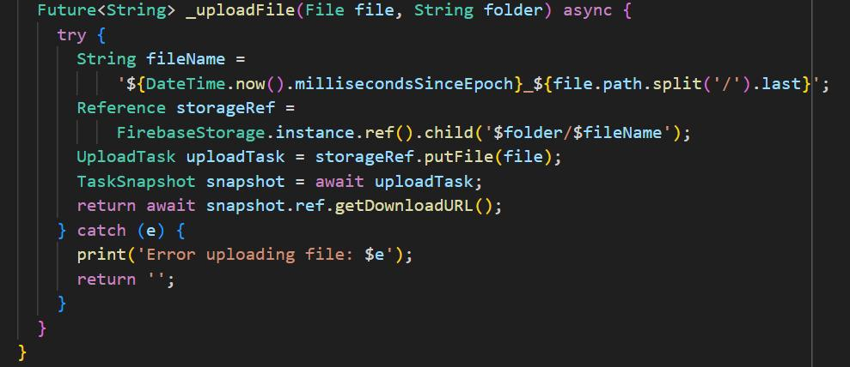

6-Image Upload to Firebase Storage in _uploadFile():

Description: Handles the uploading of files (car and license images) to Firebase Storage and retrieves their download URLs.

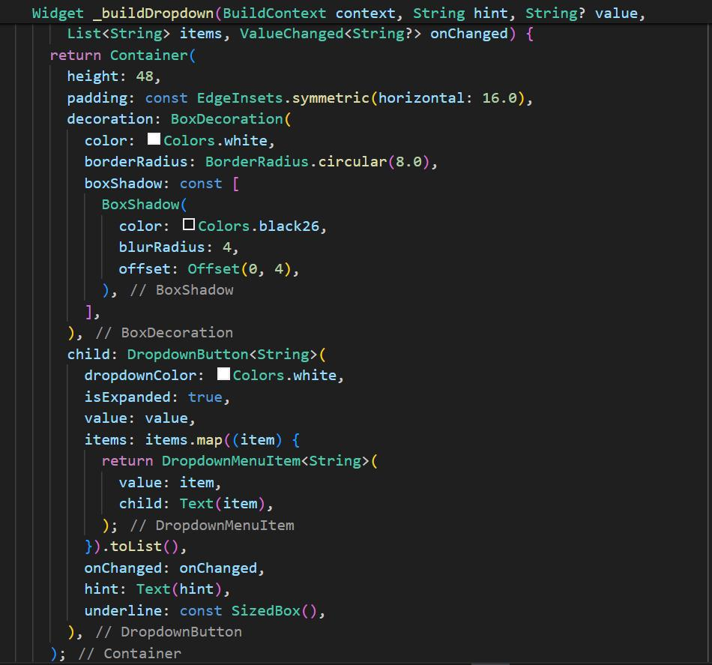

7-Dropdown Builder in _buildDropdown():

Description: Creates a dropdown widget for selecting vehicle type and brand.

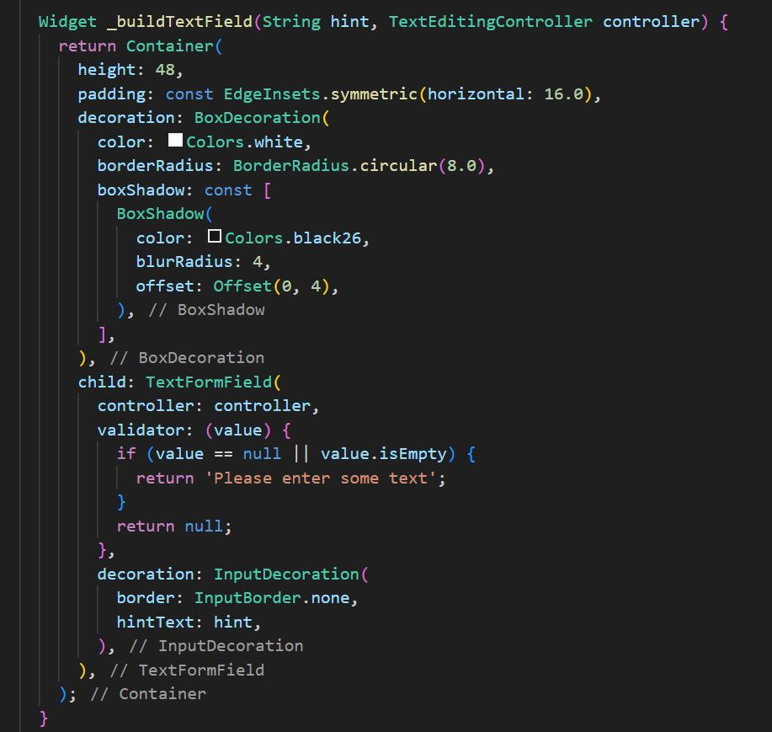

8-Text Field Builder in _buildTextField():

Description: Builds a text field widget for entering model and plate details.

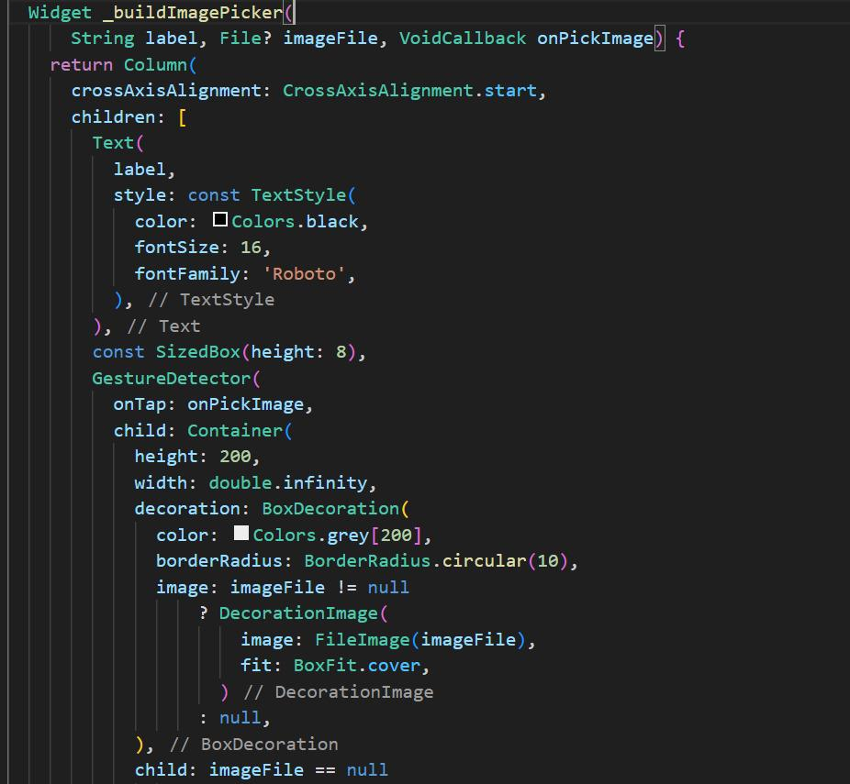

9-Image Picker Builder in _buildImagePicker():

Description: Constructs an image picker widget for selecting and displaying images of the car and license.

4.6. Profile Page:

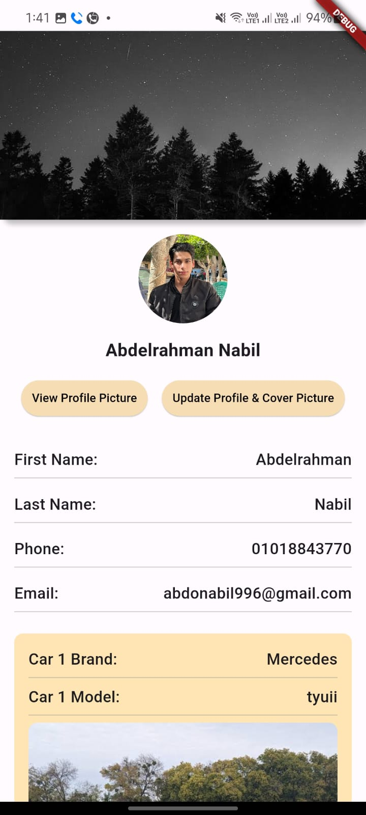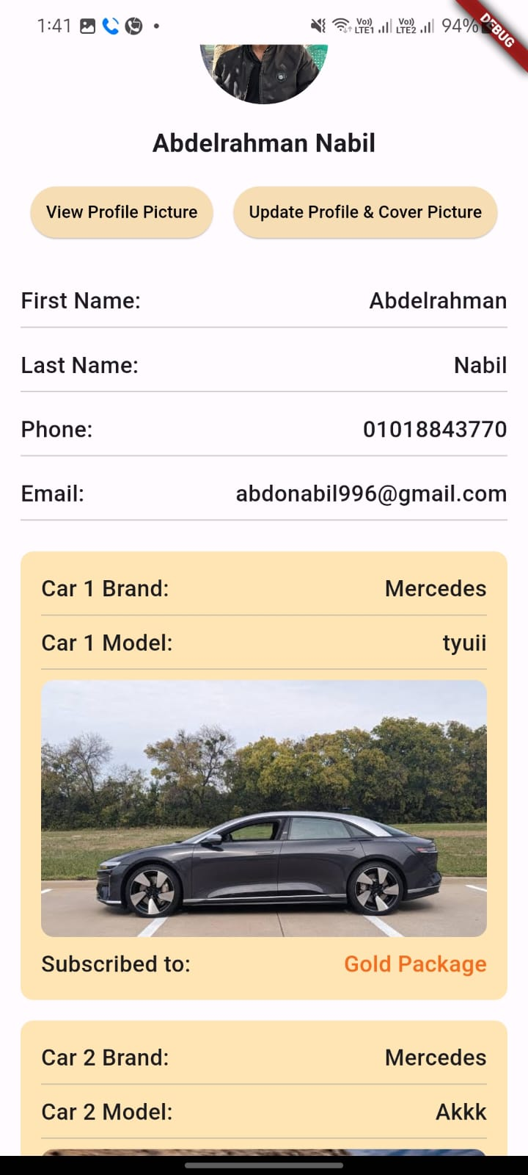profile page that allows users to manage and view their profile and cover images, personal information, and associated vehicle details. The app integrates with Firebase for authentication, storage, and Firestore for data management.

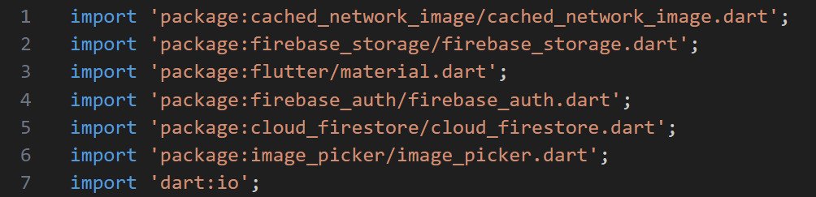

Imports

The necessary packages are imported, including:

cached_network_image for efficient image caching.

Firebase packages for authentication, storage, and Firestore.

image_picker for image selection from the gallery.

dart:io for handling file operations.

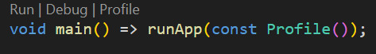

Main Function

The main function runs the Profile widget, which serves as the entry point of the application.

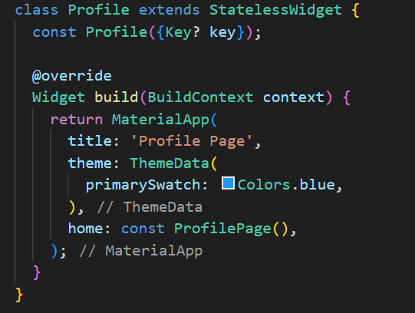

Profile StatelessWidget

The Profile class extends StatelessWidget and builds the MaterialApp with the ProfilePage as the home screen.

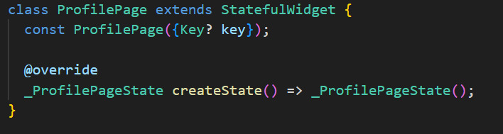

ProfilePage StatefulWidget

The ProfilePage class extends StatefulWidget to manage the profile page state.

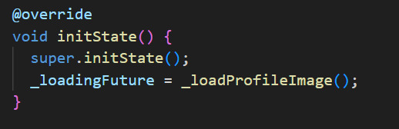

_loadProfileImage Method

This method retrieves the current user's profile and cover images from Firestore.

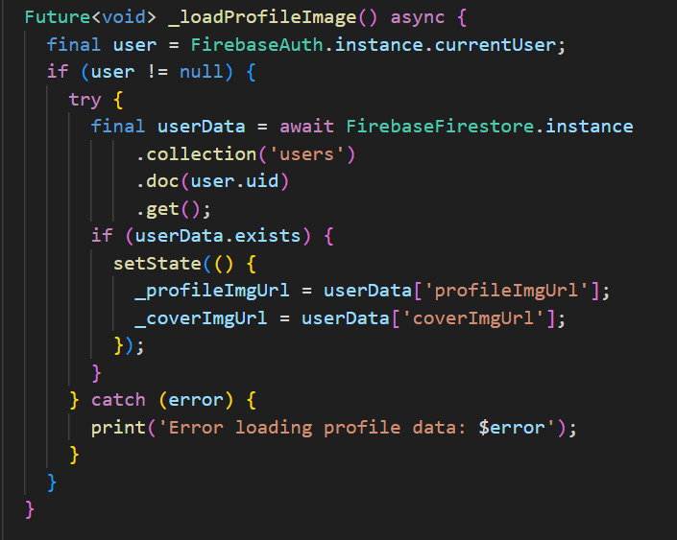

_pickImage Method

This method allows users to pick an image from the gallery and updates the corresponding state variable.

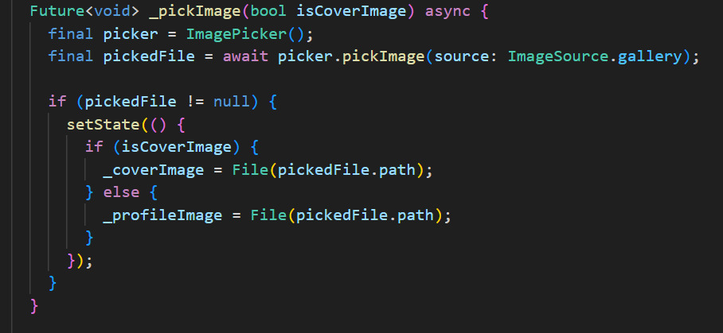

_uploadProfileAndCoverImages Method

This method uploads the selected profile and cover images to Firebase Storage and updates their URLs in Firestore.

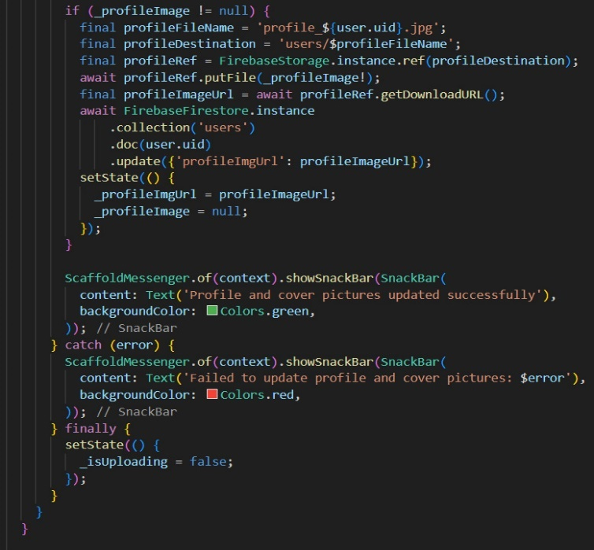

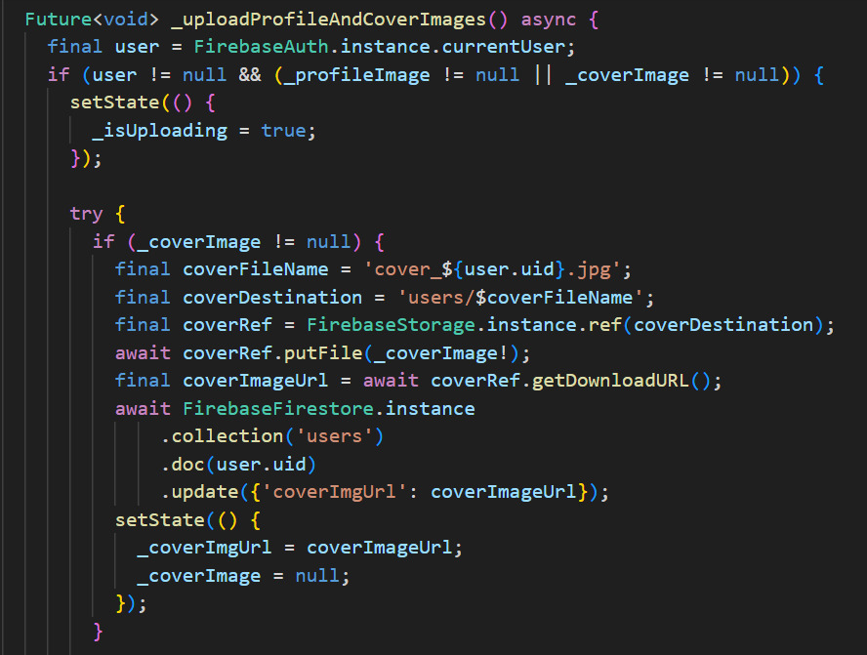

_showProfilePicture Method

This method displays the current profile picture in a dialog.

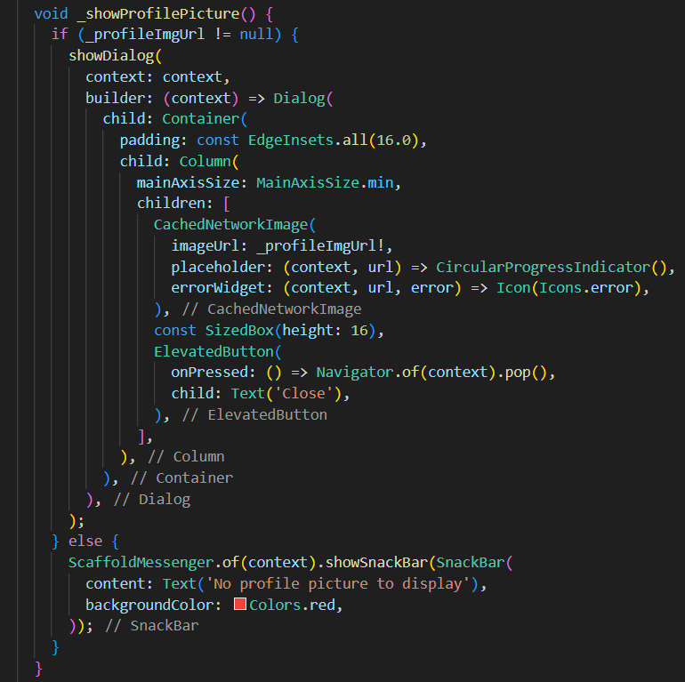

build Method

The build method constructs the UI, including image upload and display functionalities, and user information sections.

4.7. Sign Up Page:

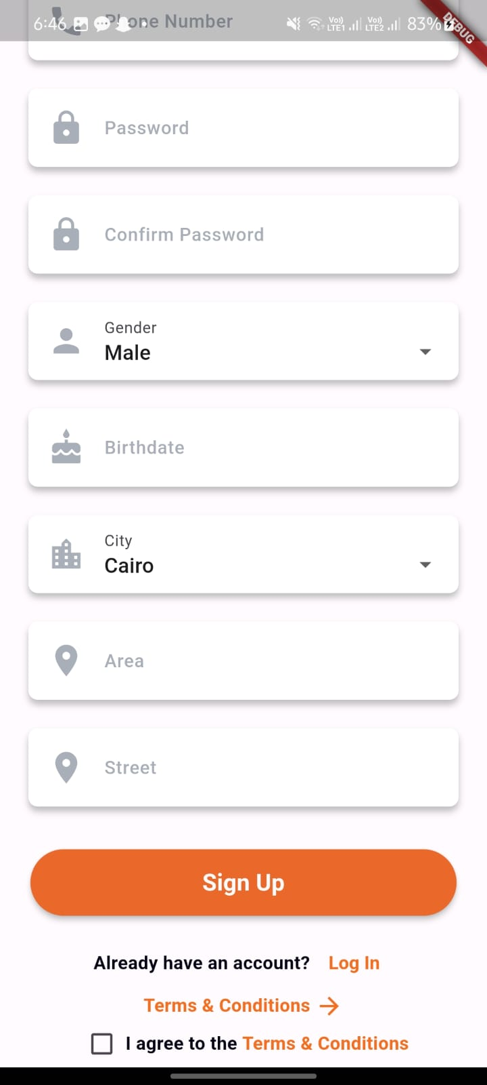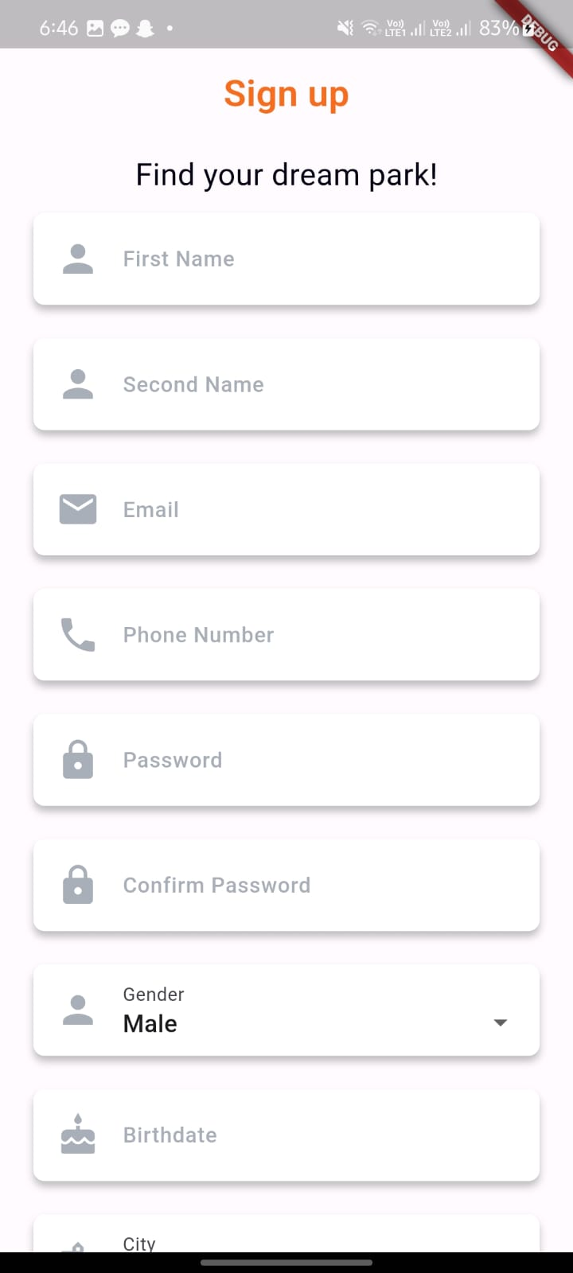

This page allows users to sign up for an account using Firebase Authentication and Firestore for backend services.

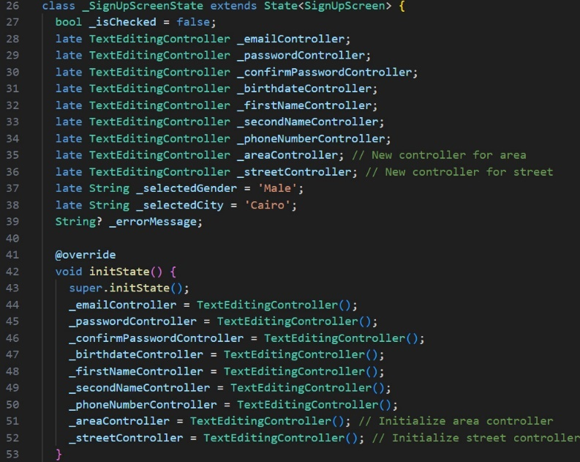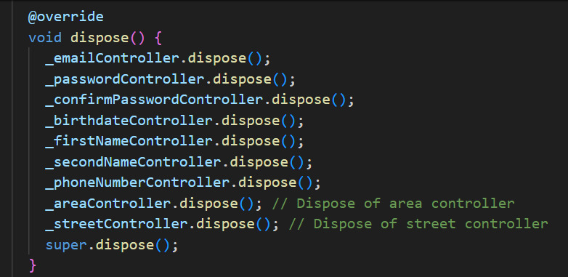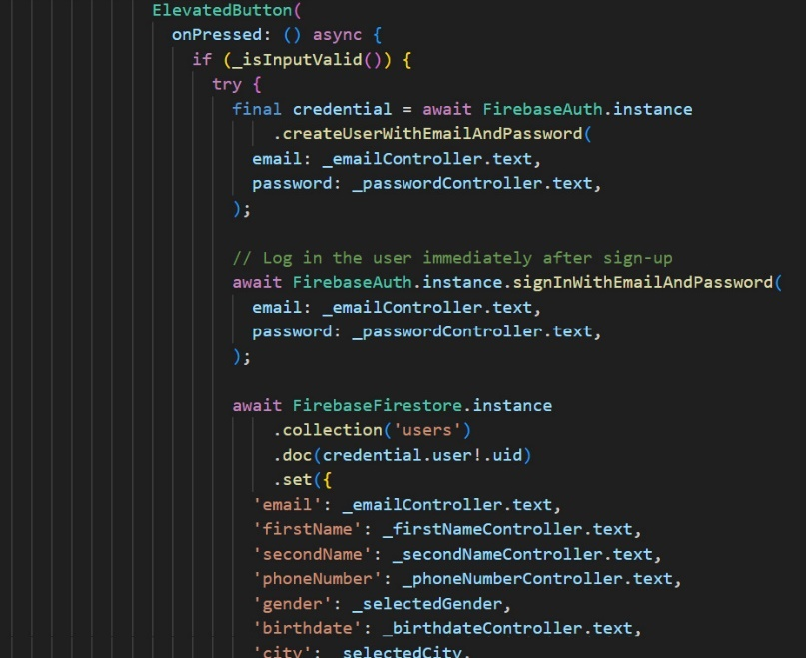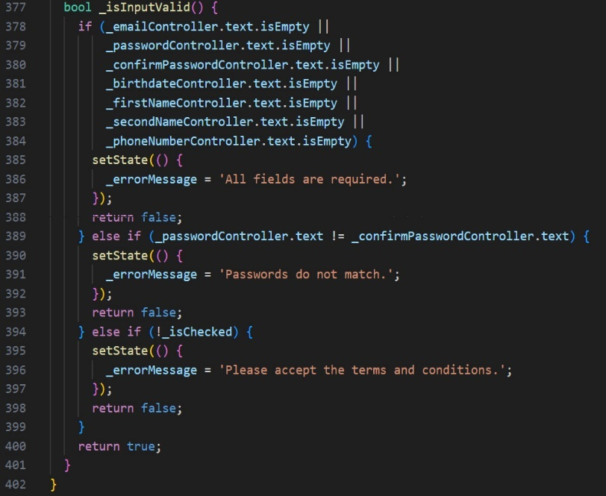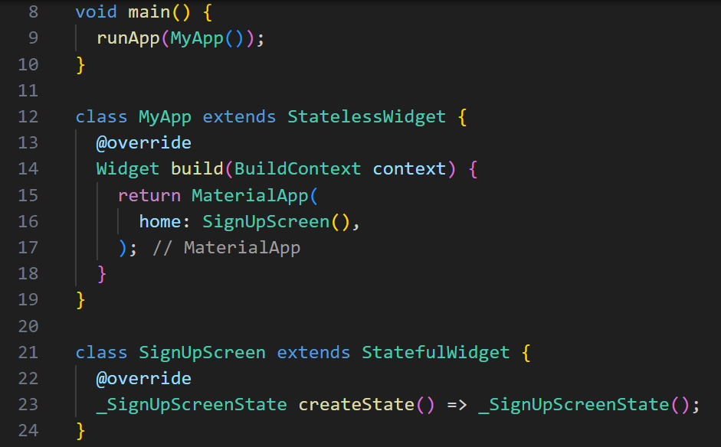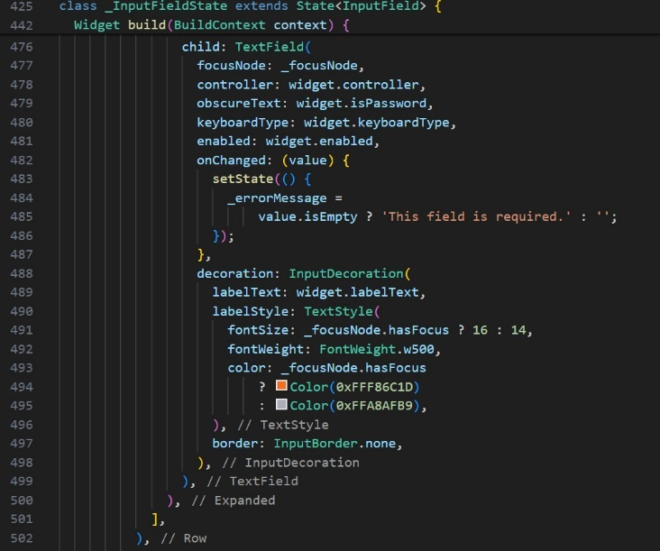

Imports:

firebase_auth.dart: Provides Firebase Authentication services.

material.dart: Flutter's material design library.

cloud_firestore.dart: Provides Firestore database services.

login.dart, home.dart, terms_and_conditions.dart: Custom modules for the login page, home page, and terms and conditions page.

Main Application:

main(): The entry point of the application that runs the MyApp widget.

MyApp: A stateless widget that sets up the MaterialApp with SignUpScreen as the home screen.

SignUpScreen:

SignUpScreen: A stateful widget that manages the sign-up form.

_SignUpScreenState: Holds the state and logic for the SignUpScreen.

State Variables:

TextEditingControllers: Controllers for handling text input for email, password, confirm password, birthdate, first name, second name, phone number, area, and street.

_selectedGender: Dropdown value for gender selection, initialized to 'Male'.

_selectedCity: Dropdown value for city selection, initialized to 'Cairo'.

_isChecked: Boolean for terms and conditions acceptance.

_errorMessage: String to display error messages.

Lifecycle Methods:

initState(): Initializes the text controllers.

dispose(): Disposes of the text controllers to free up resources.

UI Build Method:

build(): Constructs the UI using a Scaffold and SingleChildScrollView.

Contains a form with input fields for first name, second name, email, phone number, password, confirm password, gender, birthdate, city, area, and street.

An ElevatedButton to submit the form.

If there's an error message, it displays it below the submit button.

A row for navigating to the login page if the user already has an account.

A checkbox and text for agreeing to the terms and conditions.

Form Validation:

_isInputValid(): Validates the input fields to ensure they are not empty, passwords match, and terms are accepted.

Form Submission:

onPressed: The submit button triggers:

Validation of the form inputs.

Attempt to create a new user with Firebase Authentication.

On successful sign-up, log in the user and save additional user data to Firestore.

Navigate to the HomeScreen.

InputField Widget:

A custom widget to create a text input field with an icon.

Manages focus and displays an error message if the field is empty.

DropdownField Widget:

A custom widget for dropdown selection with an icon.

Takes parameters for the label text, icon, current value, onChanged callback, and dropdown items.

4.8. Login Page :

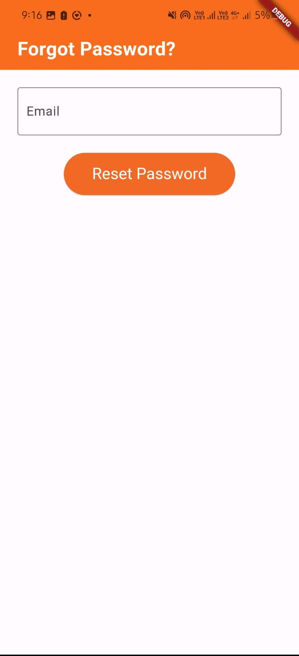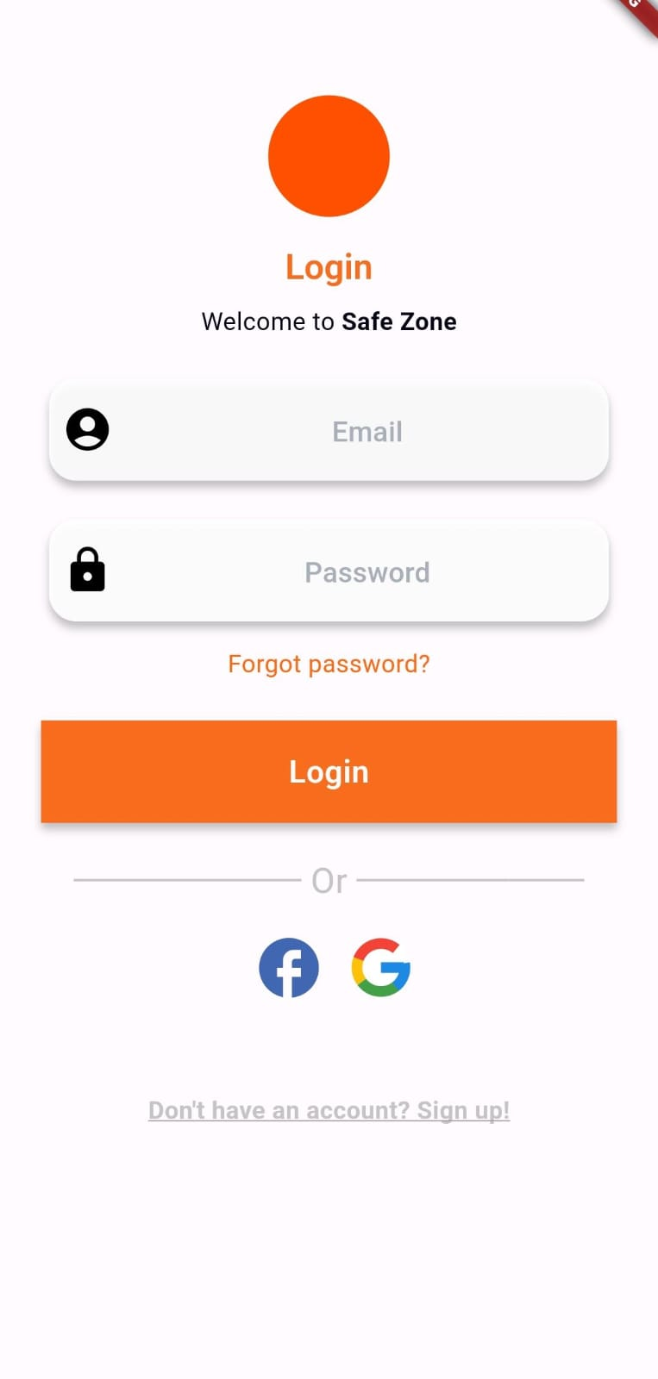

Login page:

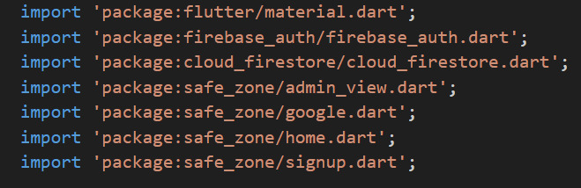

Importing necessary packages and dependencies for Flutter, Firebase authentication, Firestore, and custom views.

LoginPage StatefulWidget.

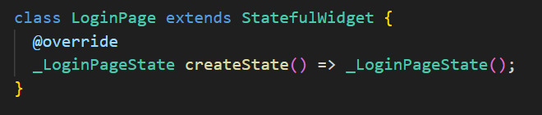

Defining the LoginPage as a stateful widget.

_LoginPageState Class: Controller Initialization.

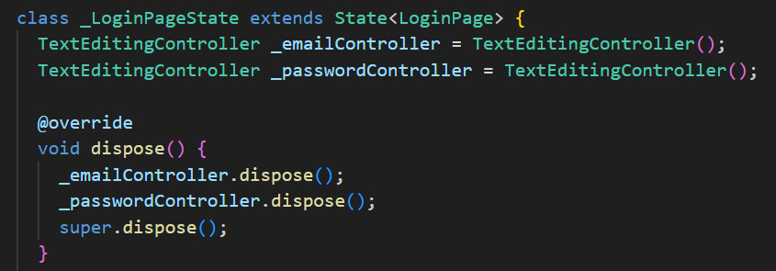

Initializing text controllers for email and password input fields and disposing of them properly.

Build Method: Scaffold and Main UI Structure.

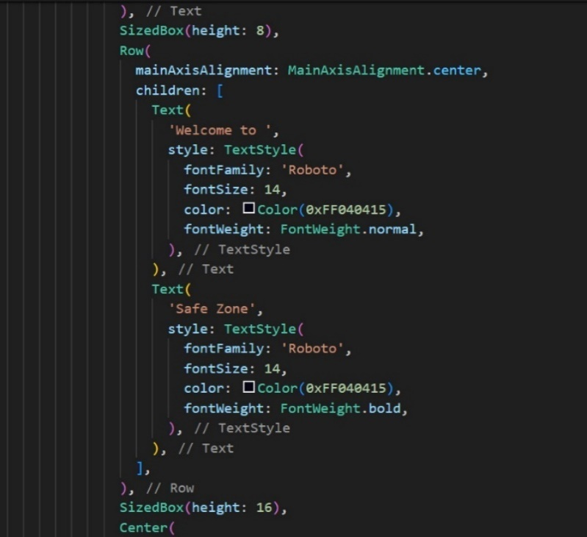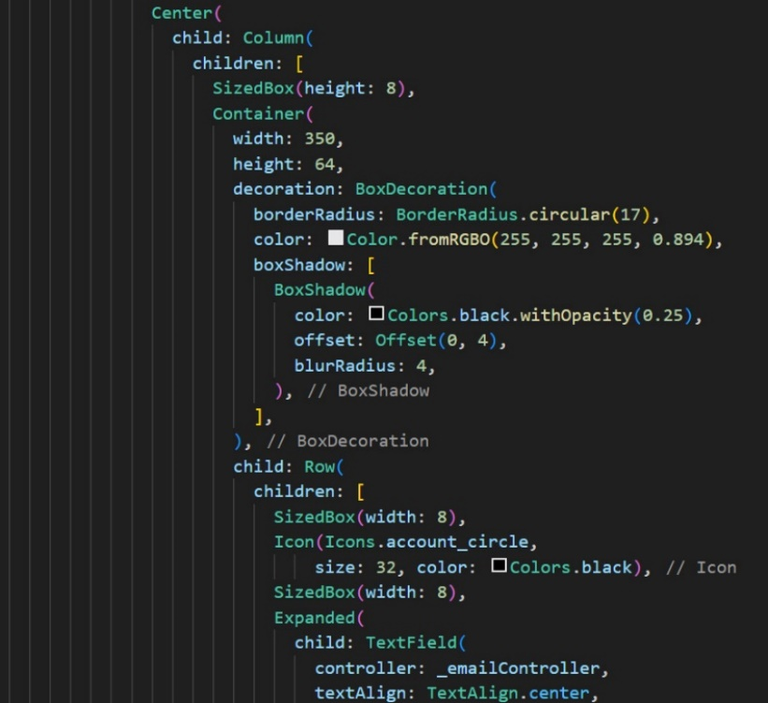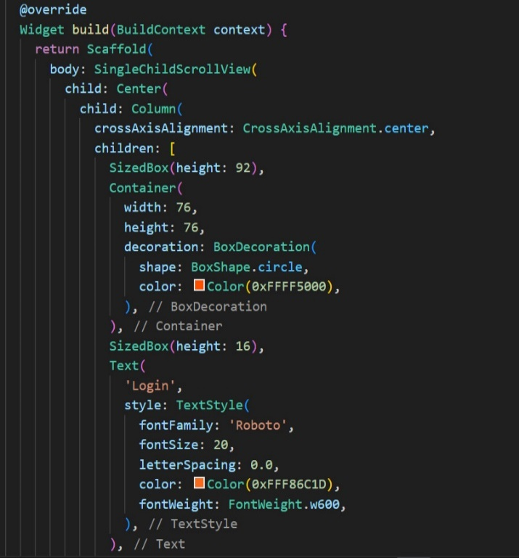

Building the main structure of the login page, including logo, title, and email/password input fields.

Forgot Password and Login Button

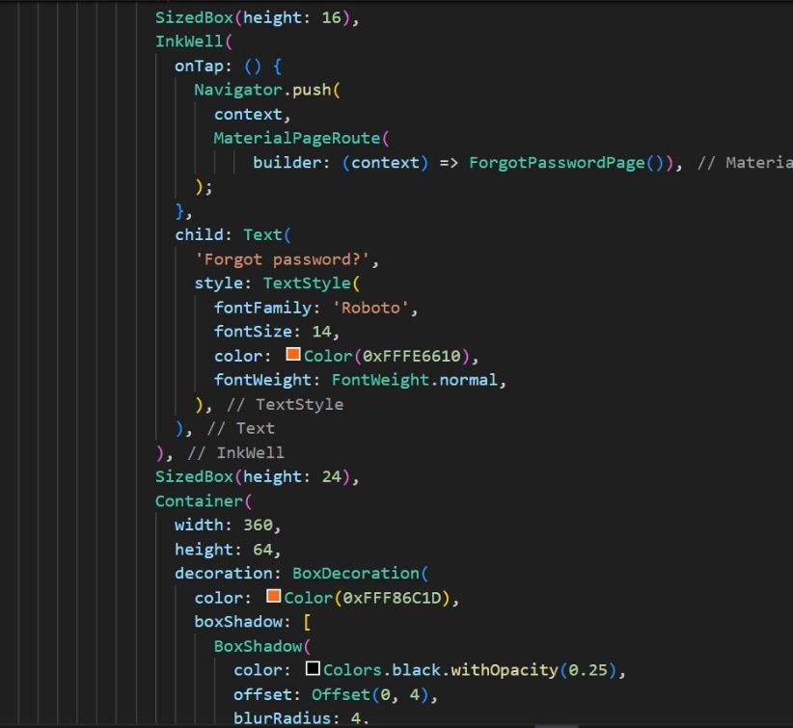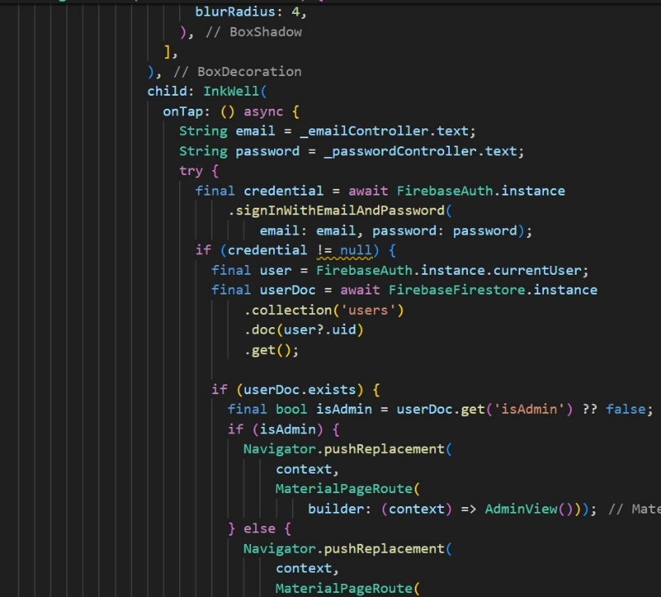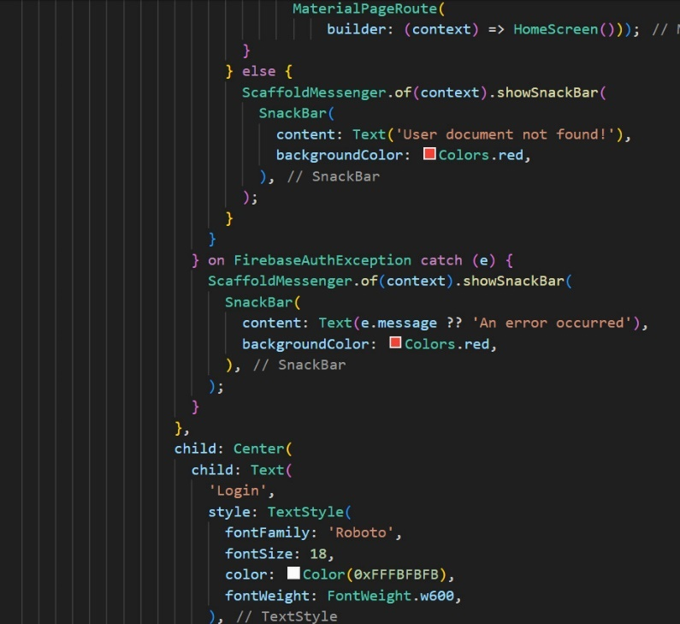

Adding a "Forgot Password" link and a login button with the logic to authenticate the user and navigate based on the user type.

Social Login and Sign Up Link

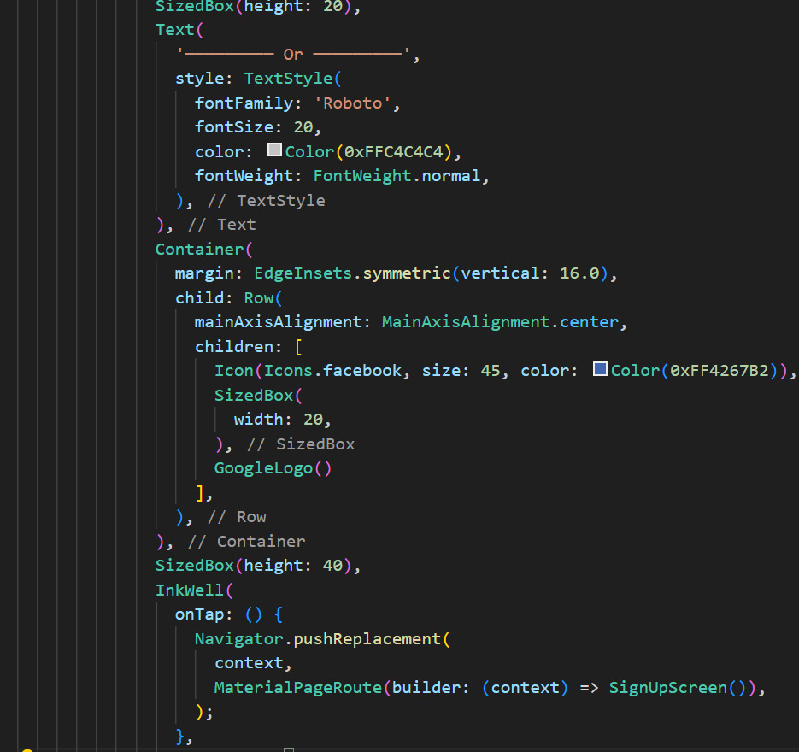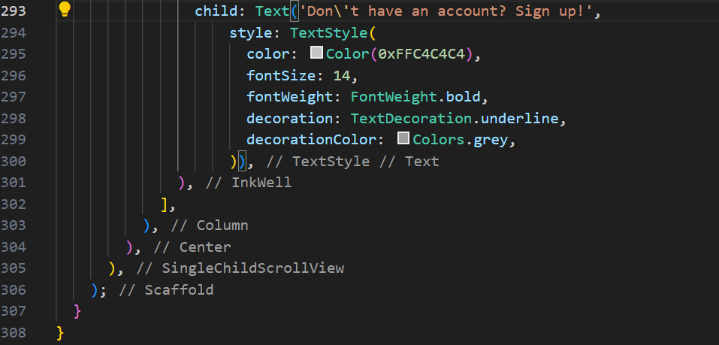

Adding options for social login and a link to the sign-up page.

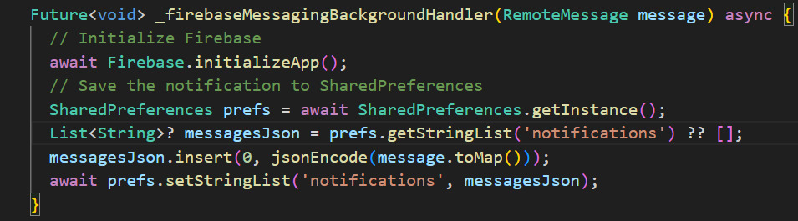

Defines a handler to manage background messages received via Firebase Cloud Messaging and save them to local storage.

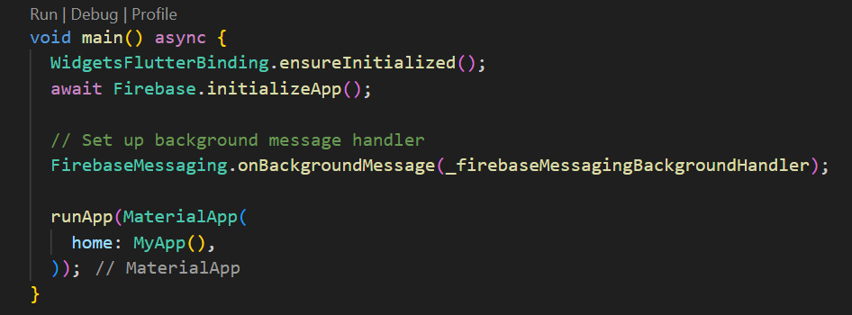

Main Function

Initializes the Flutter app and Firebase, sets up the background message handler, and runs the main application.

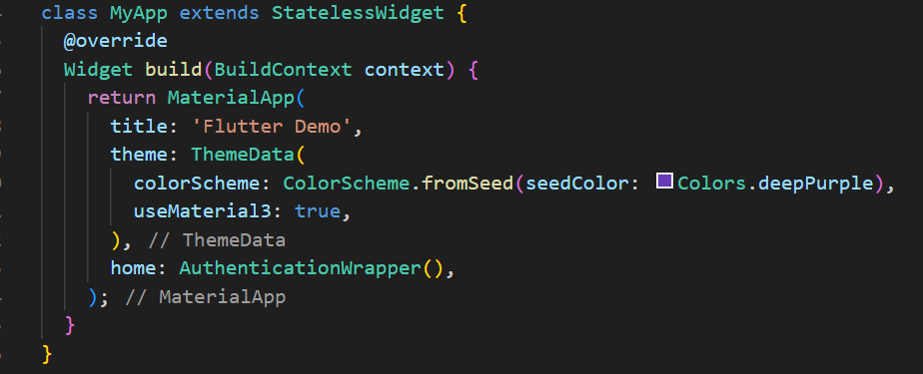

Defines the main app widget with a theme and sets the home screen to AuthenticationWrapper.

AuthenticationWrapper Widget

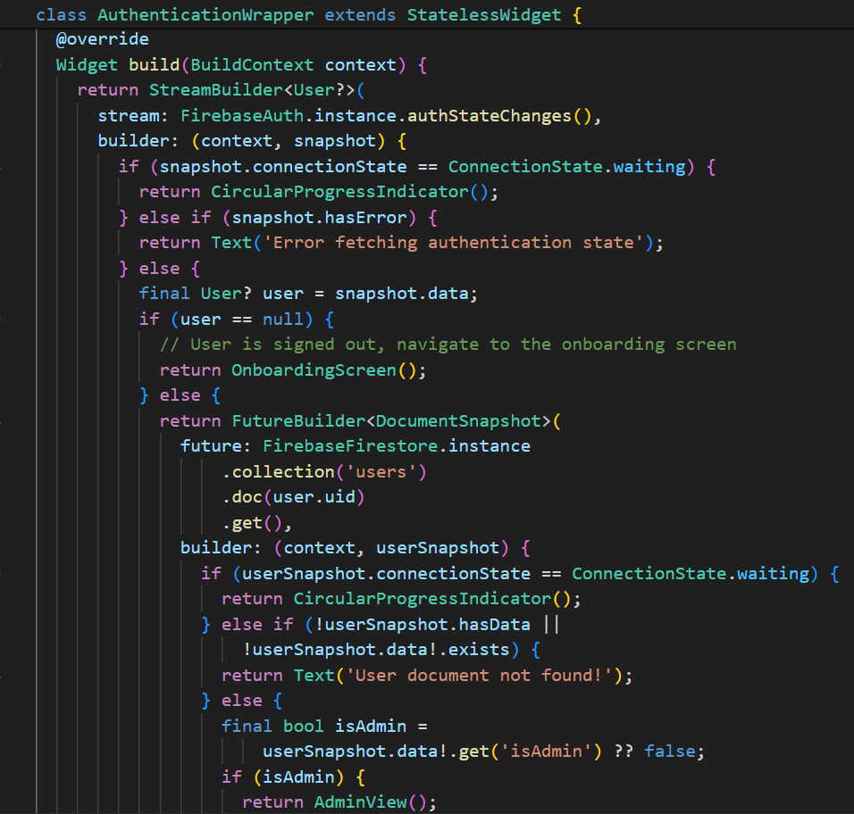

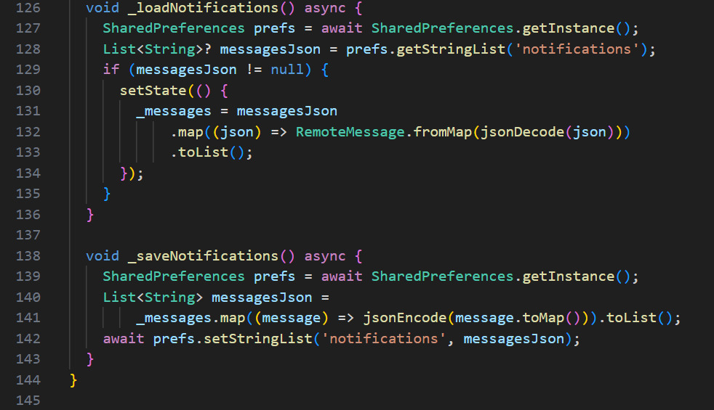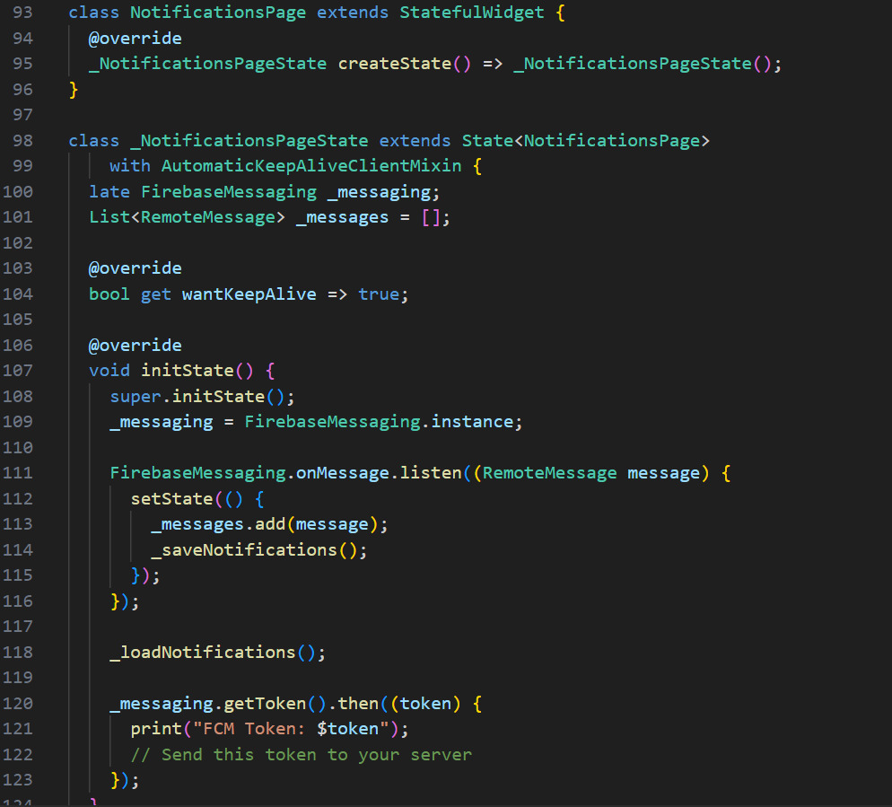

Manages real-time notification handling, saving and loading notifications from local storage, and obtaining the Firebase Cloud Messaging token.

4.9. Home Page:

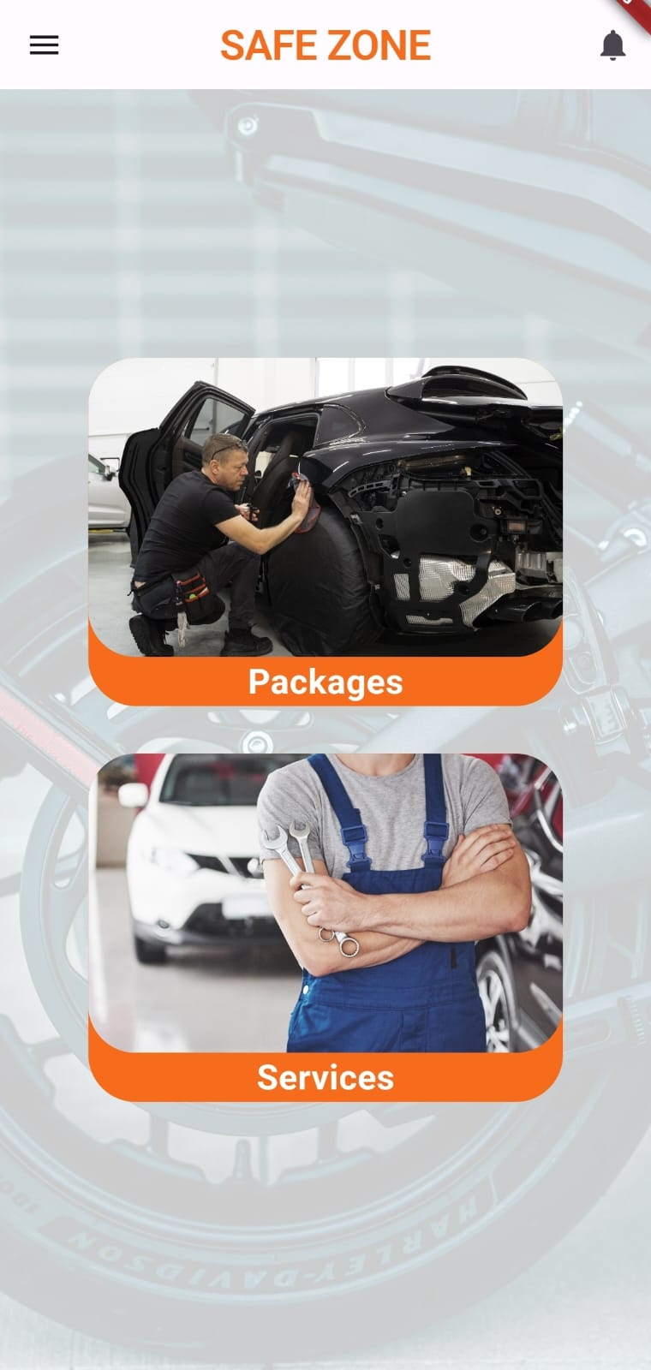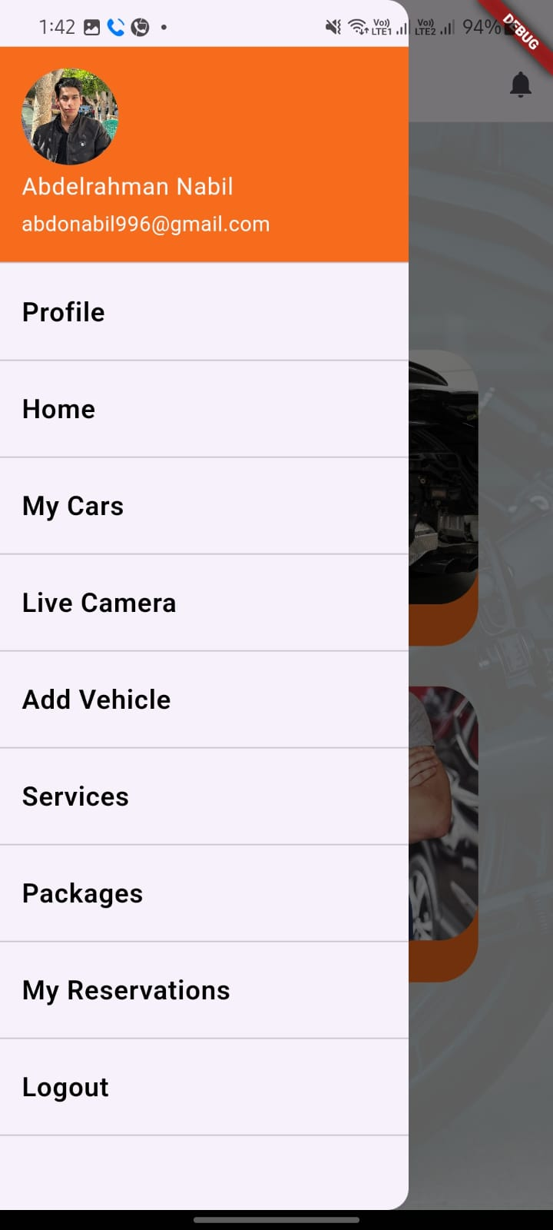

Home page

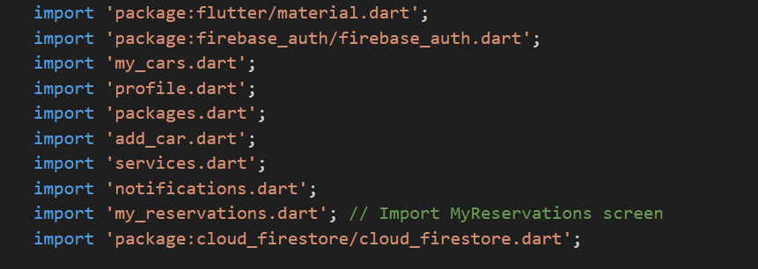

This snippet imports necessary Flutter and Firebase packages, as well as several custom Dart files that represent different screens in the app.

Main Function

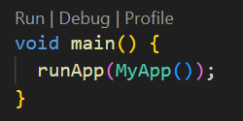

The entry point of the application. It calls the runApp function and passes an instance of MyApp.

MyApp Class

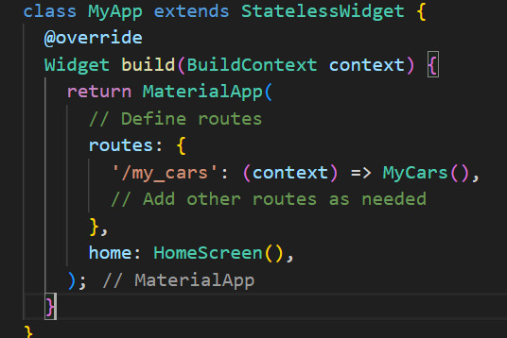

A stateless widget that sets up the MaterialApp, defines routes for navigation, and sets HomeScreen as the home screen.

HomeScreen Class

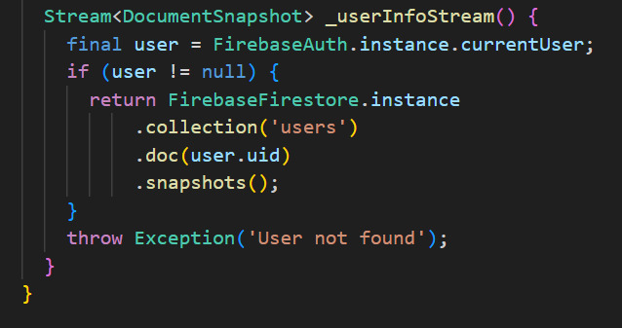

A helper method that returns a stream of user information from Firestore for the current authenticated user. If no user is found, it throws an exception.

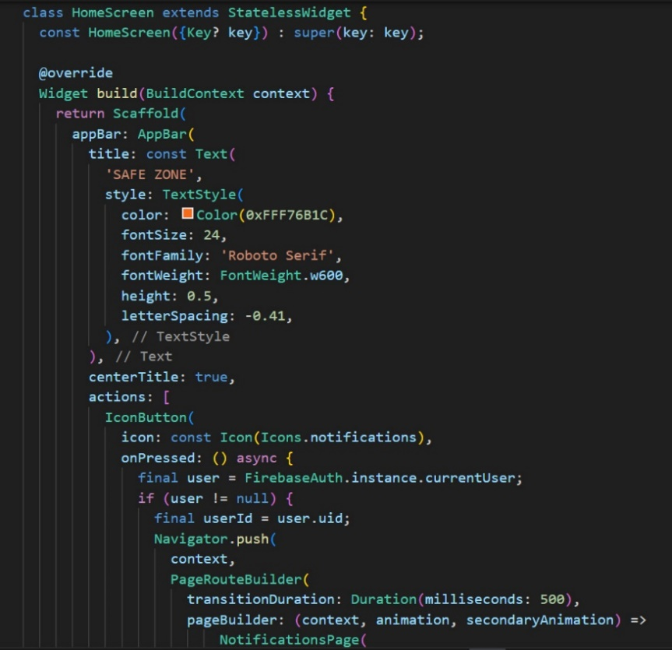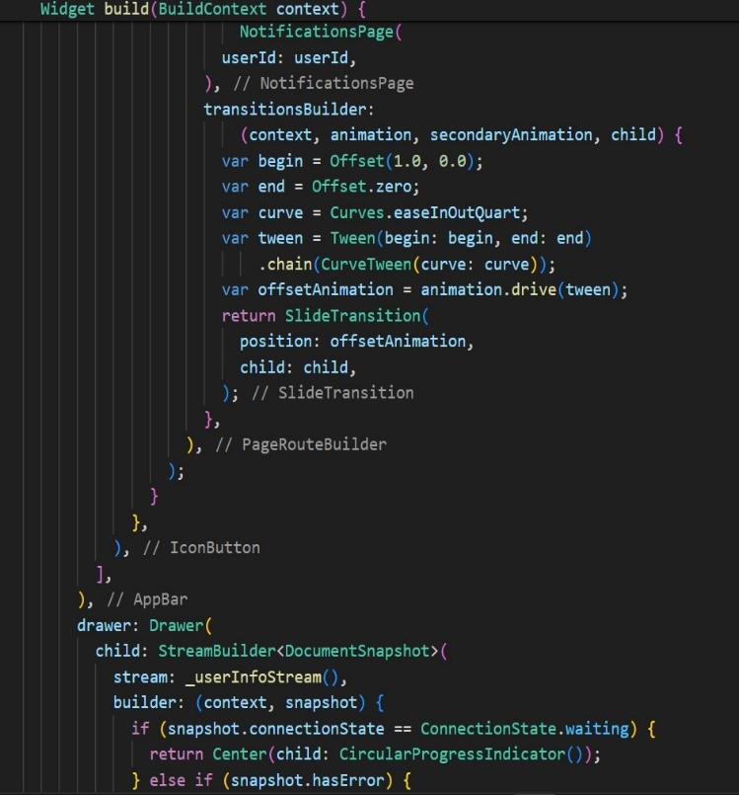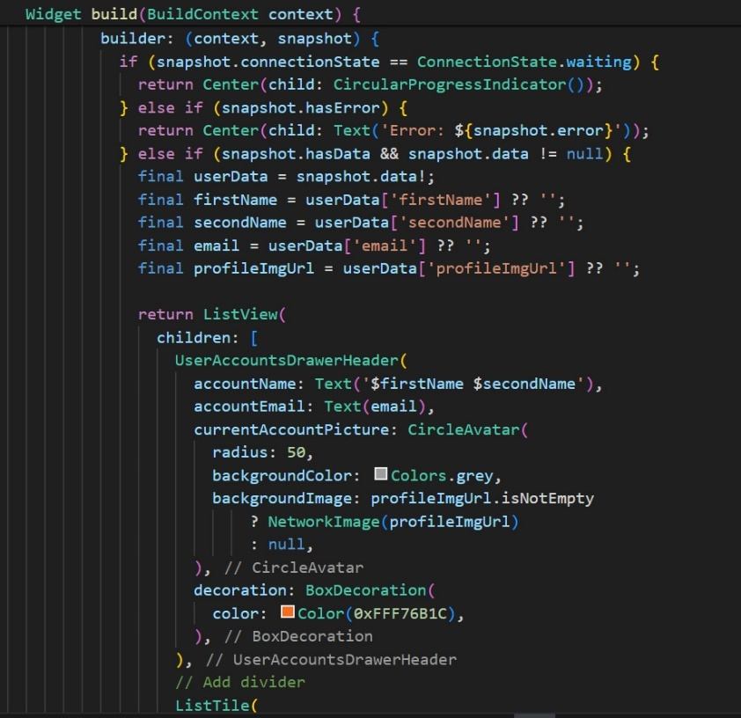

Defines the HomeScreen widget with an app bar, a navigation drawer, and a body.

The app bar includes a title and a notifications button.

The navigation drawer contains a StreamBuilder to fetch and display user information from Firestore.

The body contains two main options (Packages and Services) that navigate to respective screens on tap.

_userInfoStream Method

Chapter (5): Conclusion and result

5.1. Conclusion:

The "Safe Zone" mobile app marks a significant milestone in the realm of automotive care, providing an all-encompassing solution for vehicle owners who prioritize convenience, security, and comprehensive service. Our primary objective was to alleviate the common concerns of car owners, especially those who frequently travel or need to leave their vehicles unattended for extended periods. By offering a variety of subscription-based packages, the app ensures not just secure parking but also regular maintenance to prevent common issues like flat tires and oil degradation.

A standout feature of the Safe Zone app is its seamless integration of cutting-edge technology to enhance user experience and vehicle security. The live cam feature, for instance, allows users to monitor their cars in real-time, delivering unparalleled peace of mind through round-the-clock surveillance. Furthermore, the app empowers users to request additional services on demand, ensuring that their vehicles receive personalized care tailored to specific needs.

The development journey of Safe Zone has been a comprehensive endeavor involving meticulous research, innovative design, and rigorous testing. Our focus has been on creating an intuitive user interface backed by a robust and secure backend system capable of managing user data, service requests, and payment processing efficiently.

In summary, the Safe Zone mobile app is a trailblazing solution in the car care industry, seamlessly blending convenience, security, and extensive service offerings. It highlights the transformative potential of mobile technology in enhancing traditional services and improving user experiences. Looking ahead, we envision numerous opportunities for further development and expansion, such as integrating with automobile manufacturers, offering more personalized services, and penetrating new markets. We believe that Safe Zone has the potential to revolutionize the way car owners manage the care and maintenance of their vehicles, setting a new benchmark in the industry

5.2. Future Work:

**Another Features:**

* **Loyalty Program:**

Earn points for bookings, redeemable for discounts or free services.

* **Emergency Assistance:**

Request roadside help for flat tires, dead batteries, or lockouts.

* **Eco-Friendly Options:**

Access oil recycling, eco-friendly car washes.

* **Online Payment:**

Pay from the app with a button click.

**Advanced Features:**

* **Predictive Maintenance:**

AI analyzes data to predict maintenance needs and send reminders.

* **In-App Navigation:**

Get guided directly to available parking spots.